Preface

This Guide explains how to use Trade Innovation to process Buyer and Seller centric finance (including Dealer Financing) and Pool Based Factoring. It assumes that you are familiar with the basic principles of Supply Chain Finance, and with web browsers.

Events Covered in this Guide

The tables below list the products and events covered in this Guide, explaining what each event allows you to do. The table lists the names given to events when Trade Innovation is delivered. Your bank can change these names once the system is installed. Consequently, the names in your version of Trade Innovation may be different from the ones listed here.

In addition to the events listed in the table, you can also use the functionality described in the Common Facilities User Guide – Trade Innovation when processing transactions in Trade Innovation.

|  |  |
| --- | --- |
| Invoice Event | Purpose |
| Create | Enables an invoice to be manually or automatically created. |
| Amend | Enables an invoice to be manually or automatically amended provided that it has not been included in a finance deal. |
| Cancel | Enables an invoice to be manually or automatically cancelled providing it has not been included in a finance deal. |
| Discount | At pre TI Plus 2.5 level, this enabled an individual invoice to be manually or automatically discounted. This is disabled for new event creation. |
| Settle | Enables a partial or full payment of the invoice and financing to be paid. It also allows pre TI Plus 2.5 discount at the invoice level to be repaid. |
| Link to credit note | Automatically created when a credit note is applied or linked to an invoice providing the invoice has been included in a finance deal or not. |
| Unlink from a credit note | Automatically created when a related credit note is unlinked from an invoice where the invoice has been included in a finance deal or not. |
| Link to a buyer or seller centric finance | Automatically created when a buyer or seller centric finance deal is generated against an invoice. |
| Unlink from a buyer or seller centric finance | Automatically created when a related buyer or seller centric finance deal is cancelled. |

|  |  |
| --- | --- |
| Credit Note Event | Purpose |
| Create | Enables a Credit note to be recorded and/or linked to one or more invoices. |
| Adjust | Enables an invoice to be manually or automatically adjusted provided that linked invoices have not been included in a finance deal. |
| Cancel | Enables a credit note to be manually or automatically cancelled so that it becomes inactive, providing that any invoice(s) to which it is linked have not been financed.   1. Cancelling a credit note does not automatically reset the value of any linked invoices to their original value. This is achieved via the Link/Unlink event. |
| Link/Unlink | Automatically or manually created when a credit note is applied or linked to an invoice where the invoice has been included in a finance deal or not.  Automatically or manually created when a credit note is unlinked from an invoice where the invoice has been included in a finance deal or not. |

|  |  |
| --- | --- |
| Buyer Centric Finance Event | Purpose |
| Create | Enables a Buyer centric finance to be manually or automatically created. |
| Cancel | Enables the finance to be cancelled. |
| Repay | Enables the finance to be manually repaid fully or partially. |
| Scheduled repay | Enables the finance to be automatically repaid on the due date based on a diary event. |
| Past due | Enables the unpaid finance on the due to be categorised as past due. |
| Past Due Transfer | Enables the finance to be transferred into another book with new characteristics. |

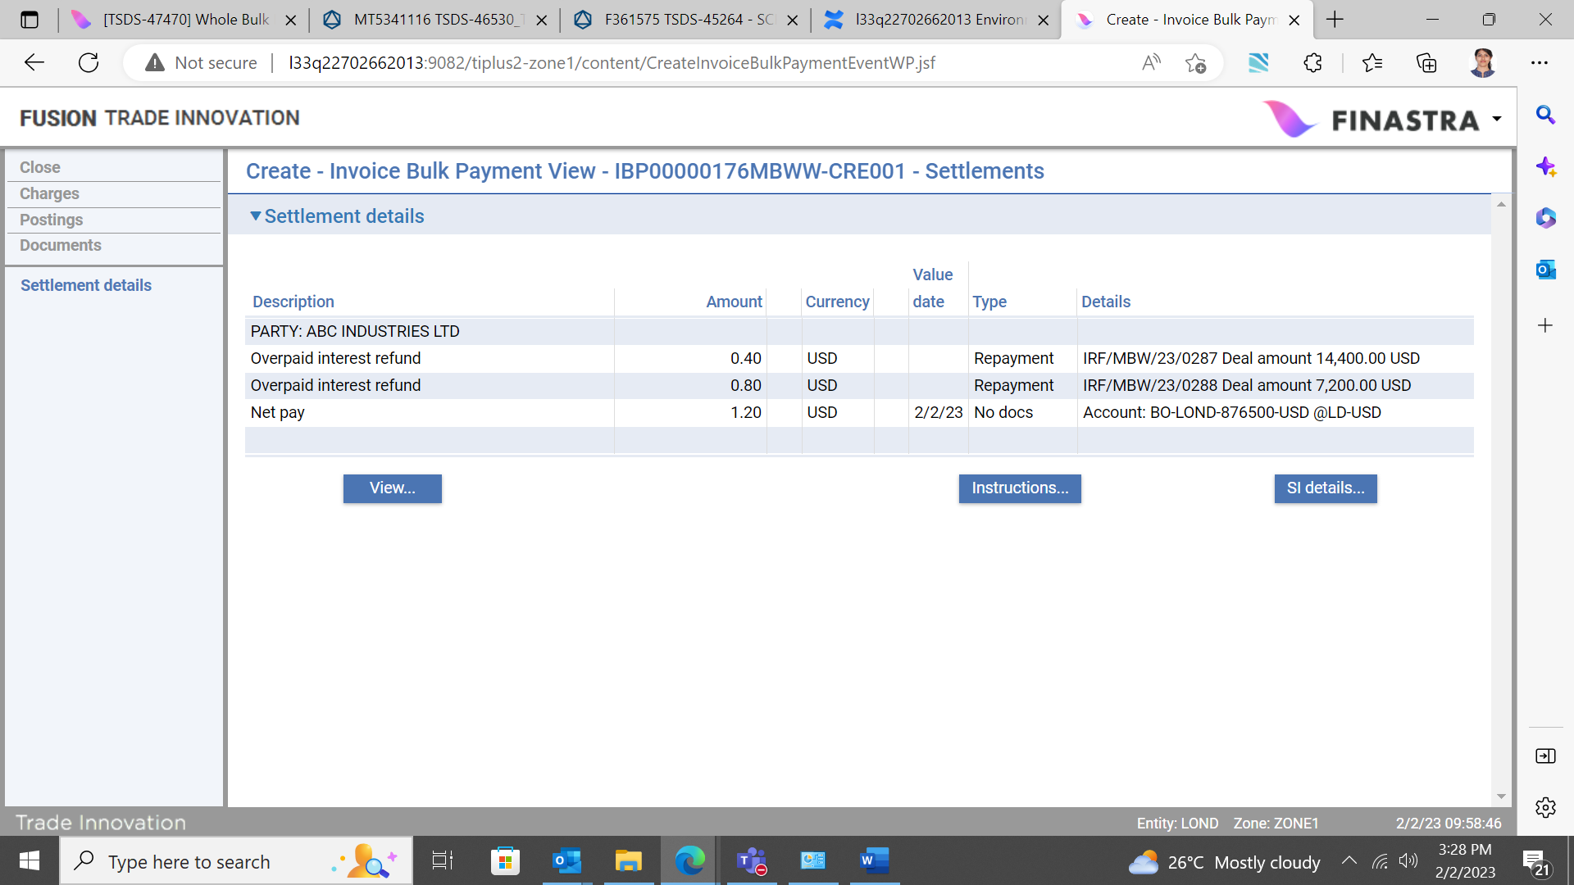

|  |  |
| --- | --- |
| Seller Centric Finance Event | Purpose |
| Create | Enables a Buyer Centric Finance to be manually or automatically created. |
| Cancel | Enables the finance to be cancelled. |
| Repay | Enables the finance to be manually repaid fully or partially. |
| Scheduled repay | Enables the finance to be automatically repaid on the due date based on a diary event. |
| Past due | Enables the unpaid finance on the due to be categorised as past due. |
| Past Due Transfer | Enables the finance to be transferred into another book with new characteristics. |

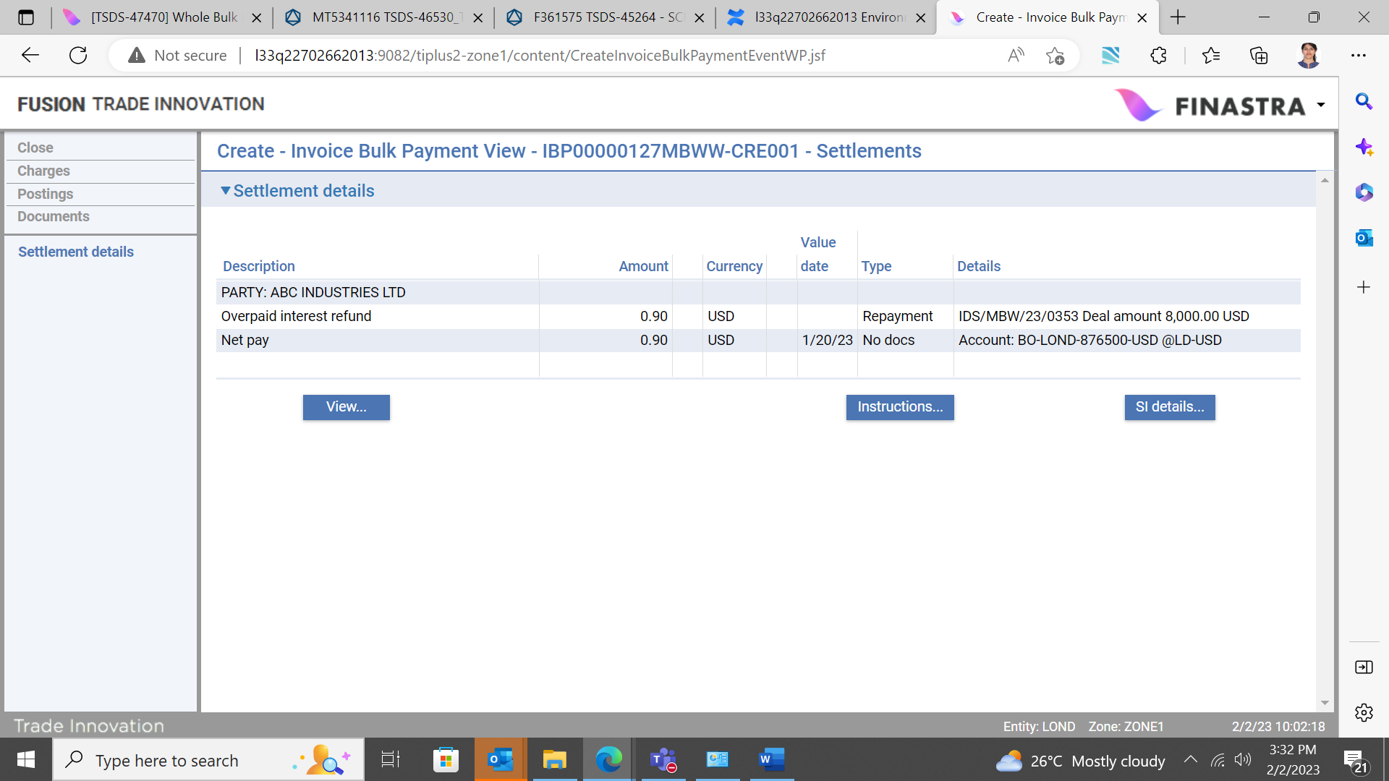

# Introduction

This chapter provides an overview of how Trade Innovation handles Supply Chain Finance and introduces the terminology used in this Guide.

## Supply Chain Finance

Trade Innovation’s Supply Chain Finance functionality covers three means of processing finance or drawdown against your customers’ eligible invoices:

* The *Pool Based F*actoring functionality covers drawdowns against your customer’s pool of invoices.
* The *Seller Centric* functionality covers financing against your customer’s invoices either individually, or in bulk. Data workflow originates from the seller, who owns the ‘Programme’ and submits requests to buyers. The seller is therefore the ‘Anchor party’.
* The *Buyer Centric* functionality covers financing against your customer’s invoices either individually, or in bulk. Data workflow originates from the buyer, who owns the ‘Programme’ and offers financing opportunities to its sellers. The buyer is therefore the ‘Anchor party’.

## Supply Chain Finance ‘Programmes’

To enable your bank to record, finance or settle invoices received from your customer, it is necessary to set up a Supply Chain Finance ‘Programme’. A customer may have one or more programmes, each of which must be allocated its own unique identifier when the terms are agreed between your bank and your customer.

A Programme may relate to a one-to-one relationship between buyers and sellers. When invoices and credit notes are received in the system, they are loaded under a designated programme. The programme provides a framework for transaction processing and is established and maintained in the Static Data application.

Limits, needed for the calculation of drawdowns or advances (finances) must be set up. Each customer, whether they are a buyer, or seller can be assigned either a buyer or seller centric programme depending on the contractual agreement and their trading role within it.

Your bank sets up a notional *invoices (debtor) concentration* limit for each buyer, which defines the total value of invoices (awaiting payment) that the buyer is allowed to have recorded at any one time. When your bank receives details of an invoice, it uses the information to reduce the buyer's limit availability in order to monitor and control its own exposure to that debtor, buyer. These limits are also updated whenever an invoice is settled, amended or cancelled.

As each seller/buyer relationship is defined, your bank defines what percentage of eligible invoices is to count towards the amount available for drawdown or finance/advance and also a maximum limit amount for that buyer.

Your bank may be responsible for maintaining the customer's receivables or payables ledger, recording and settling invoices (applying related credit notes) using information provided by the customer and their buyers or sellers and for chasing overdue payments.

Trade Innovation uses a separate application - Supply Chain Finance - and the following separate products and product sub-types to handle buyer and seller centric financing and pool based factoring:

* Buyer Centric finance, which is used to create finances against eligible invoices in order to make advance payments to sellers under buyer centric programmes
* Seller Centric finance, which is used to create finances against eligible invoices in order to make advance payments to sellers under seller centric programmes
* Pool Based Factoring, which is used to drawdown funds through factoring facilities against respective pools of invoices in order to make advance payments to sellers under seller centric programmes
* Bulk financing, which provides the bulking of invoices and subsequently financing the same.
* Multiple financing, where the buyer/seller can request partial financing in tranches of the full amount.
* Assigning of credit notes automatically to invoices based on pre-defined criteria.

1. Your bank may create its own product sub-types, each with its own unique code and description but based upon the above buyer or seller sub-types.

Details of new invoices, and requests to amend, cancel, finance or settle them, may be received electronically via customer gateway interface service messages, as may factoring drawdown requests and requests to calculate the amount available for drawdown.

## The Supply Chain Finance Master Browser

The Supply Chain Finance Master Browser is the initial entry point for the banking user to maintain invoices, credit notes, finance deals and pool based factoring facilities for the purpose of inquiry, assessment, workflow and formulating finance deals. It is designed to speed up the processing of invoices and credit notes, allowing you to:

* display the invoices and credit notes for a particular programme or customer
* create, settle, finance and repay (single or multiple) invoices, without having to open its Master Summary window,
* or to link (or unlink) a credit note to an invoice and
* to open a related factoring facility for processing

(See page 9 for details.)

## The ‘Anchor Party’ Role in Supply Chain Finance

A programme is defined for a customer which is referred to as the ’Anchor party’:

* They exist as a customer in the bank’s books
* They own a Supply Chain Finance programme backed up by a legal contract with the bank
* They typically assume credit liabilities
* In the context of a buyer centric programme they:
* Have significant credit worthiness
* Are likely to be a valuable customer of the bank
* Are involved in significant trading activity as the buyer of goods or services from multiple sources
* Are interested in enabling financing opportunities to their trading counterparties, sellers
* In the context of a Seller centric programme they:
* Have stable credit worthiness
* Are involved in significant trading activity as the seller of goods or services
* Are interested in accessing financing or advance payments

## Invoices

Invoices can be submitted to Trade Innovation via the customer gateway, or they may be received and input manually by your bank.

They may be submitted individually or in bulk (i.e. a batch or group of invoices), provided that their details clearly identify programme, buyer, seller and anchor party.

If submitted via electronic means, they may be straight through processed automatically and will create individual master records, depending on how you have configured your system.

## Credit Notes

A Credit note can be submitted to Trade Innovation via the customer gateway, or it may be received and input manually by your bank. A single credit note can be linked to one or more invoices or alternatively, several credit notes can be linked to a single invoice. You can apportion a specific amount to each invoice which will reduce the face value amount of the invoice accordingly.

It is also possible to unlink a credit note from an invoice whether it is financed or unfinanced.

The system also enables an invoice face value amount to be ‘Adjusted’ for reasons other than linking a credit note.

Any changes to the face value amount of the invoice are detailed in the invoice master summary screen.

(See page 26 for details.)

## Buyer or Seller Centric Finance

Buyer Centric Financing involves your bank making advances to the seller against buyer ‘Approved’ invoices, or sets of invoices. Invoices and credit notes are typically submitted by the buyer.

Seller Centric Financing involves your bank in making advances to the seller against individual invoices, or sets of invoices. Invoices and credit notes are submitted by the seller.

A request for finance against specific invoices always originates from the seller.

Your bank may make an ‘Offer’ of finance to the seller if requested to do so. Acceptance of this finance offer by the seller results in Trade Innovation automatically calculating an advance against a single, or multiple invoices by applying the discount percentage set up for the relevant seller/buyer relationship to the outstanding amount. This is capped by the seller/buyer limit availability, and then, by the customer's advance credit limit availability.

Each approved invoice can be financed once only. A finance request can be received in electronic or paper format. Such requests to finance invoices received electronically via the gateway are automatically processed by the system, requiring minimal user intervention.

## Pool Based Factoring

Pool Based Factoring is the contractual outsourcing by a corporate customer to its bank of all aspects of that customer's credit control management. The bank - the factor - grants the customer an associated line of overdraft facility, which is based on the total amount of eligible invoices recorded for the customer. The customer can make drawdowns (access advance/early payments) against this line of facility on an ad hoc basis, up to an agreed percentage of the value of eligible invoices at the time of the drawdown.

When your bank enters into a factoring agreement with a customer, it sets up a single programme and related factoring facility for them in Trade Innovation.

On a regular basis (defined separately for each factoring facility) Trade Innovation calculates the amount available for drawdown (based on invoices recorded for that customer and on the percentages, the advance limit set up for each buyer/seller relationship, and the customer's factoring limit) and advises the customer. Any drawdowns against a factoring facility are subject to limit checking against the customer's factoring limit (which constitutes the customer's overall funding limit).

Your bank can configure a factoring facility so that it requires review on a regular basis, which is carried out using an Amend Factoring Facility event generated in the diary. Similarly, regular Scheduled Charges diary events can be scheduled to collect charges relating to the factoring facility.

(See page 55 for details.)

## Settlement and Repayment

Trade Innovation allows for the settlement of non-financed invoices as well as the repayment of financed invoices. For the purposes of this guide “settlement” refers to payment of invoices whilst “repayment” refers to repayment of finance transactions. The bank may initiate payment of an invoice (Settle invoice event) or repayment of a finance (Repay finance event) through its respective Master.

Invoice Bulk Payments allows the bank to process multiple settlement and repayment requests for multiple invoices or multiple finances or a combination of both in a single transaction. The invoices and finances in the bulk may be under different programmes and there may be different seller/buyer relationships covered in the same bulk payment transaction. The next chapter covers defining Programmes and Buyer and Seller relationships.

# Before You Begin

This chapter explains what needs to be set up on your system before you can begin using Supply Chain Finance functionality.

In addition to the configuration described in this chapter your bank can also set up tracers, as described in the System Tailoring User Guide – Trade Innovation; and reports, as described in the Report Tailoring User Guide – Trade Innovation.

## Configuring your System to Use Supply Chain Finance

To use Trade Innovation’s Supply Chain Finance functionality your bank must implement Trade Innovation’s financing functionality.

Before you can start using Pool Based Factoring and buyer and seller centric financing in the system, there are certain things that need to be set up on your system, in addition to the usual product configuration described in the System Tailoring User Guide – Trade Innovation. These include:

* Setting the system options that control aspects of how factoring and financing are handled - see the next section
* Setting up necessary customers and their credit limits to use Supply Chain Finance functionality
* Setting up necessary programmes for your customers and their counterparties
* Setting up necessary buyers, sellers and related limits and seller/buyer relationships
* Setting up necessary customer accounts and internal accounts
* Setting up necessary standing settlement instructions
* Setting up necessary interest, account postings, charges, clauses and documents
* Setting up customer limits in the risk management system used by your bank
* Setting up any programme specific participation deals
* Defining the warnings and error messages to be produced by the Supply Chain Finance application
* Including batch processing actions relating to factoring and financing in overnight processing
* Setting up the product sub-type at buyer-seller relationship level which can be defaulted during the invoice bulk transactions.
* Setting up the product sub-type at buyer-seller relationship level which can be defaulted during the multiple finance transactions.

Your bank also needs to set factoring and invoice related user capabilities, as described in the Security Guide – Trade Innovation.

## System Options

The following system options govern the processing of factoring and financing programmes and invoices:

|  |  |
| --- | --- |
| Identifier | What the Parameter Controls |
| CustomerFactoringLimitCategory | Relevant only if CustomerSupChnFinLimitAvailability is set to Departmental limits. This system option defines the code of the departmental limits category to be used when accessing the customer's pool based factoring limit availability. Option is set at Branch/Service option level. |
| CustomerSupChnFinLimitAvailability | Determines where the system will retrieve the limit details used to calculate the amount available for drawdown or advance. Possible values are:   * The internal departmental limits application provides the limit details * The limit details are held locally within Trade Innovation (in parallel with information held in your bank's risk management system)   Option is set at Branch/Service option level. |
| SellerCentricLimitCategory | Relevant only if CustomerSupChnFinLimitAvailability is set to Departmental Limits. This system option defines the code of the limits category to be used when accessing the customer's seller centric advance limit availability. Option is set at Branch/Service option level. |
| BuyerCentricLimitCategory | Relevant only if CustomerSupChnFinLimitAvailability is set to Departmental Limits. This system option defines the code of the limit category to be used when accessing the customer's buyer centric limit availability for calculation purposes. Option is set at Branch/Service option level. |
| InvoiceStalePeriod | Option is set at Zone level – Defines the period after the issue date that the invoice is considered to be stale. |
| InvoiceTotalsCcy | Defines the currency to be used for invoice summary totals. Option is set at the Zone level. |
| SpeedUpInvoiceCreateAndSettle | If the flag is checked (Yes), the Master Summary window will be by-passed when the input clerk is processing invoice Create and Settle events. This is to speed up invoice processing. Option is set at the Zone level. |
| SupplyChainFinanceLimitsCurrency | Defines the default currency for buyers' limits and seller/buyer relationship limits. If this is not defined, local currency is used as the default. Option is set at the Zone level. |
| SCFAutoCreateAnchorParty | If set to Yes, the system will automatically create the anchor party upon creation of a programme. |

## Customers

For the purposes of Supply Chain Financing functionality, customers of your bank are defined as usual, taking account of Trade Innovation considerations.

For more information see the Static Data Maintenance User Guide – Trade Innovation.

## Customer Credit Limits

Your bank will need to set up the required customer credit limits within whatever credit risk management system it uses, and monitor and review them regularly.

## Programmes

The concept of a Supply Chain Finance Programme refers to a set of details interpreted from a legal contract agreed between the bank and its corporate customer for the purpose of processing invoices, credit notes and related finances or drawdowns. A programme is defined for a customer of the bank who is referred to as the ‘Anchor party’.

Programmes are set up and maintained in the *Static Data Maintenance* – Trade Innovation application.

It is necessary to create and/or assign counterparties to programmes and also to set up the necessary seller/buyers relationships. Counterparties may be either the buyer or seller in a programme (depending on whether it is buyer or seller centric) and may, or may not be customers of your bank.

Refer to the *Static Data Maintenance User Guide* – Trade Innovation for details on setting up programmes, buyers, sellers and their relationships.

## Buyers, Sellers and Their Relationships and Limits

Your bank can define the counterparties as buyers or sellers with whom a customer (the anchor party) has a trading relationship. For each anchor party, it is necessary to define their trading role in the context of their programme as buyer or seller. Then under each programme, it is necessary to define buyer/seller relationships.

See the Static Data Maintenance User Guide – Trade Innovation for further information on setting Supply Chain finance limits.

## Accounts and Settlement Instructions

Your bank will need to set up the accounts required for postings arising out of invoice settlement, advances and drawdowns; for example, invoice settlement suspense accounts, customer pool based factoring funding accounts, customer discounting accounts and customer settlement accounts.

## Product and Event Tailoring

Your bank will need to set up the relevant product options and product types for invoices, buyer centric finance, seller centric finance, pool based factoring, credit notes and invoice bulk payment. It will also need to define the relevant product event map and/or workflow orchestrations for each of these products and also the reference number definitions. See the *System Tailoring User Guide* – Trade Innovation for more information.

## Warning and Error Messages

Your bank is able to define warnings and error messages to be produced for specific events in certain circumstances, in addition to those delivered with the system. You can use this functionality to set up any warning messages and error messages to be returned to the Supply Chain Finance application, for example as a result of limit checking when an invoice is created or amended.

If your bank does not permit buyers to exceed their invoice concentration limits, then it is necessary to configure invoice Create and Amend Invoice events so that an error message is produced if the event results in a limit being breached.

Your bank can also use warning and error messages, for example:

* To prevent drawdowns against a Pool Based Factoring facility that has reached its expiry date
* To advise that a manually entered advance amount exceeds availability
* To advise when an amendment to an invoice amount and maturity date conflict with an existing advance

See the System Tailoring User Guide – Trade Innovation for instructions on setting up warning messages and error messages.

## Batch Processing Actions

The following batch processing actions are specific to factoring and related invoices:

|  |  |
| --- | --- |
| Operation | Description |
| Invoice Buyer Reorganisation | Deletes buyers and seller/buyer relationships flagged for deletion. |
| Invoices Exposure Rebuild | Revalues and rebuilds exposure against customers, buyers and seller/buyer relationships using the details of invoices with master records with a status of 'LIV' and, where relevant, spot rate. |
| Invoice Exposure Revaluation | This action:   * Revalues buyer’s exposure relating to invoices using current spot exchange rates * If applicable, revalues customer and seller/buyer exposures using current spot exchange rates * Updates an invoice's status (and their eligibility status) should the invoice become overdue * Updates the eligibility status (that is, whether an invoice is eligible for drawdown or not) and associated Reason text due to a post-dated invoice becoming current or an invoice becoming overdue or a buyer’s status changing from 'Active' to 'Referred/Blocked' or vice versa * Adds a note to an invoice when any of its details change in the ways described above (except for buyer’s exposure revaluation) * Establishes the link between invoices and their factoring programme, if the latter was created in the system after the former |

See the Business Operations User Guide – Trade Innovation for more information on including these actions in overnight batch processing.

## Security Capabilities

In order to control user access to specific Supply Chain Finance functions; within the Static Data application, your bank must set the appropriate access authorities for each user. This will be dependent on your bank’s hierarchy. To enable a user to create the necessary setup for the Supply Chain Finance application, it’s necessary to assign the capabilities relating to Supply Chain Finance which are detailed in the following user guide: *Security Guide – Trade Innovation.*

# The Supply Chain Finance Masters Browser

This chapter explains how to use the Supply Chain Finance (SCF) masters browser, to manage invoices, Pool Based Factoring facilities and Credit Notes. It also describes the access point to view limits details of buyer exposure, programme exposure and programme/buyer exposure.

The purpose of the SCF browser is to provide a single point of access to all SCF products and events and thus to speed up transaction processing. It is possible, via the browser, to record and maintain invoices and credit notes, to formulate a single finance deal against one or more invoices, to view existing finance deals and to create, drawdown and maintain pool based factoring facilities.

Depending on whether your bank uses the SLA Dashboard function, when you open the Supply Chain Finance application the first window you see is the supply chain finance masters browser.

## The SLA Dashboard

If your bank does use the SLA Dashboard function, it is still possible to record new invoices, credit notes and factoring facilities via the ‘New Master’ pane if required. Select the product from the dropdown list provided and click the ‘New’ button. This initiates the appropriate create event for the product selected. However, the use of the Supply Chain Finance Browser is necessary to formulate buyer centric or seller centric finance deals.

## Setting the ‘View’ in the SCF Master Browser Filters Pane

It is possible to filter for SCF products by setting a specific ‘View’.

In the Master browser filters pane, you must select the product that you want to work on from the ‘View’ dropdown list. The default ‘View’ is set to ‘Invoices’.

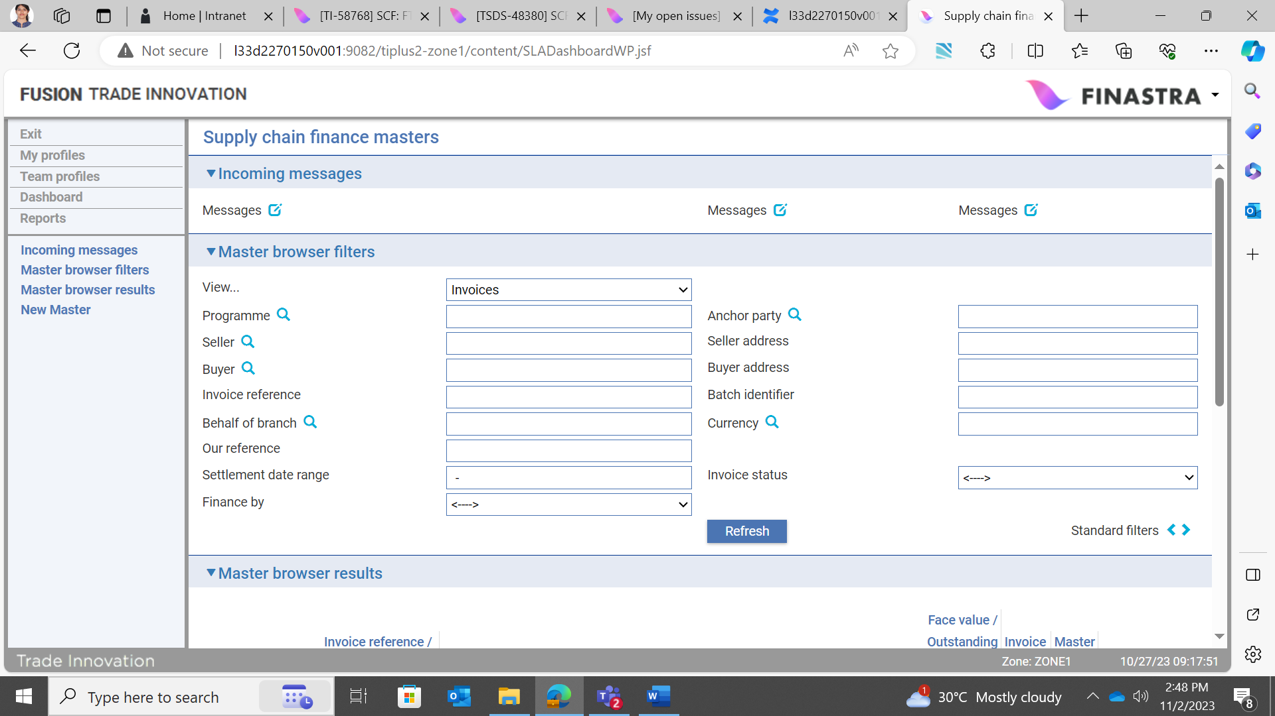

The dropdown list provides the following options:

* Invoices – all invoices listed in your system
* Invoices for financing – all invoices that meet required eligibility criteria and are available to be financed (see page 68)
* Invoice finance deals – all seller and buyer centric finance deals listed in your system
* Pool based factoring – all factoring facilities listed in your system (see page 55)
* Credit notes – all credit notes listed in your system (see page 26)
* Open account – all transactions related to your Open Account business in Trade Innovation
* Bulk payments – all invoices and finances grouped for payment (see page 49)

Business Reference is where parameters that govern how the system operates with regard to account are set up and maintained.

## The Master Browser Results Pane

Clicking Refresh causes the system to list all records on your system, depending on the view selected.

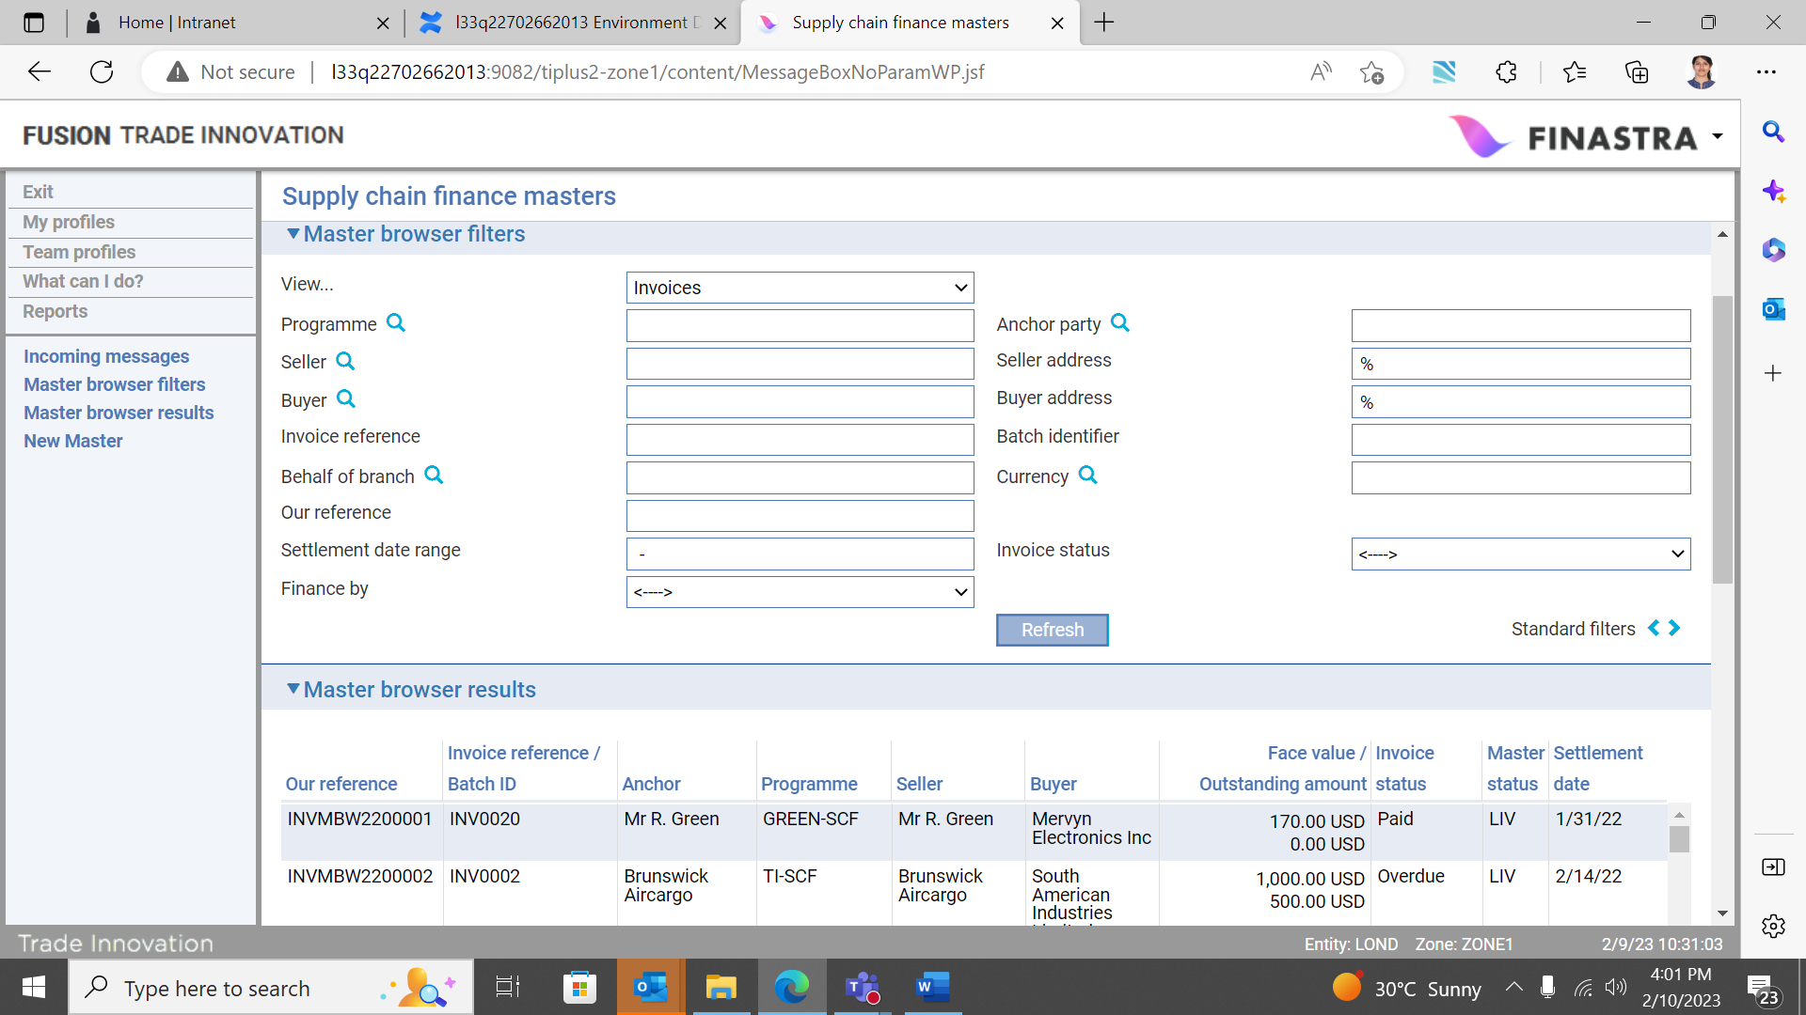

The filters in the Master browser results pane allow you to display invoices matching certain criteria. In particular:

* The Programme filter allows you to select a programme and display all items in the selected view (e.g. invoices) relating to that programme
* The Anchor Party filter allows you to select the anchor party and display all items in the selected view (e.g. invoices) for all programmes for that anchor party
* The Invoice Status filter allows you to display invoices with a particular status
* The Finance By filter allows you to display invoices by sub-type, for Pool based factoring, Buyer centric finance or Seller centric finance. Clicking the Refresh button activates your selection criteria

The filters available vary, depending on the View selected. Setting a specific View enables certain filters appropriate to the product/function specified.

Trade Innovation restricts the number of rows displayed, depending on the setting of the MasterBrowserRowLimit system option. Refer to the *System Tailoring User Guide* – Trade Innovation for more details.

The system shows:

* The total face value of all the invoices meeting your criteria
* The total amoun*t outstanding*
* The total amount paid
* The total value of any cancelled invoices
* The total amount of any overdue invoices

The Buyer Exposure button displays exposure details for the buyer identified in the Buyer filter field.

The Programme exposure button displays exposure details against the SCF programme identified in the Programme field.

The Programme/Buyer (seller) Exposure button displays details of the exposure at the seller/buyer level identified in the Seller and Buyer filter fields.

Highlighting an invoice and clicking the Open button below it opens the Master Summary window for that invoice. Clicking the Settle button instead opens a Settle event. This speeds up the settlement of invoices by allowing you to create a Settle event without having to open the Master Summary window for the invoice first.

If you set the view to Pool Based Factoring and highlight a row in the Master browser results pane, clicking the Open button opens the Master Summary window for the related pool based factoring facility.

If you set the view to Bulk payments, the Master browser results pane displays the Invoice bulk payment reference, Anchor party, Programme, Seller, Buyer, Settlement amount, Settlement date and Master status. When the bulk payment contains invoices and finances from more than one programme, the Programme, Seller and Buyer columns in the Master browser results pane is blank. When you highlight a row, clicking the Open button opens the Master Summary window for the related Invoice Bulk Payment.

If the invoices are all in the same currency the total figures are shown in that currency. If they are in different currencies, the total figures are shown in the currency defined by the system option InvoiceTotalsCcy (base currency is used if this is not set), with spot rate being used for any foreign exchange conversions that are necessary.

Clicking the Standard Filters chevrons displays additional standard filters. The Invoice Filters button returns you to the SCF masters browser, set to the ‘View’ originally specified.

The Exit button closes the Supply Chain Finance application and returns you to the window used to select and run Trade Innovation applications.

## Grouping Invoices for Financing

If you set the master browser filters to view invoices available for financing, the master browser results pane groups invoices by programme, buyer/seller combination, currency and settlement date. It is then possible to select an automatically identified group, or individual invoices meeting the same criteria to create a ‘Bulk’ finance deal if required. Refer to page 90 for details of eligibility criteria applicable.

## The New Master Pane

The fields in the New Master pane allow you to enter a new credit note, an export or import open account, a factoring facility, an invoice or invoice bulk payment. The Team and Behalf of branch must be input and this enables the ‘Create new master’ dropdown list, from which you can select the type of master that you wish to create.

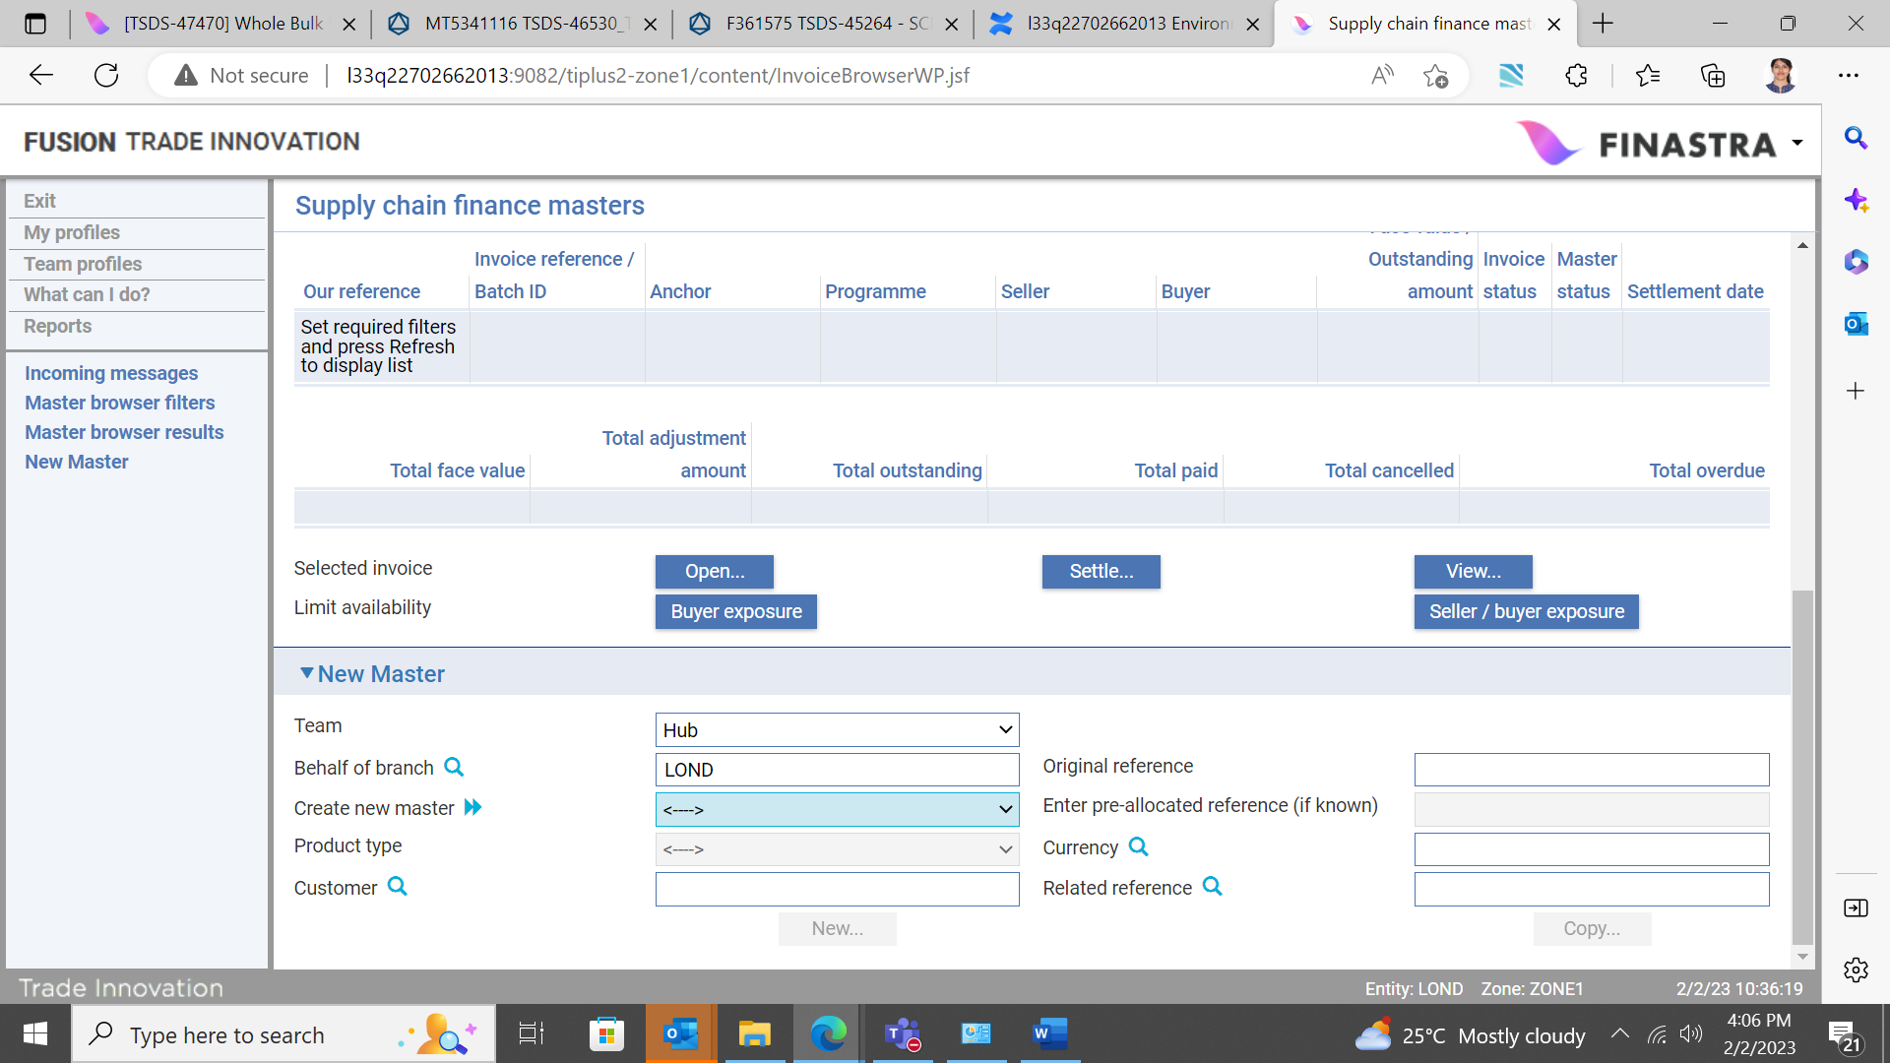

If the customer for the transaction has been allocated a block of reference numbers, enter the reference number provided by the customer into the Enter Pre-allocated Reference field, then click the New button. The system searches for the customer to whom the number has been allocated and displays their name. The reference number entered here is used to generate the unique reference number for the transaction. If you do not enter anything into the Enter Pre-allocated Reference field the system uses the next available sequence number to generate the unique reference number.

If this transaction is related to another one, you can use the Related Reference field to specify that transaction’s master record.

1. If you are displaying credit notes, factoring facilities, invoices or other products for a specific programme and customer, that customer is not carried over to the new master as a default value.

Once you have completed input, click **New**.

## Viewing Buyer Exposure Breakdown

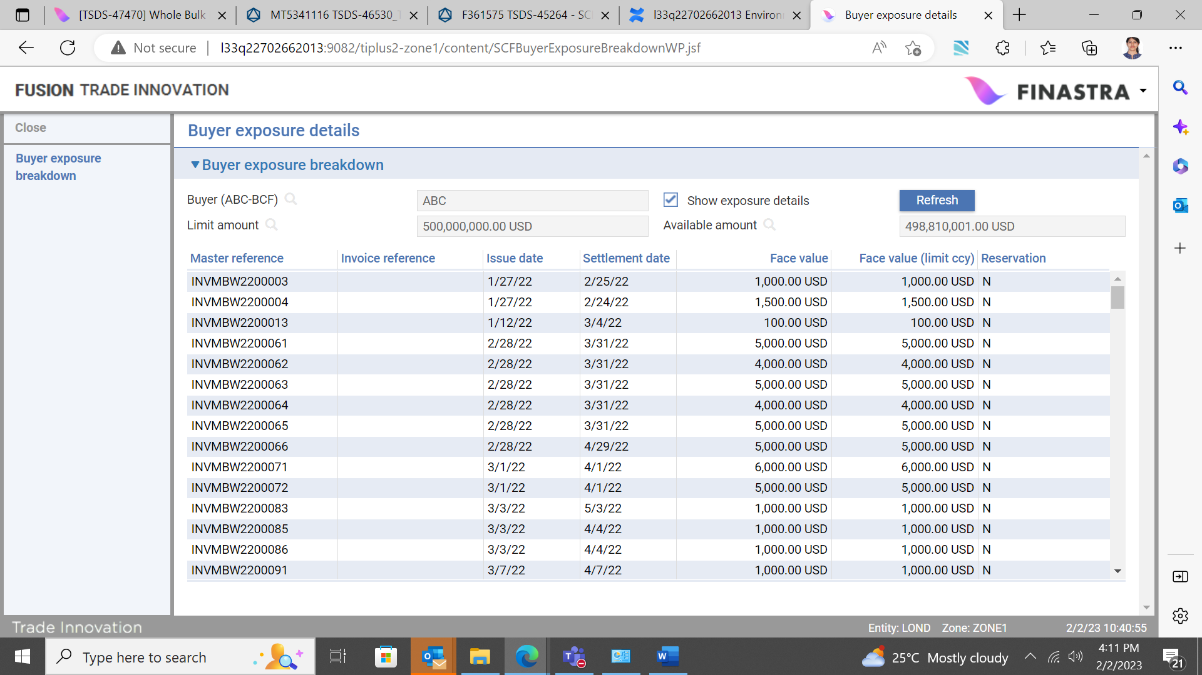

The Buyer Exposure Breakdown window shows the buyer’s current invoice (debtor) concentration limit amount and available amount with a flag to show related exposures. Check the Show Exposure Details field to list all the invoice-related exposure entries recorded against the buyer. The face value of each invoice is shown in the currency of the invoice, and also in the limit currency, calculated using current spot exchange rate. These values are recalculated during overnight processing using the latest spot exchange rates.

The Reservation column indicates whether exposure arising from an invoice is actual exposure (Y) or just a reservation (N).

## Viewing Programme Exposure Breakdown

Clicking the Programme Exposure button displays the Programme Exposure Breakdown window. This window shows the customer’s current programme related credit limit amount and available amount with a flag to show related exposures.

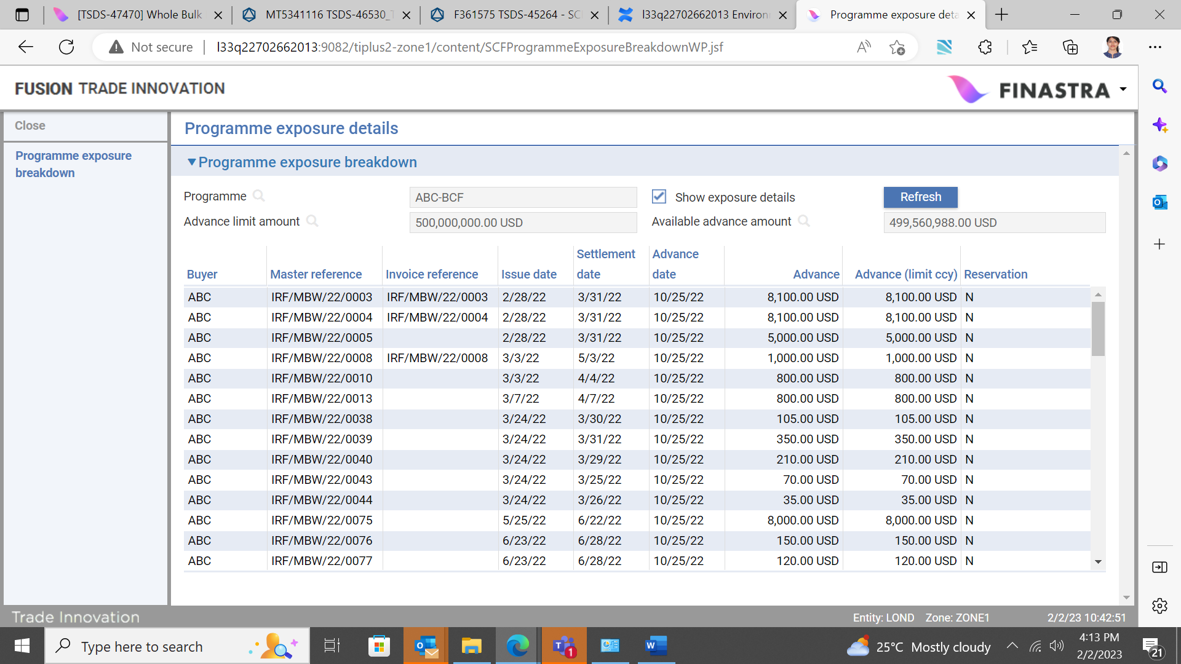

Checking the Show Exposure Details field lists all the exposure entries relating to financed advances recorded against the customer.

The value of each advance is shown in the currency of the advance, and also in the limit currency, calculated using the current spot exchange rate.

The values shown in these windows are recalculated during overnight processing using the latest spot exchange rates.

The Reservation column indicates whether an exposure entry represents actual exposure (Y) or just a reservation (N).

## Viewing Seller/Buyer Exposure Breakdown

If you have clicked the Seller/Buyer Exposure button the window shows the current programme/counterparty (respective buyer or seller) relationship specific limit amount and available amount with a flag to show related exposures.

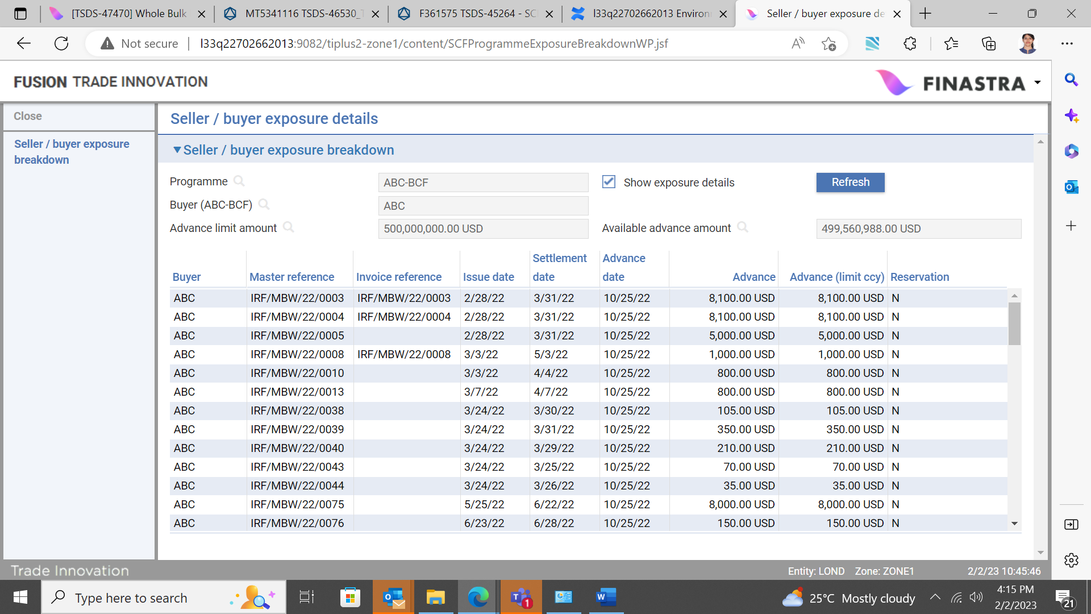

Check the Show Exposure Details field here lists all the exposure entries recorded at programme/buyer level relating to financed invoices (see page 90).

# Recording Invoices

This chapter explains how to record invoices.

Each invoice received is recorded using a separate invoice master record.

Details of invoices may be received in electronic format via the customer gateway interface service, in which case they automatically create a new invoice master record. Depending on how your system is configured, such master records may need to be completed manually.

It is also possible to manually record invoice details received from your customer via non-electronic means. This is possible via the Supply Chain Finance Masters browser.

Invoices must be recorded against either a seller centric programme, or a buyer centric programme. It is possible to finance a single invoice, or multiple invoices, provided that they meet the bulk financing criteria.

If the programme anchor party (customer) against whom you are recording the invoice uses a pool based factoring facility, you can only enter invoices for that customer after the actual factoring facility has been created in Trade Innovation. If you enter them before, Trade Innovation’s overnight processing will automatically create the link to the factoring facility and its related invoices, once the factoring facility has been created. This latter approach is possible but not recommended as it is best practice to establish the required factoring facility as soon as the related programme exists.

Once an invoice has been either paid in full, or cancelled, its book-off date is set and it is then removed from the system in the usual way – see the Common Facilities User Guide – Trade Innovation for details.

1. An invoice can be booked off only if it has been fully paid or cancelled, and only if it has no related finance and no outstanding charges recorded against it. There is no Expire event for invoices.

## Entering Invoice Details in the SCF Master Browser

Invoice master records created automatically but requiring manual intervention to complete can be opened in the usual way from within the SCF Masters browser.

To manually record details of a new invoice, in the SCF Masters browser, ‘New master’ pane (see page 12), specify the team and behalf of branch and select ‘Invoice’ from the Create new master dropdown list. You may also specify the customer if known.

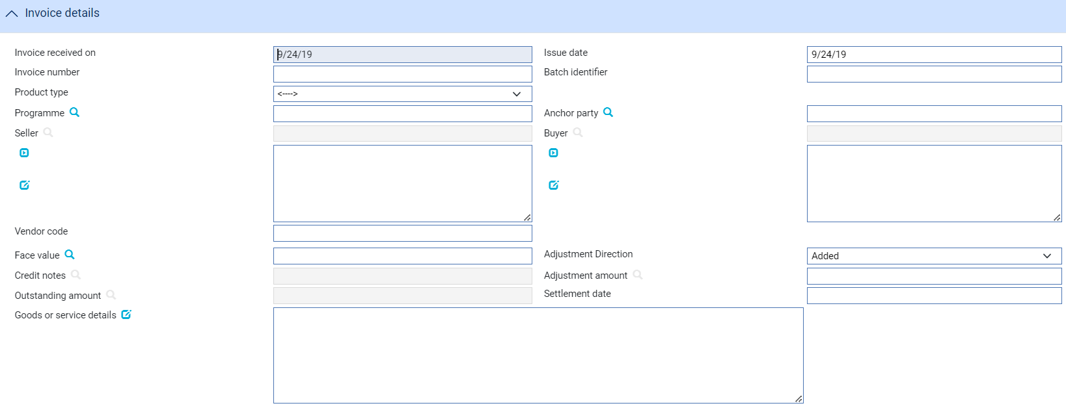

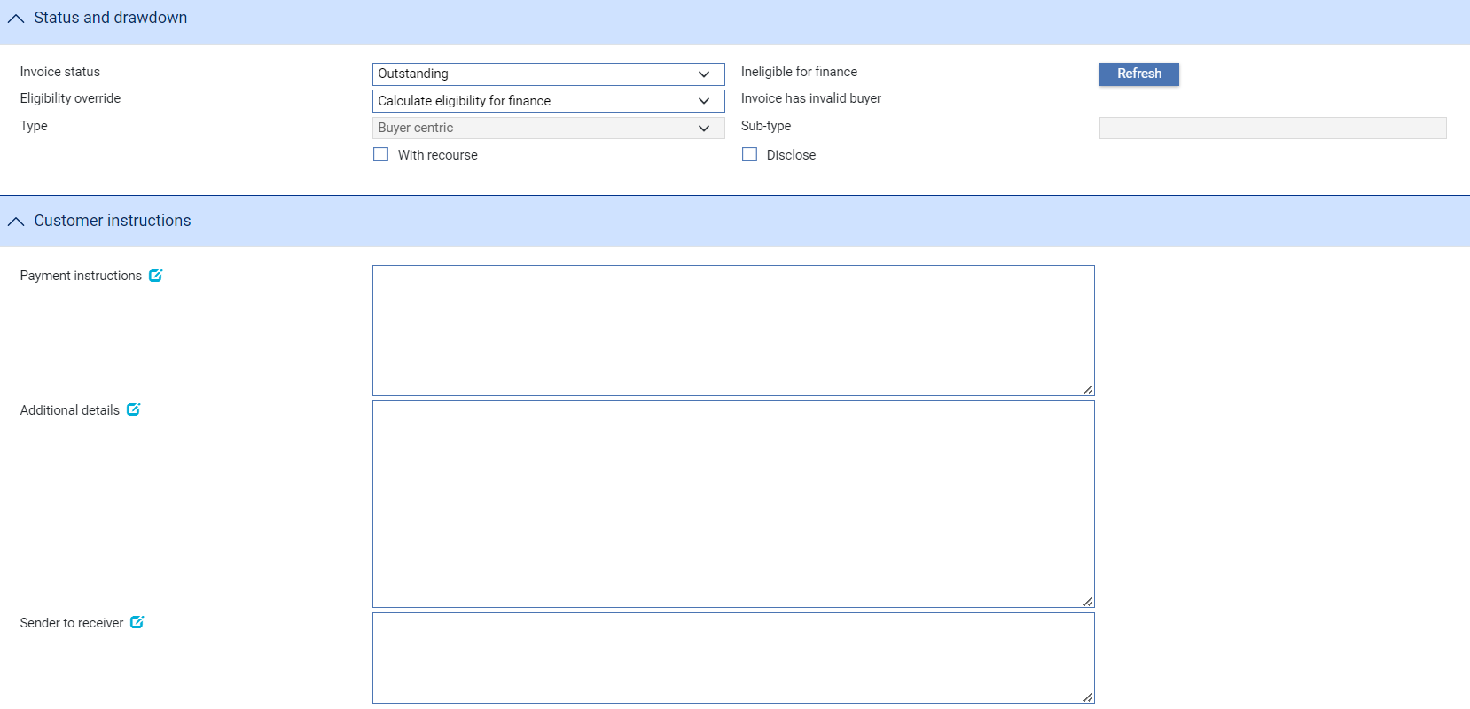

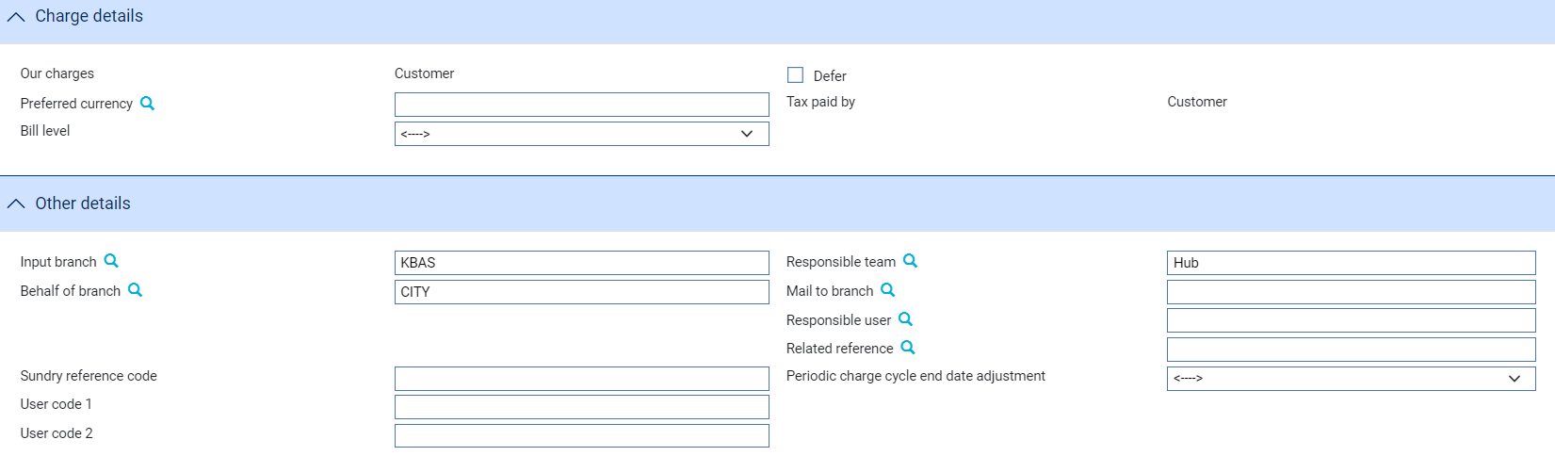

The following optional filters are also available if required:

* Enter pre-allocated reference (if known)
* Product type
* Currency
* Related reference

The system creates a Create Invoice event at either the Log step or the Input step, depending on how your system has been configured. The same fields are used by both steps.

The window used to enter details of an invoice has the following panes:

* The Invoice Details pane (see page 17)
* The Status and Drawdown pane (see page 18)
* The Customer Instructions pane (see page 18)
* The Charge Details pane (see page 20)
* The Other Details pane (see page 21)

## The Invoice Details Pane

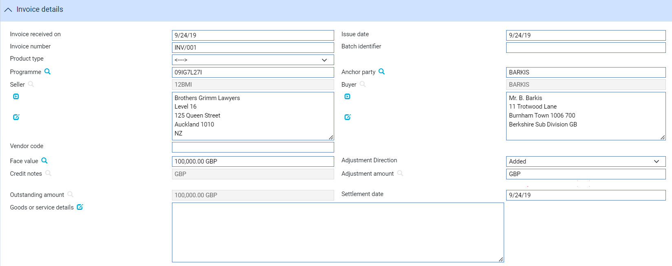

The following table explains what to enter into the fields in this pane.

Your bank must have recorded a relationship between the seller and buyer:

|  |  |  |
| --- | --- | --- |
|  | Field | What to Enter |
|  | Received On | If the Create event was generated from an incoming electronic message, the date that the message was received defaults here.  If the Create event is being created manually, enter the current processing date instead. |
|  | Issue Date | The date the invoice was issued. |
|  | Invoice number | A unique identifier for the invoice per buyer/seller (and programme) combination, provided by the customer. |
|  | Batch Identifier | A batch identifier associated with the invoice, provided by the customer. |
|  | Product Type | If your bank has set up product types for invoices, select the appropriate one from the drop-down list on this field. Depending on how your system has been configured, this field may be mandatory. |
|  | Programme | The buyer or seller centric programme against which the invoice is being recorded. |
|  | Anchor party | The party (either seller or buyer) that owns the programme and whose credit line is used. |
|  | Seller | The customer who is the credit party on the invoice. The system limits the browser on this field to customers who have been set up using a factoring or financing programme. |
|  | Buyer | The buyer who is the debit party on the invoice. The system limits the browser display to buyers set up for the selected programme. |
|  | Face Value | The amount of the invoice. |
|  | Adjustment Amount | If any adjustment or payment has already been made against the invoice, enter the amount here. |
|  | Credit notes | If any credit notes have been linked to the invoice, the ‘Amount to credit’ is displayed here. |
|  | Outstanding Amount | The system calculates and displays the amount of the invoice outstanding as face value minus any decrease amount. |
|  | Settlement Date | The invoice’s payment due date. The system uses this as the expiry date for the invoice. |
|  | Goods or Service Details | A description of the goods or services for which the invoice was raised. |

## The Status and Drawdown Pane

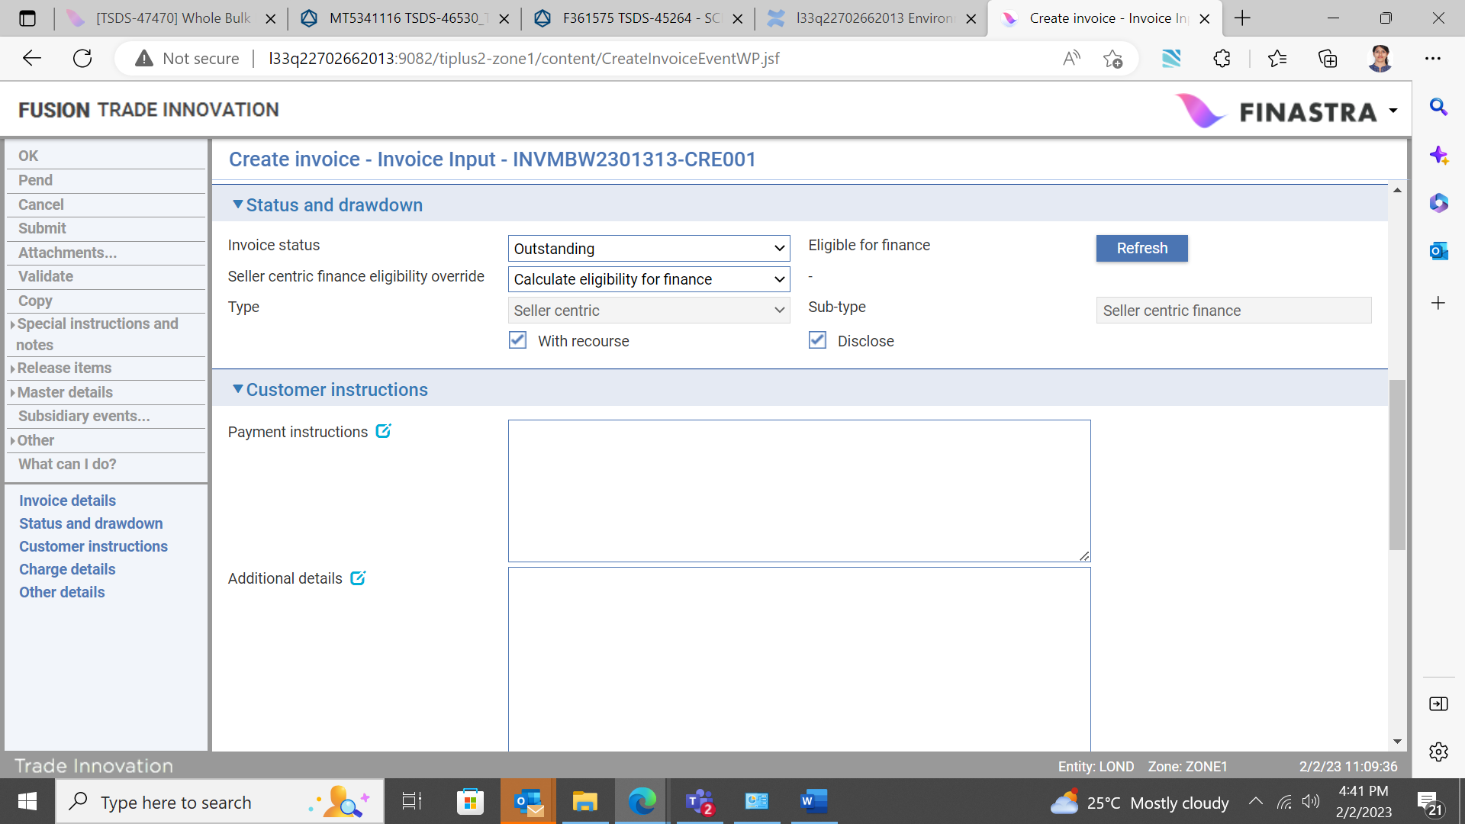

The following table explains what to enter into the fields in this pane:

|  |  |
| --- | --- |
| Field | What to Enter |
| Invoice status | The current invoice status, either:   * Outstanding – Invoice is expected to be paid on the settlement date without any issues * Inquiry – Set when there is an outstanding query with either the seller or buyer * Dishonour – Set when the buyer has refused to pay it * Cancelled – Set on instructions received from your customer * Paid – Automatically set if the outstanding amount is zero * Overdue – Automatically set if the settlement date is beyond the current processing date |
| Eligibility status | Eligible for finance (or drawdown) or Ineligible for finance text is automatically displayed once key invoice details are entered enabling the eligibility criteria to be applied to the invoice.  In the latter case, reason for the ineligibility is also displayed. The possible reasons for ineligibility are listed in the Appendix. |
| Eligibility override | If the bank’s procedures permit, this is used to override the system determined eligibility status. |
| Type | Indicates whether the programme is buyer or seller centric. |
| Sub-type | Indicates whether the programme sub-type is buyer or seller centric finance or pool based factoring. |
| With recourse | Indicates whether the invoices under this programme are with recourse or not. |
| Disclose | Check this box if related finance is to be disclosed to the buyer. |
| Approved for financing | For buyer centric finance an additional box is enabled. Check this box if the invoice being recorded has been ‘Approved’ for financing by the buyer. If this is checked, the invoice is automatically available for financing on completion of the create event, provided that other eligibility criteria is satisfied. |

## The Customer Instructions Pane

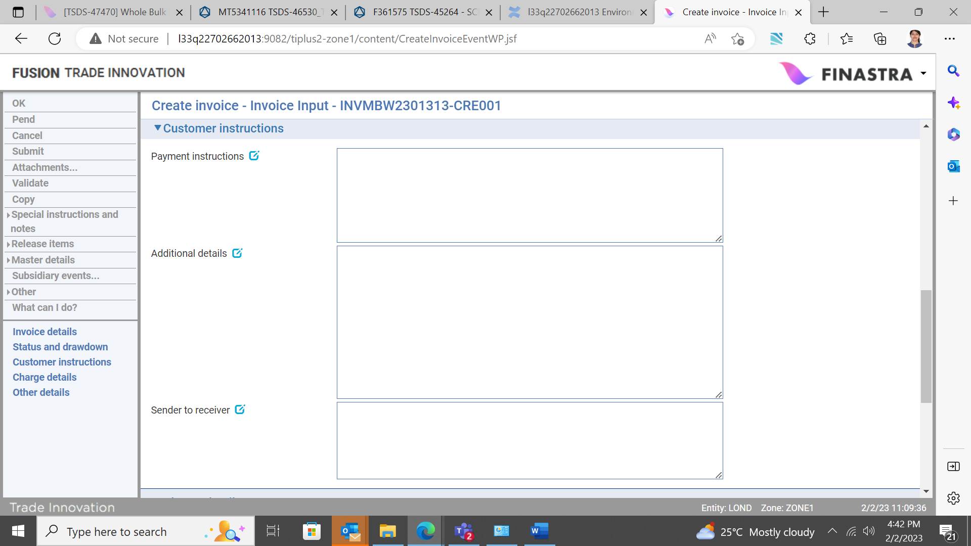

The following table explains what to enter into the fields in this pane:

|  |  |
| --- | --- |
| Field | What to Enter |
| Payment Instructions | Any pre-agreed payment instructions, for information only. It is expected that necessary standing settlements would be predefined by the bank when setting up the related programme.   1. You can also use this field to enter additional information if the invoice has a status of 'Paid' or 'Cancelled'. |
| Additional Details | Any relevant security information relating to (for example) insurance. Default security details are provided from the seller/buyer relationship definition. |
| Sender to receiver | 1. Use the Sender to Receiver Information field to enter any narrative from the sender. |

## The Charge Details Pane

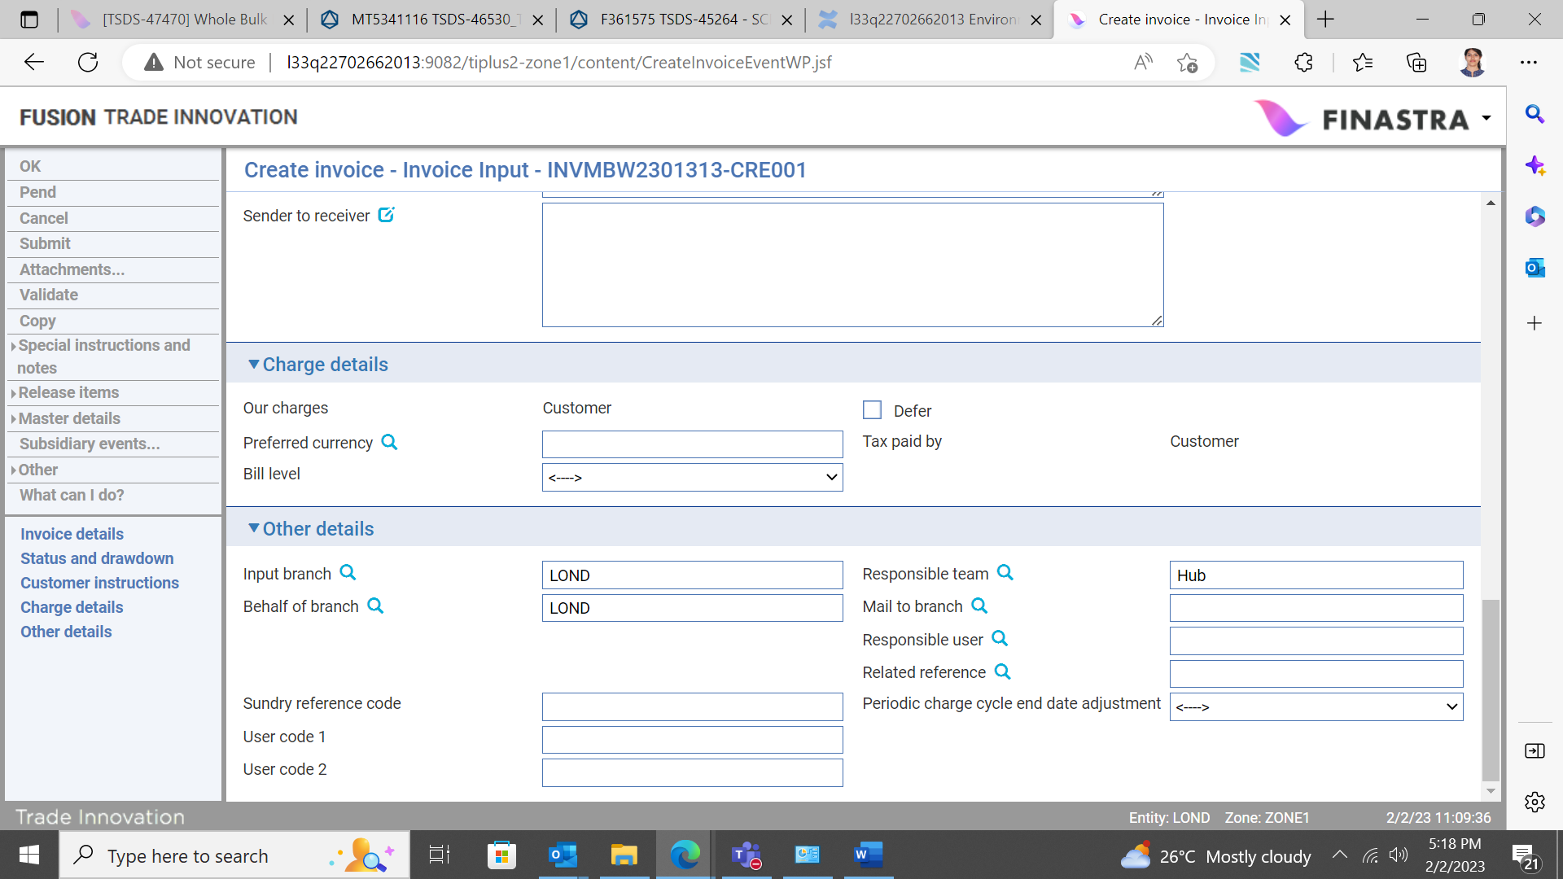

All charges raised against the invoice are for the customer for whom the programme was set up.

The following table explains what to enter into the fields in this pane:

|  |  |
| --- | --- |
| Field | What to Enter |
| Defer | Check this field to allow charges to be deferred until a later date. |
| Preferred Currency | The currency in which the charges will be collected. If you leave this field blank, it defaults to the charge currency specified on the Product Options window. See the System Tailoring User Guide – Trade Innovation for product options.  If no currency is specified in the product options, The system uses the currency of the transaction. |
| Bill Level | Select whether charges for this transaction should be billed at customer level, transaction level or product level. |

## The Other Details Pane

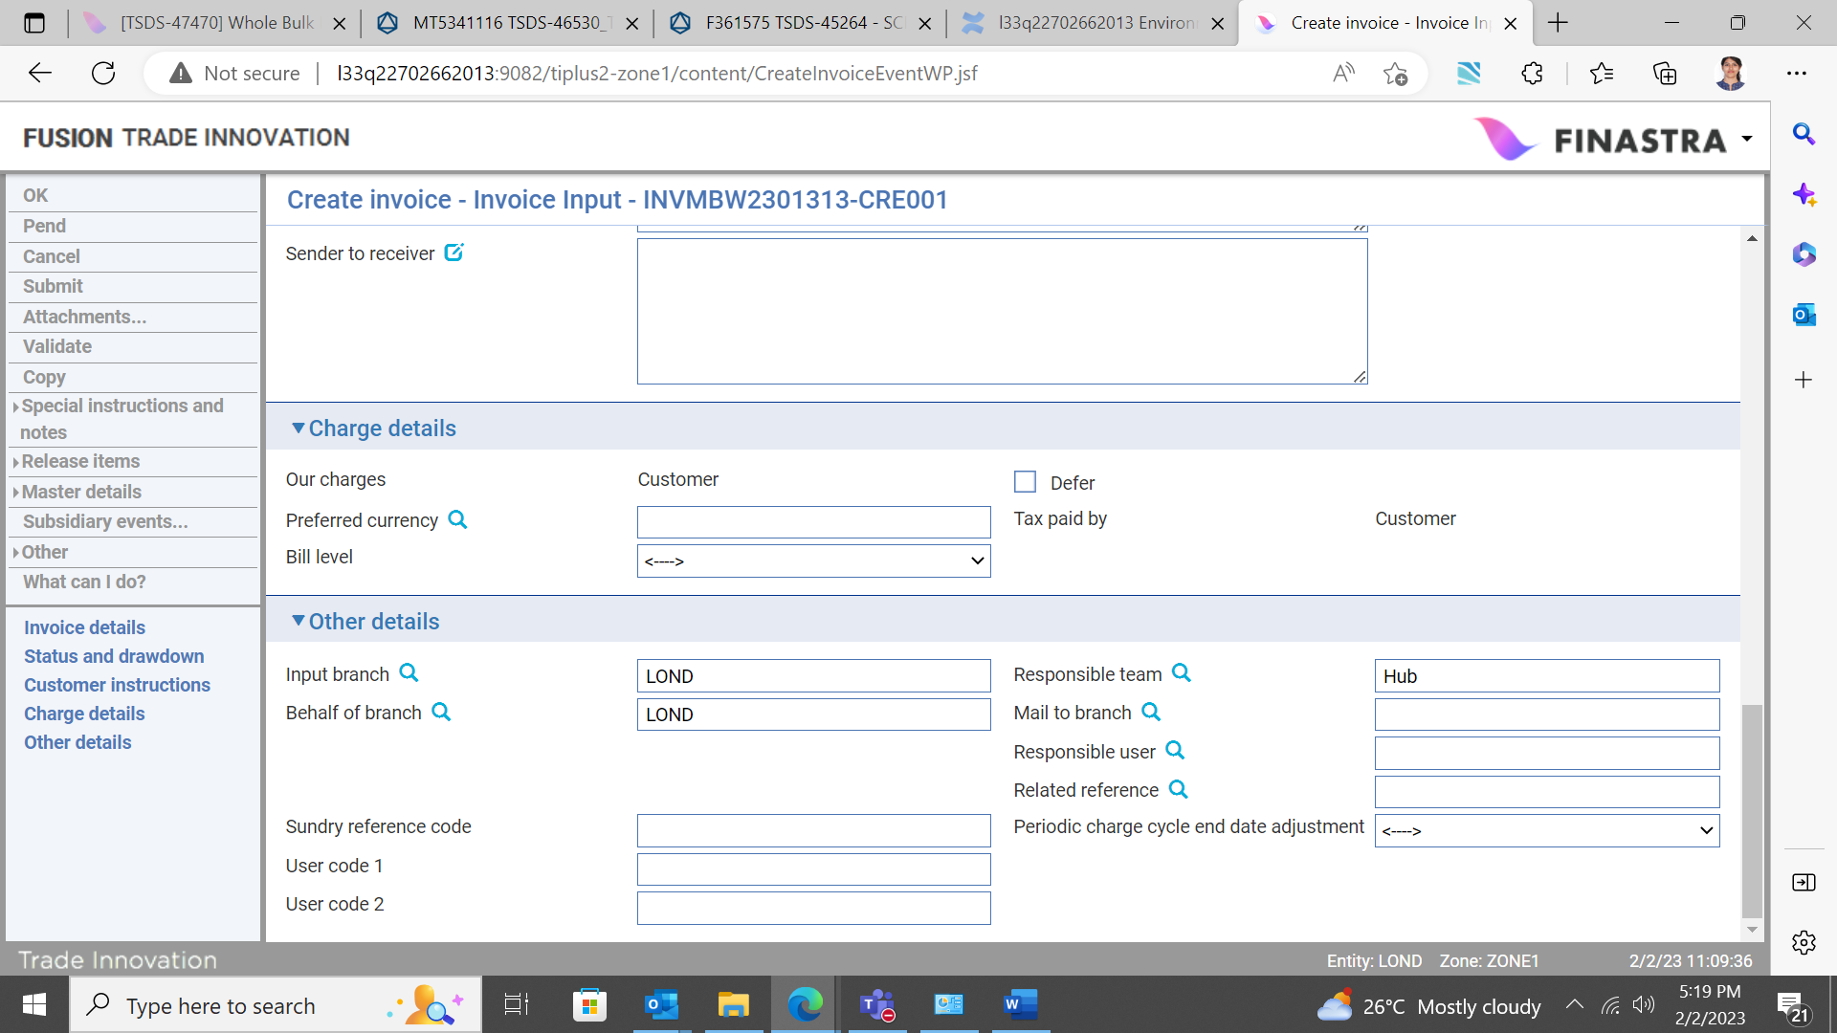

The following table explains what to enter into the fields in the Other Details pane. This pane may also include input fields defined by your bank:

|  |  |
| --- | --- |
| Field | What to Enter |
| Input Branch | The input branch for the transaction. The input branch is set from either:   * the accounting branch from the user’s team, or * the transaction branch for the user if the user has a default transaction branch or is locked to a specific branch, or * a branch associated with the user where the user can enter transactions for several branches for a team |
| Behalf Of Branch | The behalf of branch for the transaction as entered by the user or set from the incoming SWIFT or gateway message. The behalf of branch determines the parameter sets that are to be used to generate charges, documents, postings, etc. during transaction processing. The branch can be changed to any other branch within the same main banking entity that shares the same parameter sets. |
| Sundry Ref Code /User Code 1/ User Code 2 | You may use these fields to enter values for analysis purposes. Your bank will have devised its own system for using these fields. |
| Responsible  Team | The team that has overall responsibility for the master e.g. as the contact to resolve any queries or issues regarding the master and associated events. Trade Innovation defaults the responsible team when creating the transaction as follows:   * Manual – set from team creating the transaction * Gateway – set from the team specified on the incoming message (if present and valid) otherwise to the team to which the transaction is assigned through workflow allocation based on the behalf of branch * SWIFT – set to the team to which the transaction is assigned through workflow allocation based on the behalf of branch   It can be changed, if required, to either the team associated with the primary customer, default team for the product or the user’s current team. |
| Mail To Branch | If the customer requires documents to be sent to a branch other than that at which their account is held, specify the alternative branch here. The system uses the mailing branch details held on the applicant's details as the default. |
| Responsible User | A user that has responsibility for the master e.g. as the contact to resolve any queries or issues regarding the master and associated events. This can be any user assigned to the responsible team. |
| Related Reference | If the invoice is associated with an existing transaction (other than those under the related programme), enter the reference number of the associated transaction here. |

## The Invoice Master Summary Window

Once you have created an invoice, the system will display its basic details using the Master Summary window.

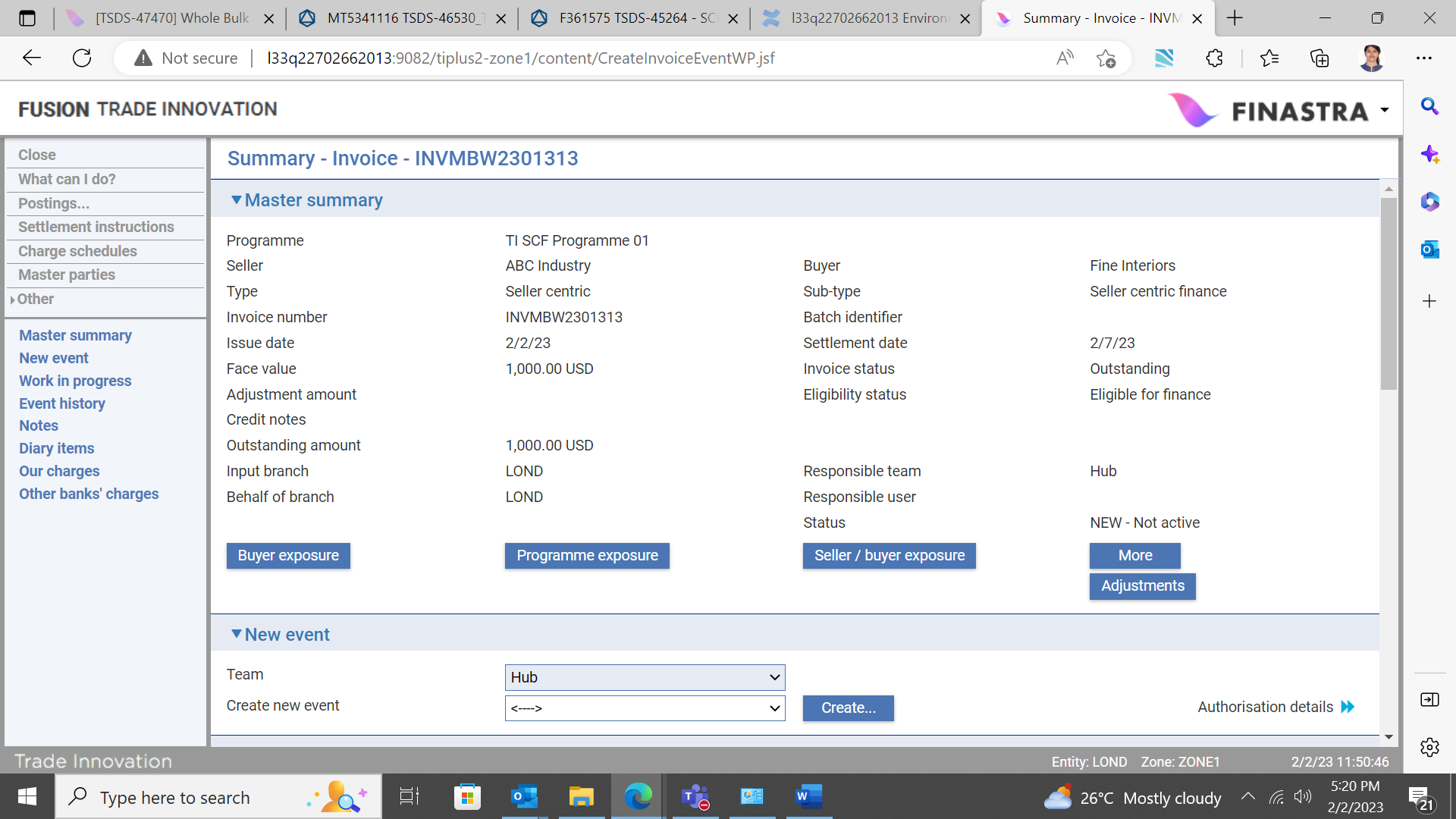

If the invoice is ineligible for financing, or inclusion in drawdown calculations (for Pool based factoring), this window displays the reason why.

The Buyer Exposure button displays exposure details for the buyer.

The Programme Exposure button displays exposure details against the supply chain finance programme.

The Programme/buyer exposure button displays details of the exposure at seller/buyer level.

For more information on how the various panes and buttons in the Invoice Master Summary window work see the Common Facilities User Guide– Trade Innovation.

# Amending and Cancelling Invoices

This chapter explains how to amend or cancel an invoice.

Requests to amend or cancel an invoice may be received in electronic format via the customer gateway interface service, in which case they automatically create a new Amend Invoice or Cancel Invoice event against the relevant invoice master record. Depending on how your system is configured, such events may need to be completed manually. You can also create a new Amend Invoice event or Cancel Invoice event manually.

Amend Invoice events and Cancel Invoice events can be created against an invoice master at any time between the release of the Create event and book-off. However, you cannot cancel an invoice that has been financed or which has a status of ‘Cancelled’.

The Amend Invoice can be used to change the status of an invoice to 'Inquiry', 'Disputed' or 'Dishonoured'; and also to reinstate a cancelled invoice.

1. Buyer/seller centric finance Create Invoice, Settle Invoice, Amend Invoice and Cancel Invoice events are mutually exclusive. In addition, there can only be one Amend Invoice event in progress at a time, and there can only be one Cancel Invoice event in progress at a time.

## Amending an Invoice

Amend Invoice events created automatically but requiring manual intervention to complete can be opened in the usual way from within the Invoice Masters window.

To create an Amend Invoice event manually, in the Master Summary window select 'Amend Invoice' from the Create New Event drop-down list and click New. Trade Innovation creates an Amend Invoice event at either the Log step or the Input step, depending on how your system has been configured. The same fields are used by both steps.

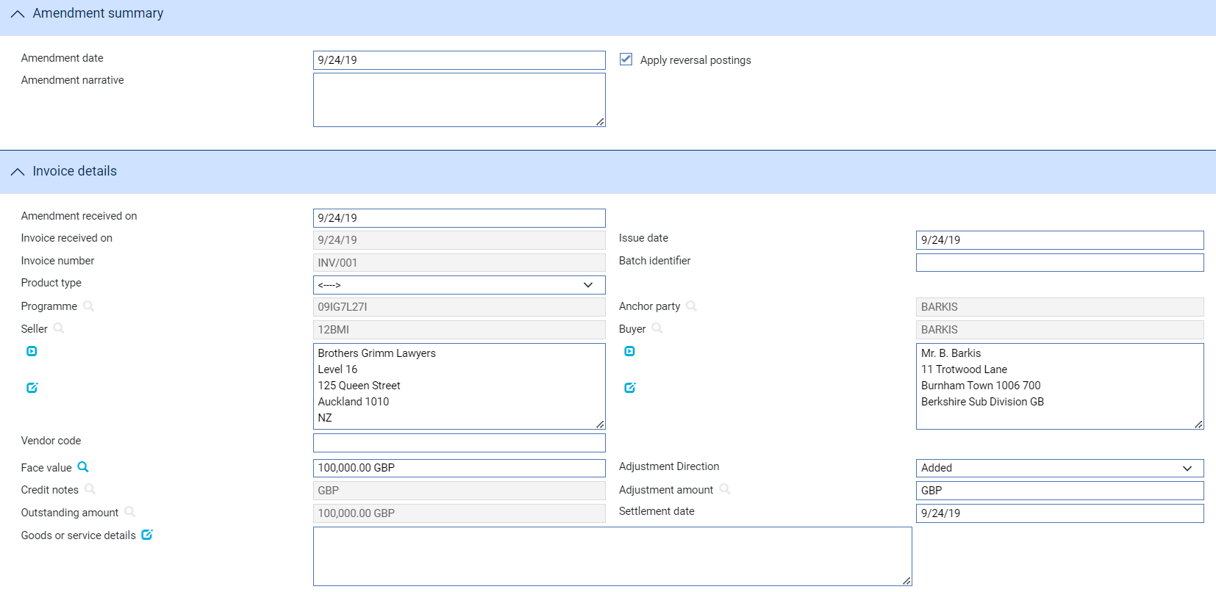

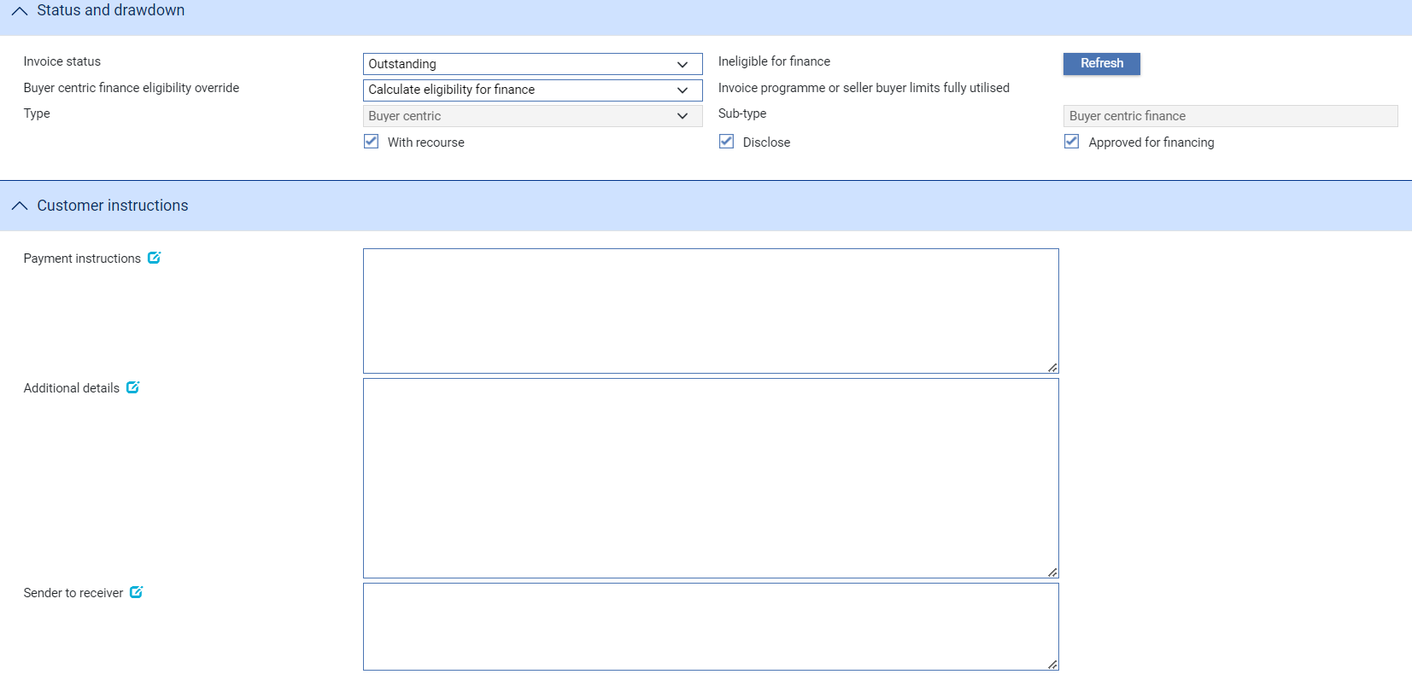

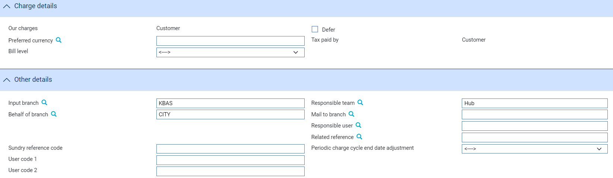

Trade Innovation displays the same details as during the Create event. You cannot change the programme or customer.

If the invoice has been financed, you cannot change its status to 'Cancelled', nor can you change the following details:

* The buyer/seller
* The issue date
* The invoice currency

In addition your bank can use bank-defined error messages or warnings to control what other changes are allowed - for example changes to the settlement date or the value of the invoice that might affect repayment for a financed invoice.

1. If you are entering a decrease amount, the figure entered must include any partial payments already made, plus any decrease amount previously entered.

The following additional fields are present:

|  |  |
| --- | --- |
| Field | What to Enter |
| Amendment Date | The date of the amendment. |
| Amendment Narrative | This field can be used to enter information about the amendment, such as the reason for it or the type of amendment made. |
| Apply Reversal Postings | Shown only if the DoNotApplyReversalPostings system option is set to 'No'. Leave it checked if your bank has set up reversal postings for the Amend Invoice event and wishes to apply them when the event is released. |
| Received On | Either the date the electronic message was received; or, for manually initiated amendments, the current processing date. |

The Changes button allows you - and reviewers and authorisers - to list those fields that have changed within the event. It opens a window that lists those fields whose value has changed and shows for each the value before the current event and the new value resulting from the event.

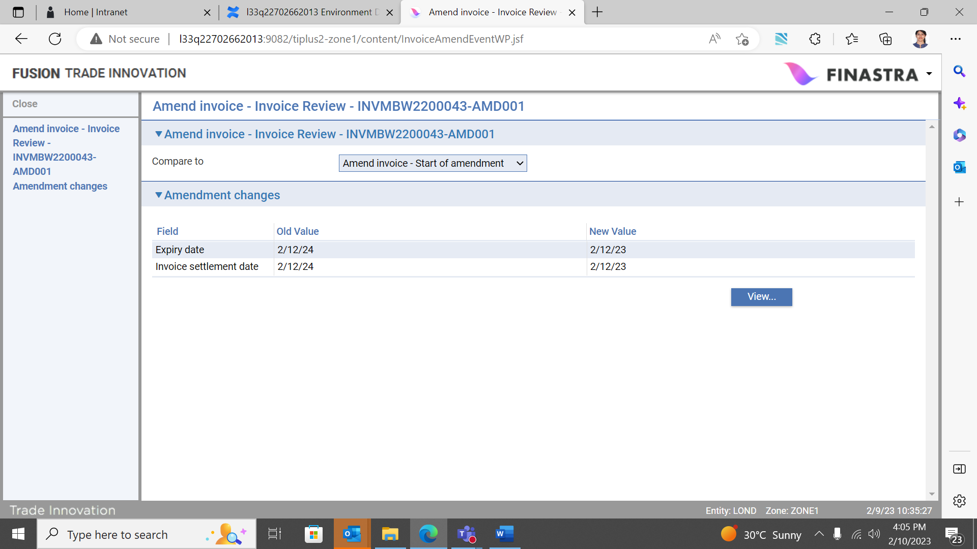

For fields where the value may not fit in the space available in this window (narrative fields, for example), you can select the field and click the View button to see complete details.

## On Completion of an Amend Invoice Event

If the face value has changed, the validation carried out at the end of the Amend Invoice event’s Input step includes a limit check, using the invoice’s outstanding amount (converted to the limit currency, if necessary, using spot rate), which is applied to the invoice concentration limit set up for the buyer. If the check is successful (or if any limit violation warnings are overridden) then the new face value of the invoice is used to increase or decrease exposure recorded against the buyer or seller and their limit availability, as appropriate.

If a user subsequently rejects the event during the Review or Authorise step, then the limit reservation recorded against the invoice concentration limit availability is reversed.

If the limit check results in an error then the Amend event will need to be pended until the problem is resolved.

The warnings and error messages resulting from validation are defined by your bank.

If the status of the invoice is set to 'Cancel' or 'Paid', when the event completes the system schedules a Book Off event for it, applying the book-off period specified in product options to the current processing date. No limit validation is carried out, but any exposure resulting from the invoice already recorded against the buyer or seller prior to this change of status is removed.

If the settlement date is changed for an invoice, then the related Settle Invoice event in the diary is updated accordingly when the Amend Invoice event completes.

## Cancelling an Invoice

1. You cannot cancel an invoice that has been financed or has a status of 'Cancelled'.

Cancel Invoice events created automatically but requiring manual intervention to complete can be opened in the usual way from within the Invoice Masters window.

To create a Cancel Invoice event manually, in the Master Summary window select 'Cancel Invoice' from the Create New Event drop-down list and click New. Trade Innovation creates a Cancel Invoice event at either the Log step or the Input step, depending on how your system has been configured. The same fields are used by both steps.

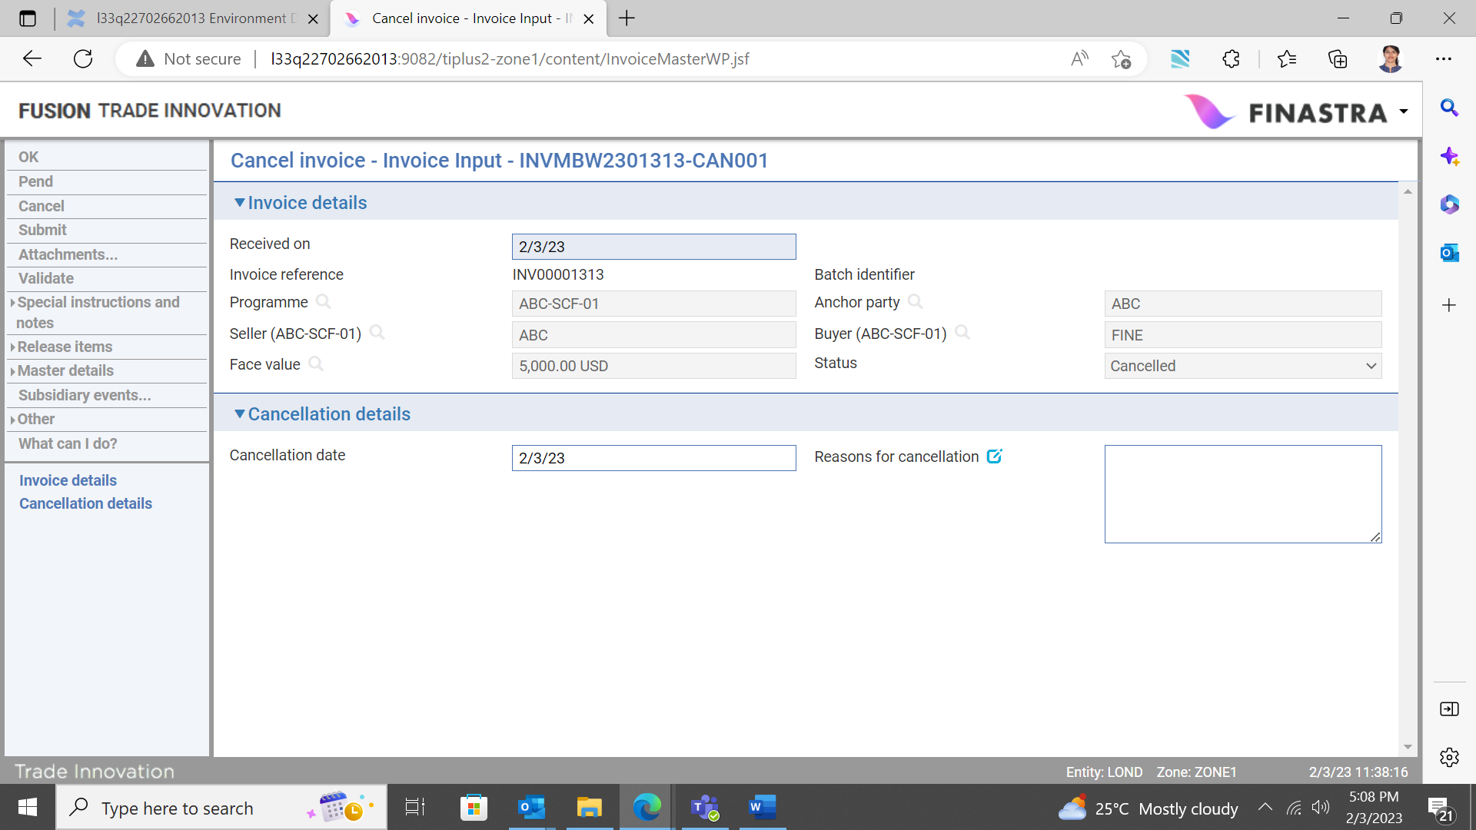

The following table lists the input fields in this window and explains what to enter into them:

|  |  |  |
| --- | --- | --- |
|  | Field | What it Holds |
|  | Received On | Either the date the electronic cancellation message was received; or, for manually initiated cancellations, the current processing date. |
|  | Programme | The programme identifier. |
|  | Anchor party | The anchor party for the programme. |
|  | Seller | The seller for the programme. |
|  | Buyer | The buyer for the programme. |
|  | Face Value | The current value of the invoice. |
|  | Status | The status of the invoice. |
|  | Cancellation Date | The date the cancellation is to take effect. Trade Innovation schedules a Book Off event for the invoice, applying the book-off period specified in product options to the date entered here. |
|  | Reasons for Cancellation | The reason for the cancellation. |

## On Completion of a Cancel Invoice Event

The invoice ceases to be eligible for inclusion in available drawdown amount calculations, its exposure against the buyer’s invoice concentration limit is cleared, and the system schedules the invoice master to be booked off, applying the book-off period specified in product options to the cancellation date.

The related Settle Invoice event (see page 41) is removed from the diary.

If a user subsequently rejects the event during the Review or Authorise step, then the changes made to the buyer’s exposure and limit availability figures are reversed.

# Credit Notes

This chapter explains how to record credit notes in Trade Innovation and how to link (apply) or unlink them to one or more invoices before or after Financing.

## Recording Credit Notes in Trade Innovation

Each credit note received is recorded using a separate credit note master record.

Details of credit notes may be received in electronic format via the customer gateway interface service, in which case they automatically create a new credit note master record. Depending on how your system is configured, such master records may need to be completed manually.

Where a credit note is submitted via the customer gateway, the face value amount of each linked invoices is automatically updated by the credit note amount that has been apportioned in the incoming message. This results in a new invoice outstanding amount and also affects the buyer’s invoice concentration limit. Similarly; this also applies when using the credit note link/unlink event (see page 38 for details of the link/unlink event functionality).

It is also possible to manually record credit note details received from your customer via non-electronic means. This is possible via the Supply Chain Finance (SCF) Masters browser.

Credit notes must be recorded against either a seller centric programme, or a buyer centric programme. It is possible to link a single credit note to a single, or multiple invoices, or multiple credit notes to a single invoice. This linkage may be made before or after an invoice is financed. A credit note can also be unlinked from an invoice, or invoices before or after an invoice is financed

## Entering Credit Note Details

Credit note master records created automatically but requiring manual intervention to complete can be opened in the usual way from within the SCF Masters browser.

To manually record details of a new credit note, in the SCF Masters browser, ‘New master’ pane, specify the team and behalf of branch and select ‘Credit note’ from the Create new master dropdown list.

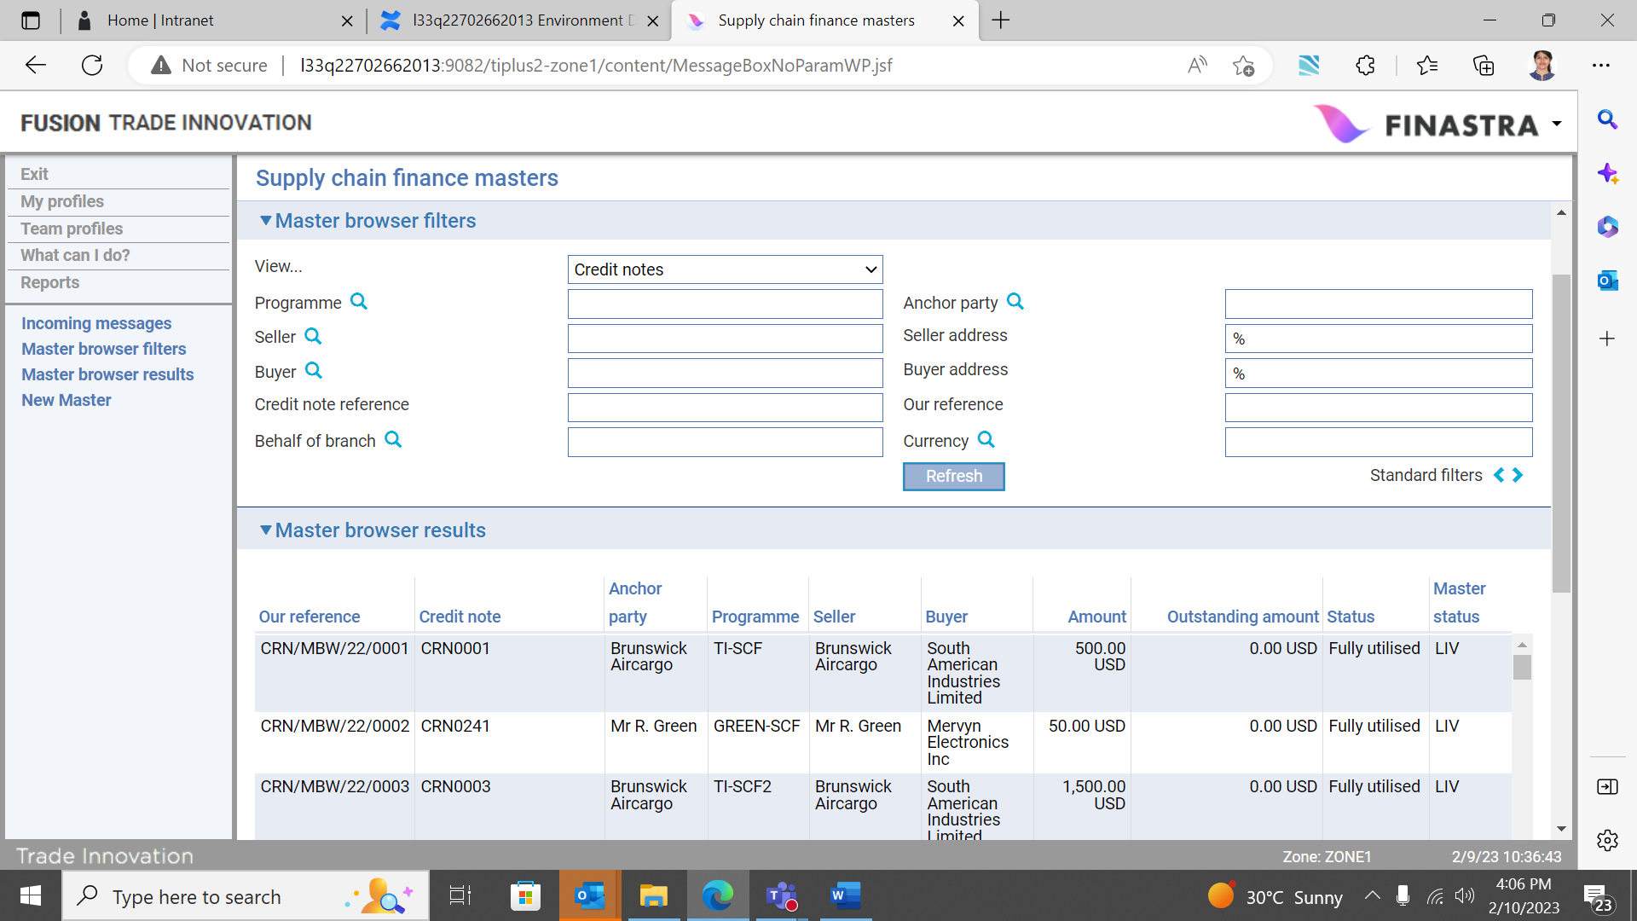

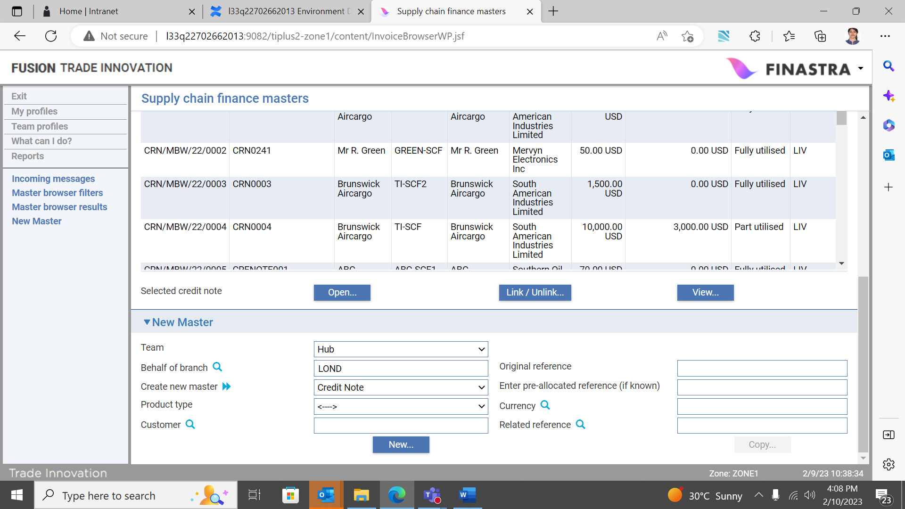

The following optional filters are also available if required:

* Customer
* Enter pre-allocated reference (if known)
* Product type
* Currency
* Related reference

Trade Innovation creates a Create Credit note event at either the Log step or the Input step, depending on how your system has been configured. The same fields are used by both steps.

The window used to enter details of a credit note has the following panes:

* The Credit note details pane (see page 30)
* The Linked invoice pane (see page 29)
* The Other Details pane (see page 35)

## The Credit Note Details Pane

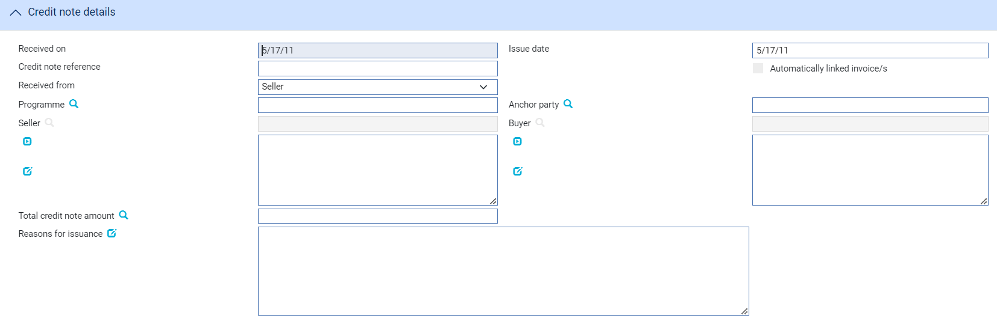

The following table explains what to enter into the fields in this pane.

Your bank must have recorded a relationship between the seller and buyer:

|  |  |  |
| --- | --- | --- |
|  | Field | What to Enter |
|  | Received on | If the Create event was generated from an incoming electronic message, the date that the message was received defaults here.  If the Create event is being created manually, enter the current processing date instead. |
|  | Issue date | The date that the credit note was issued. |
|  | Credit note reference | A unique identifier for the credit note, provided by the buyer/seller combination. |
|  | Received from | The party from whom the credit note was received. |
|  | Programme | The Programme identifier – used to identify the particular programme (and invoices) that the credit note is related to. |
|  | Anchor party | Either the buyer or the seller, depending on whether the programme is buyer or seller centric. The customer is the owner of the programme. |
|  | Seller | The trading party that issued the credit note. |
|  | Buyer | The trading party in whose favour the credit note is drawn. |
|  | Total credit note amount | The face value and currency of the credit note.  The credit note amount can be expressed in any currency. This is converted to the invoice currency using standard Trade Innovation capabilities that allow input of a foreign exchange rate code or spot rate (the use of the spot rate is the ultimate default). |
|  | Reasons for issuance | Narrative text relating to the issuance of the credit note. |

## The Linked Invoice Pane

You can link a credit note to one or more invoices. If the credit note is linked to multiple invoices, it is possible to apportion a specific amount of the credit note to a specific invoice. This is possible via the Linked invoice pane when the credit note is recorded in the system and also via the credit note ‘Link/unlink’ event (see page 38).

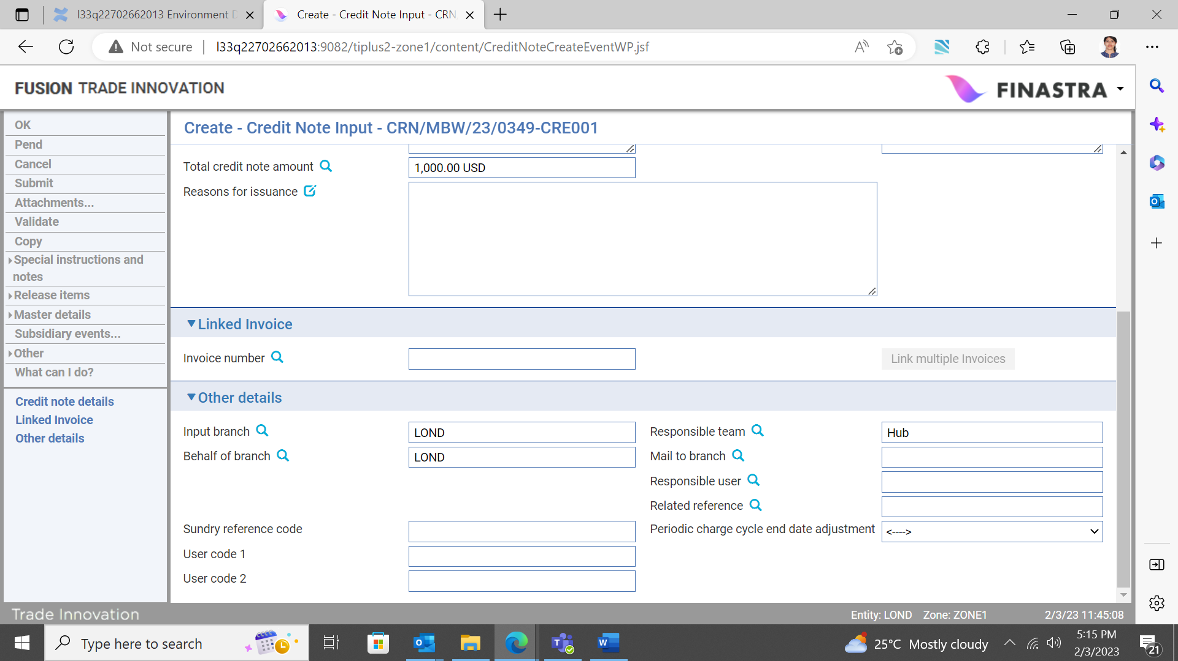

The following filters are available in the Linked invoice pane:

* Invoice number
* Link multiple invoices

## Linking a Single Invoice

Invoice number filter

Use this filter to search for and link a single invoice to the credit note.



## The Invoice Browser Pane

Clicking the Invoice number button opens the following Invoice browser.

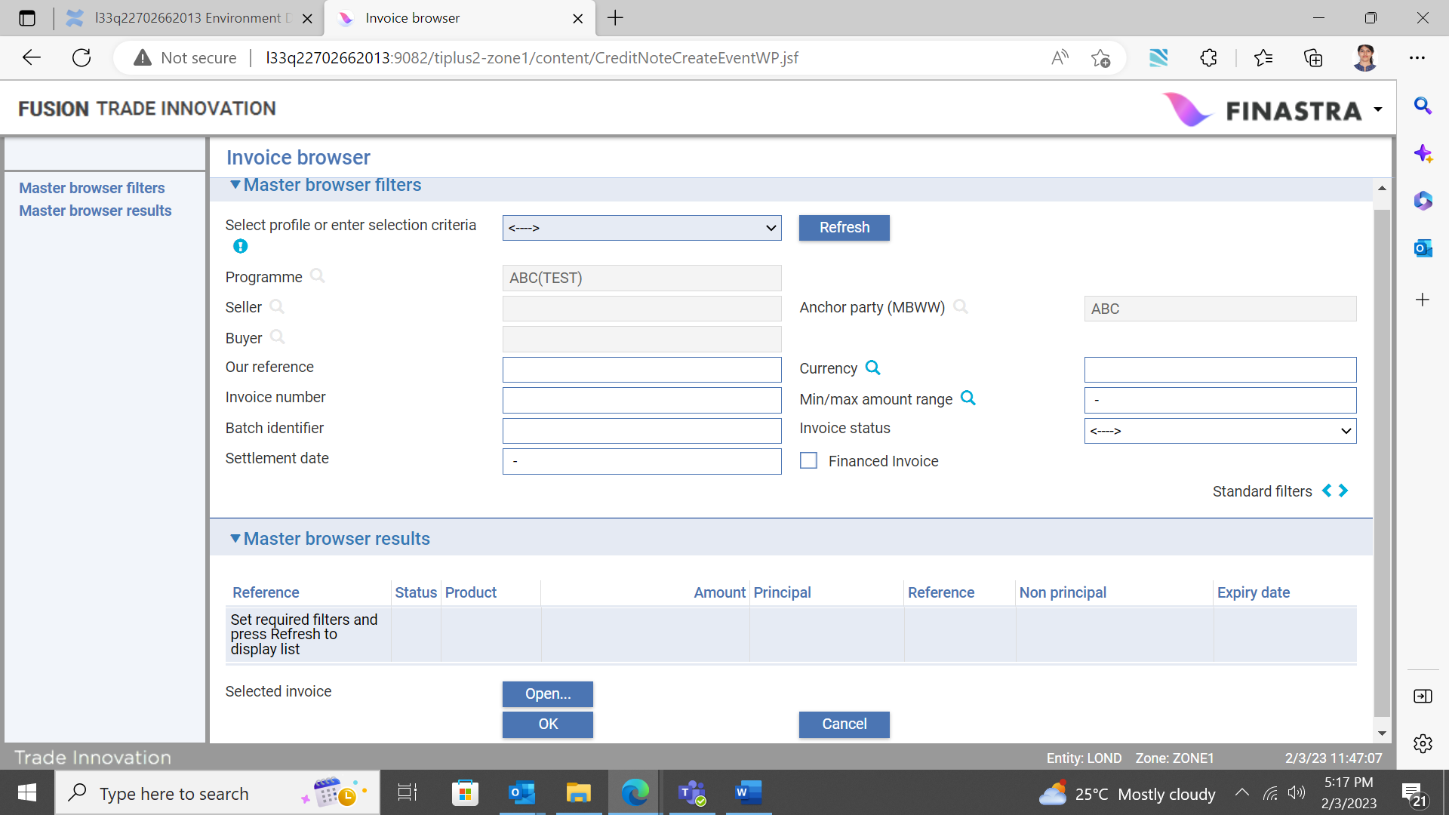

## The Master Browser Filters Pane

The programme, seller, buyer and anchor party details default and you can filter for invoices that have previously been recorded under the programme.

The following optional filters are also available:

* Our reference
* Currency
* Invoice number
* Min/Max amount range
* Batch identifier
* Invoice status
* Settlement

## The Master Browser Results Pane

If the Refresh button is clicked and check box ‘Financed Invoice’ is unticked, the Master browser results pane displays details of all unfinanced invoices available under the programme. When the check box ‘Financed Invoice’ is ticked, the Master browser results pane displays details of all financed invoices available under the programme. The invoices that have been financed or yet to finance may be selected and linked to the credit note.

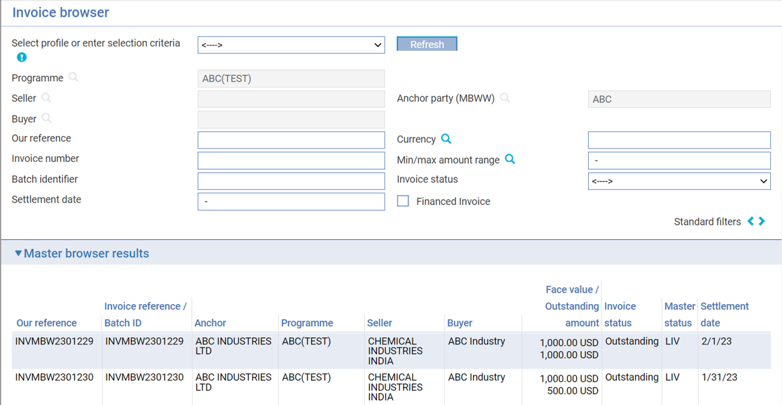

From the list of results returned, highlight an invoice that is to be linked and click the OK button (invoice details may also be viewed by clicking the Open button).Clicking the OK button will return you to the Create Credit note input screen.

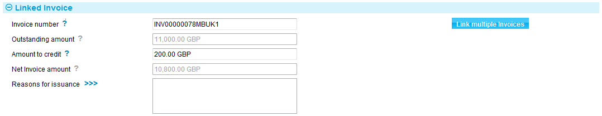

The Linked invoice pane is expanded to include the following fields:

|  |  |
| --- | --- |
| Field | What to Enter |
| Invoice number | The reference number of the selected invoice. |
| Outstanding amount | The invoice outstanding amount (this amount defaults and is unavailable for input). |
| Amount to credit | The credit note amount and currency to be apportioned to the invoice. The total credit note amount defaults but may be updated if required. The amount apportioned may be equal to, or less than the total credit note amount. |
| Net invoice amount | The invoice amount less the amount apportioned by the credit note. |
| Reasons for issuance | Narrative text relating to the issuance of the credit note. |

Click OK to complete the event and establish the link to the single invoice selected.

## Linking Multiple Invoices

If the credit note is to be linked and apportioned to multiple invoices, it is necessary to select the invoices via the Link multiple invoices button.

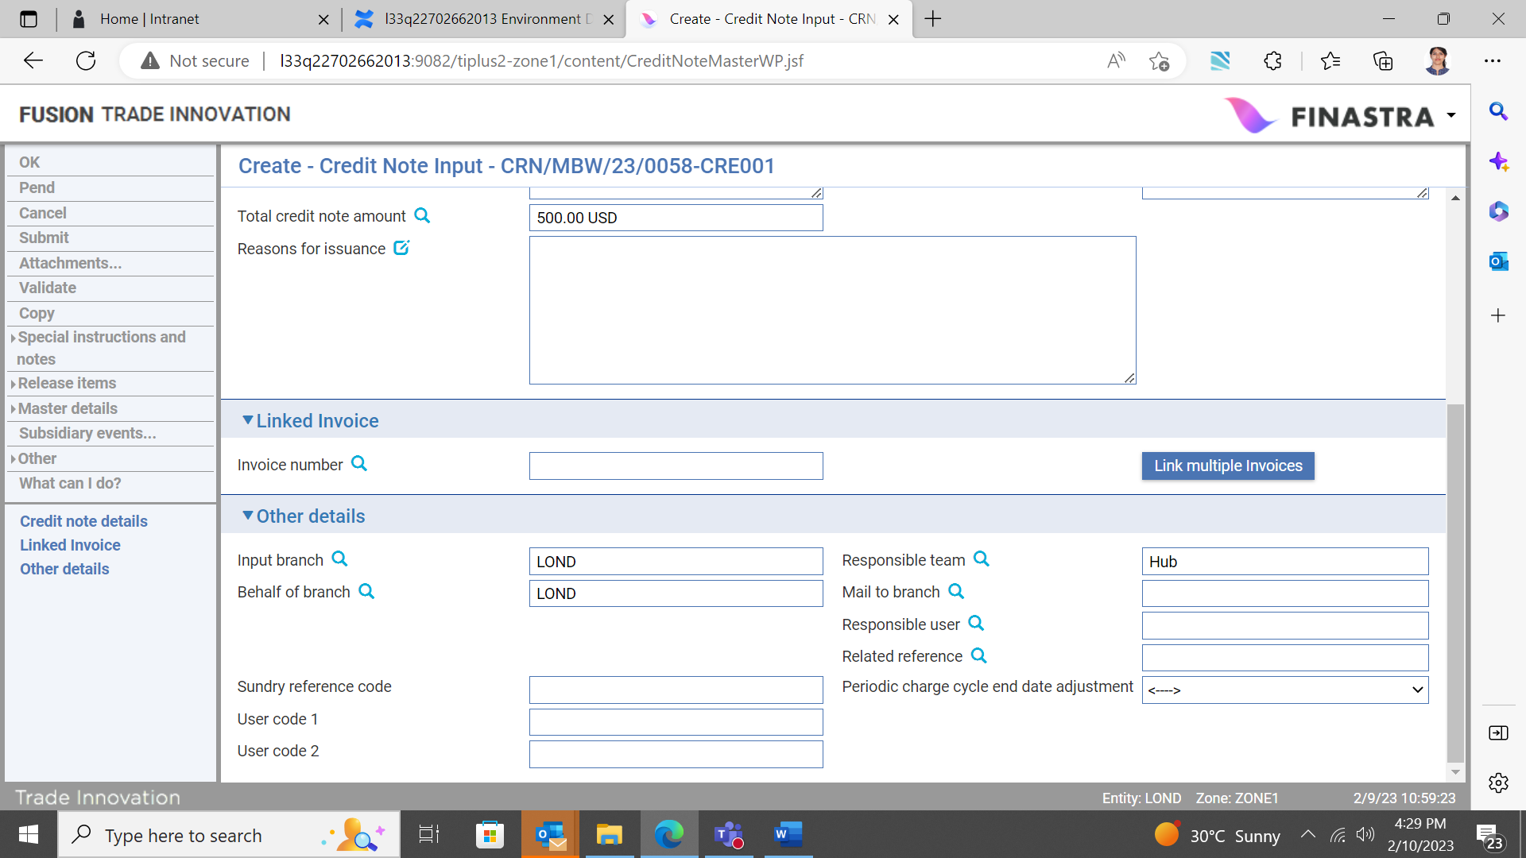

Clicking the Link multiple invoices button opens the following Master browser filters:

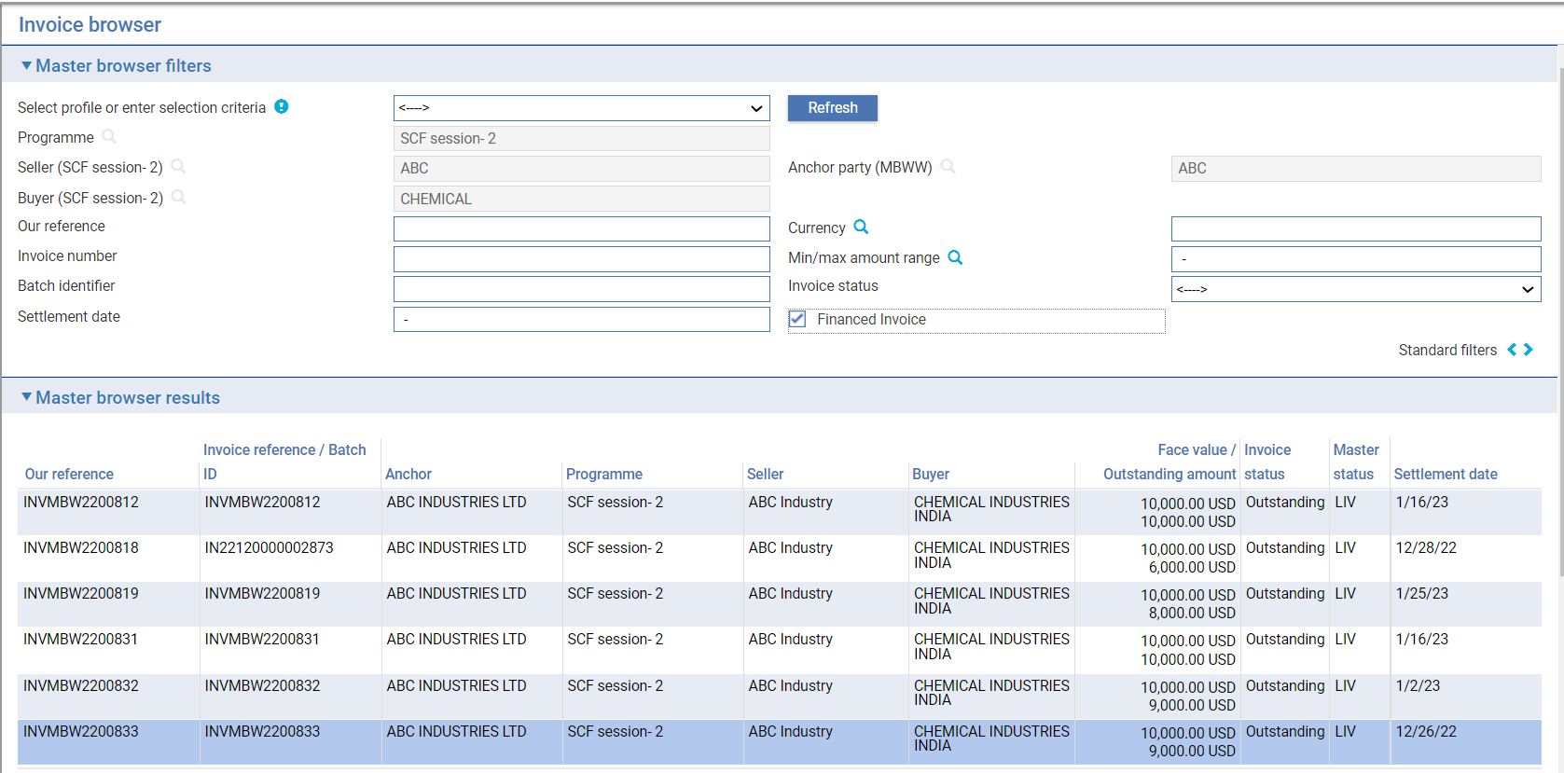

The programme, seller, buyer and anchor party details default and you can filter for invoices that have previously been recorded under the programme.

The following optional filters are also available:

* Our reference
* Currency
* Invoice number
* Min/Max amount range
* Batch identifier
* Invoice status
* Settlement

If **Refresh** is clicked, the Master browser results pane displays details of all invoices available under the programme.

From the list of results returned, highlight an invoice that is to be linked and click the ‘Add’ button (invoice details may also be viewed by clicking the ‘Open’ button).

Clicking the ‘Add’ button initialises the ‘Linked invoice’ pane.

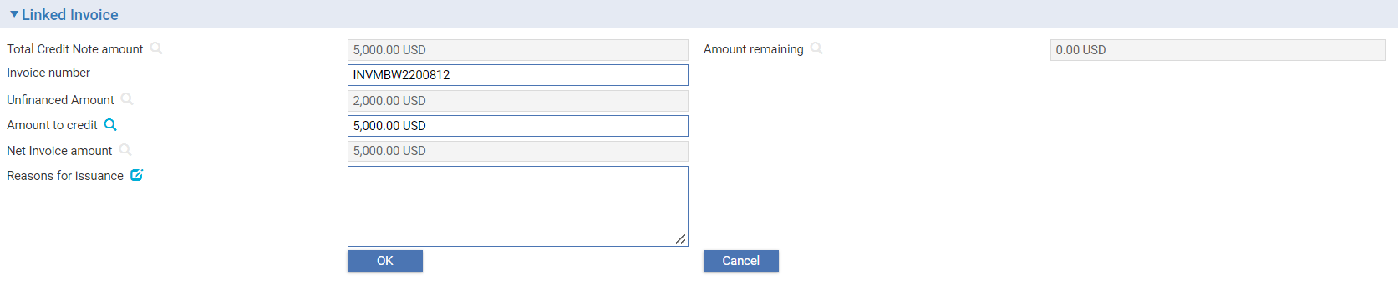

Please Note – When Financed invoice is linked to Credit Note, only the unfinanced portion of the Invoice can be adjusted with Credit Note.

When linking multiple invoices, the following fields are available in the Linked invoice pane:

|  |  |
| --- | --- |
| Field | What to Enter |
| Total credit note amount | The total face value amount of the credit note (this amount defaults and is unavailable for input). |
| Amount remaining | The outstanding credit note balance available to be apportioned (this amount defaults and is unavailable for input). |
| Invoice number | The reference number of the selected invoice. |
| Outstanding amount | The invoice outstanding amount (this amount defaults and is unavailable for input). |
| Amount to credit | The credit note amount and currency to be apportioned to the invoice. The total outstanding credit note amount defaults but may be updated if required. The amount apportioned may be equal to, or less than the total credit note amount. |
| Net invoice amount | The invoice amount less the amount apportioned by the credit note. |
| Reasons for issuance | Narrative text relating to the issuance of the credit note. |

You must specify the ‘Amount to credit’ which may be all, or part of the total credit note amount. When you have completed input, clicking the ‘OK’ button completes the linkage. The Linked invoices pane is closed and you can then select further invoices to be linked to the credit note.

The invoice that has been selected and linked is displayed in the table in the ‘Invoice list’ pane.

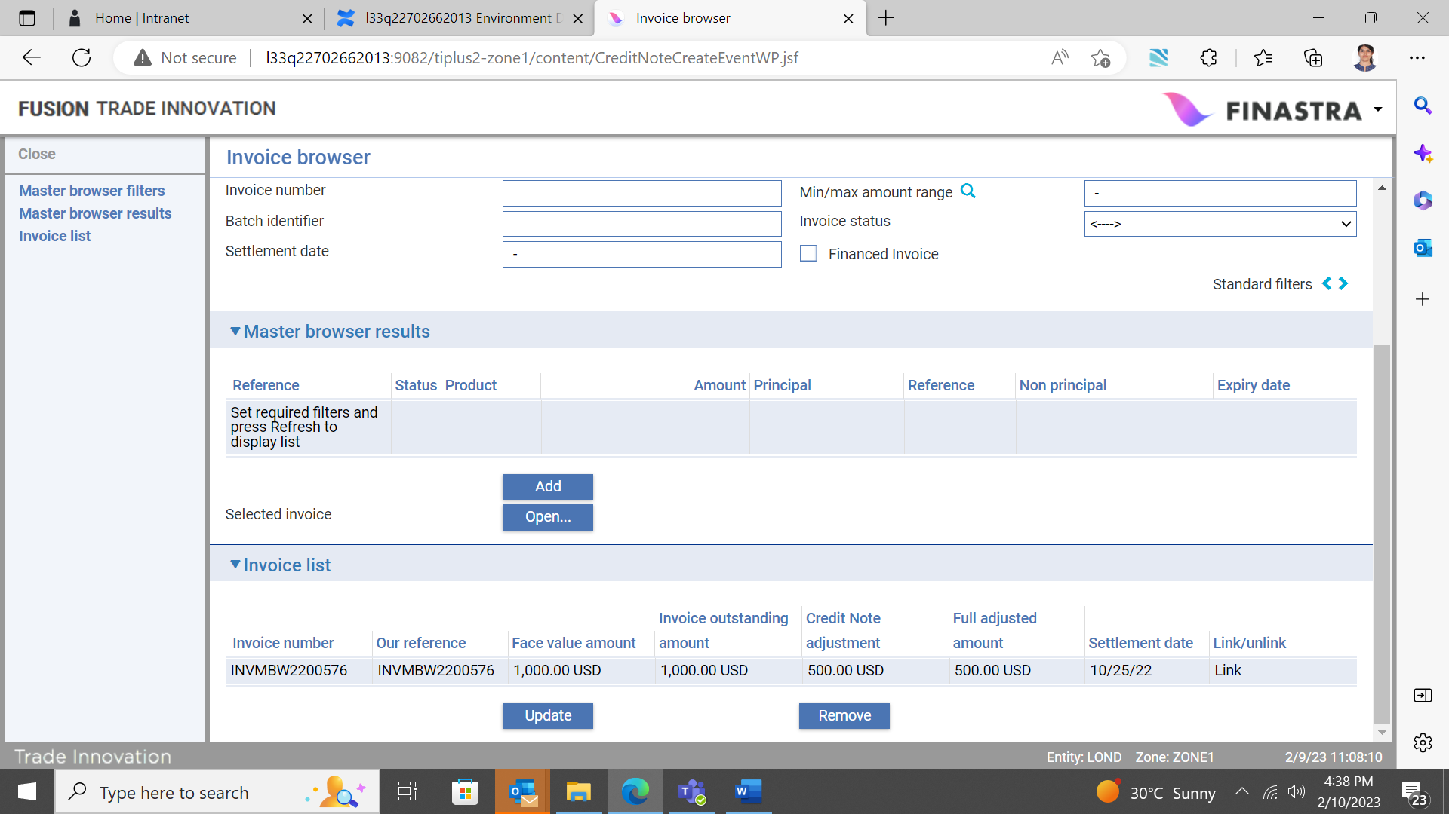

## The Invoice List Pane

The following buttons are available in this pane:

* Update
* Remove

The Update button is used to make further changes to the linked invoice if required.

## Auto Linkage of Credit Notes

Credit notes can be auto linked to invoices. If the customer does not link credit notes manually, Trade Innovation will auto link credit notes to invoices based on the following conditions:

1. Credit note to be applied to the shortest remaining tenor.
2. Credit note to be applied to the invoice with the largest amount.
3. If credit note > outstanding amount, the credit note is split amongst several invoices.

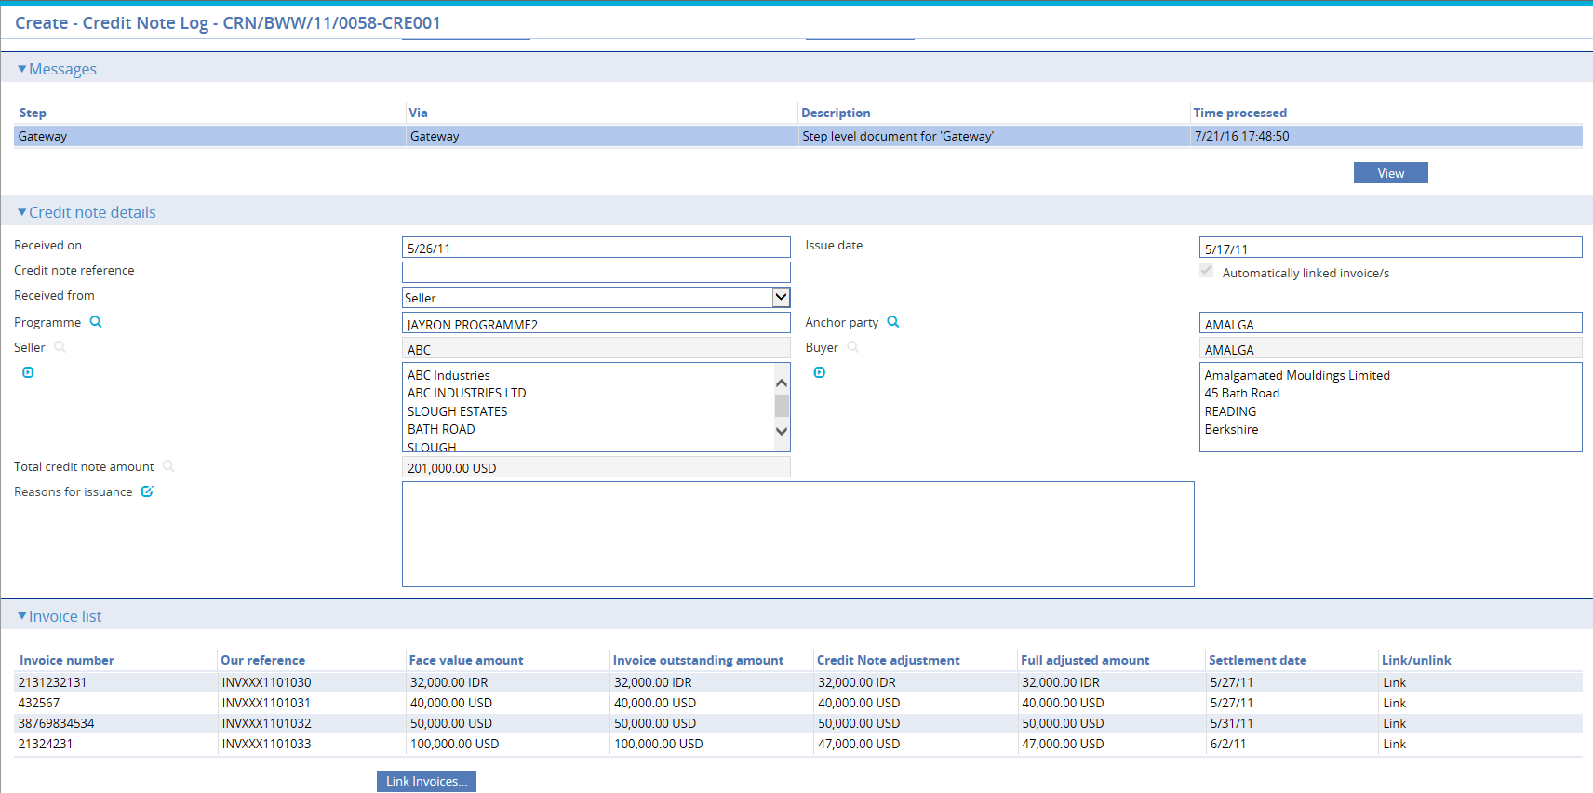

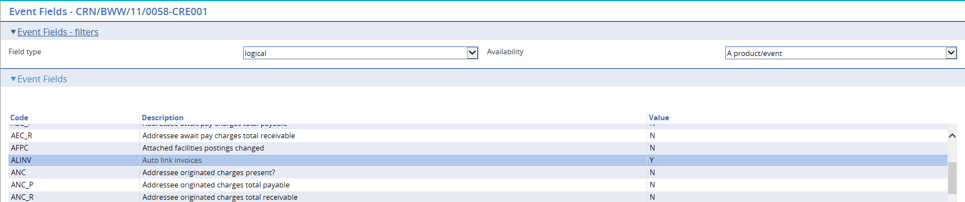

### Unlinking Invoices from the Credit Note

Clicking the Remove button automatically deletes the invoice from the Invoice list and severs the link to the credit note. This has the effect of updating the available ‘Amount to credit’.

You can continue to add/link additional invoices and apportion amounts, up to the total credit note amount.

When you have selected and linked all of the invoices required, click the Close button in the Invoice browser screen. This will return you to the Create credit note input screen.

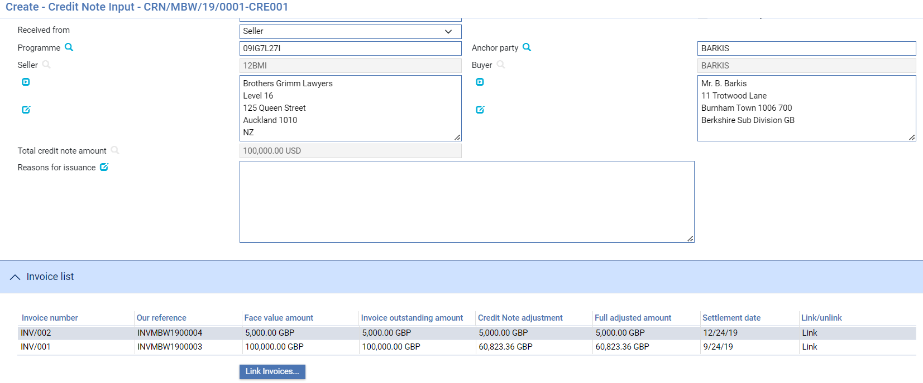

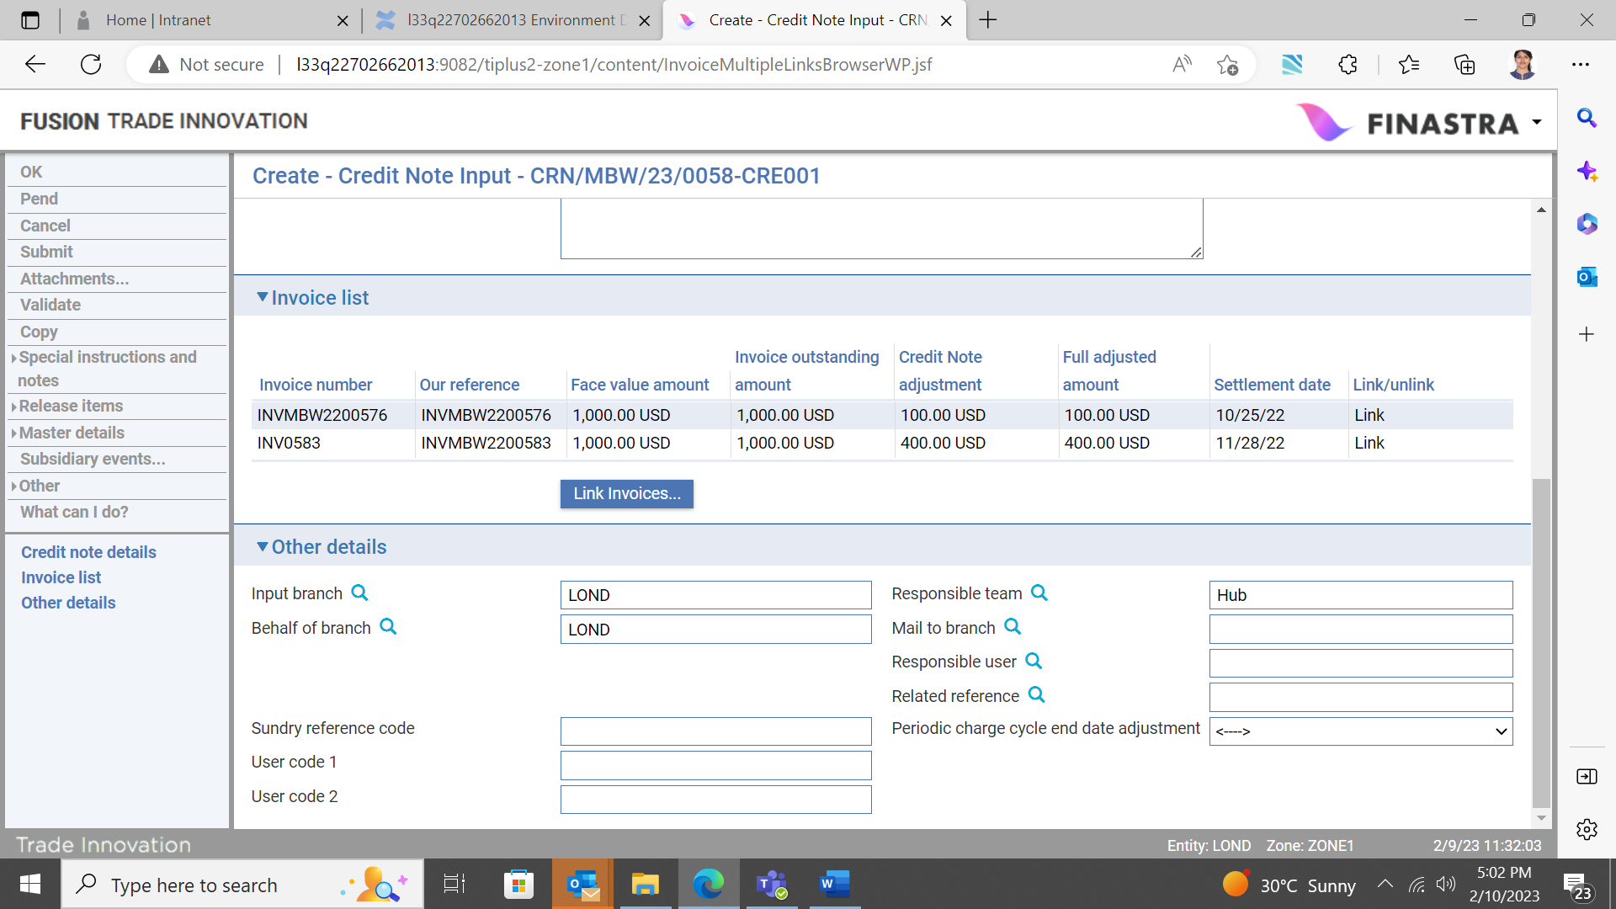

If you subsequently want to update or remove one of the selected invoices, you can access them via the Link invoices button in the Invoice list pane.

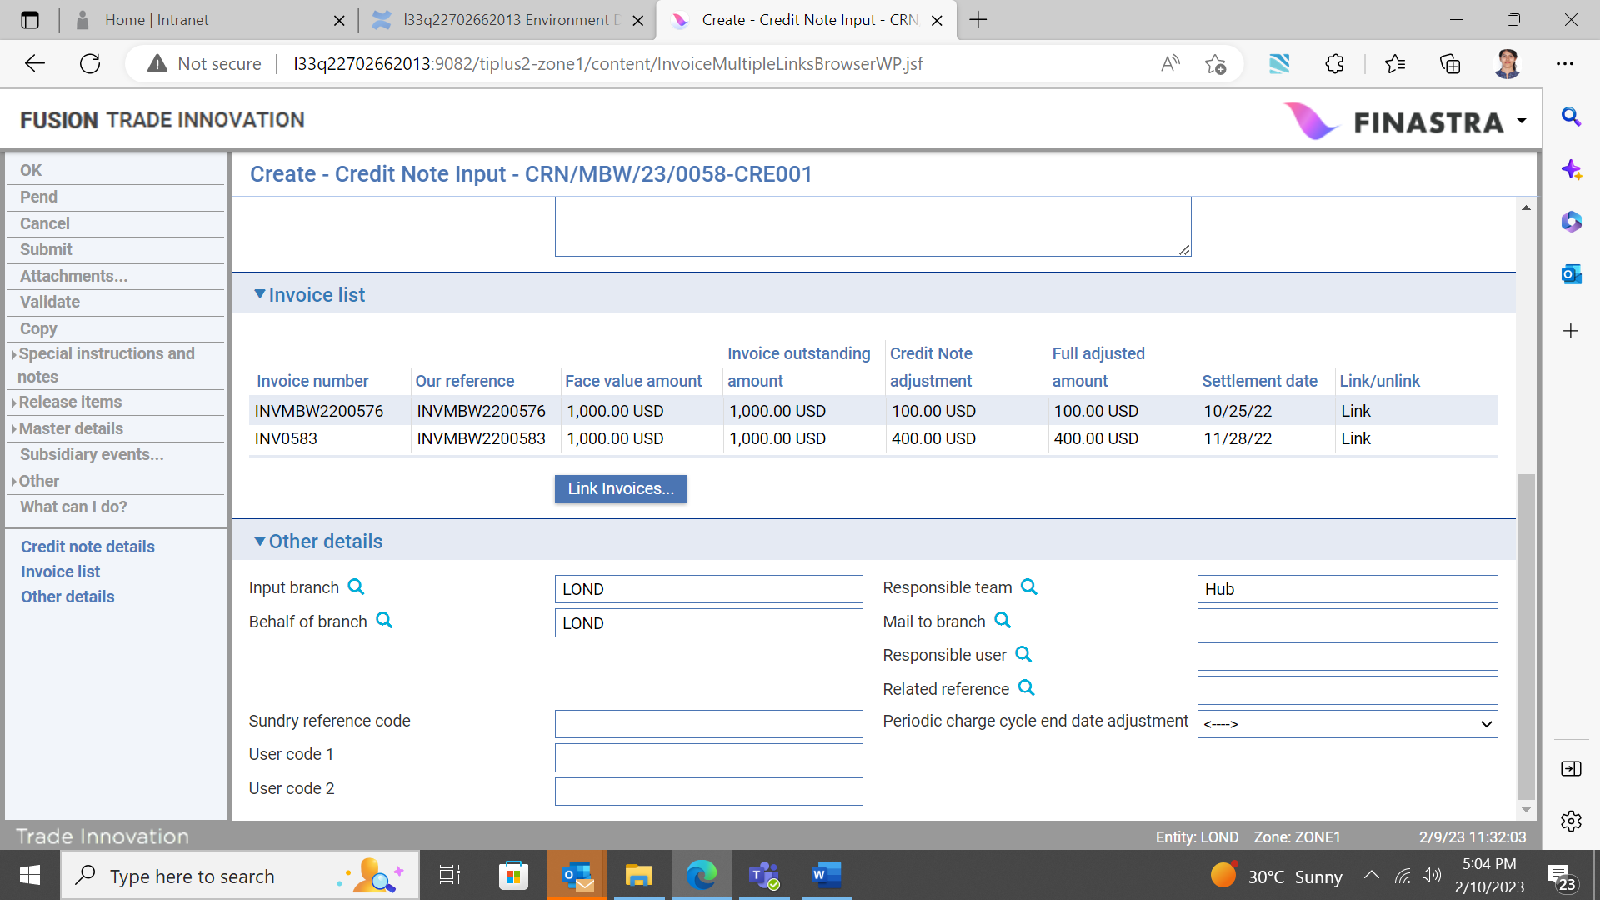

To complete the event, click the OK button. The credit note is now linked to the selected invoices. If the Total credit note amount has not been fully utilised, it is possible to link the credit note to further invoices via the Credit note, Link/Unlink event.

The Other Details Pane



The following table explains what to enter into the fields in the Other Details pane. This pane may also include input fields defined by your bank:

|  |  |
| --- | --- |
| Field | What to Enter |
| Input Branch | The input branch for the transaction. The input branch is set from either :   * the accounting branch from the user’s team, or * the transaction branch for the user if the user has a default transaction branch or is locked to a specific branch, or * a branch associated with the user where the user can enter transactions for several branches for a team |
| Behalf Of Branch | The behalf of branch for the transaction as entered by the user or set from the incoming SWIFT or gateway message. The behalf of branch determines the parameter sets that are to be used to generate charges, documents, postings, etc. during transaction processing. The branch can be changed to any other branch within the same main banking entity that shares the same parameter sets. |
| Sundry Ref Code /User Code 1/ User Code 2 | You may use these fields to enter values for analysis purposes. Your bank will have devised its own system for using these fields. |
| Responsible Team | The team that has overall responsibility for the master e.g. as the contact to resolve any queries or issues regarding the master and associated events. Trade Innovation defaults the responsible team when creating the transaction as follows:   * Manual – set from team creating the transaction * Gateway – set from the team specified on the incoming message (if present and valid) otherwise to the team to which the transaction is assigned through workflow allocation based on the behalf of branch * SWIFT – set to the team to which the transaction is assigned through workflow allocation based on the behalf of branch   It can be changed, if required, to either the team associated with the primary customer, default team for the product or the user’s current team. |
| Mail To Branch | If the customer requires documents to be sent to a branch other than that at which their account is held, specify the alternative branch here. Trade Innovation uses the mailing branch details held on the applicant's details as the default. |
| ResponsibleUser | A user that has responsibility for the master e.g. as the contact to resolve any queries or issues regarding the master and associated events. This can be any user assigned to the responsible team. |
| Related Reference | If the credit note is associated with an existing transaction, enter the reference number of the associated transaction here. |

## When the Create Event Completes

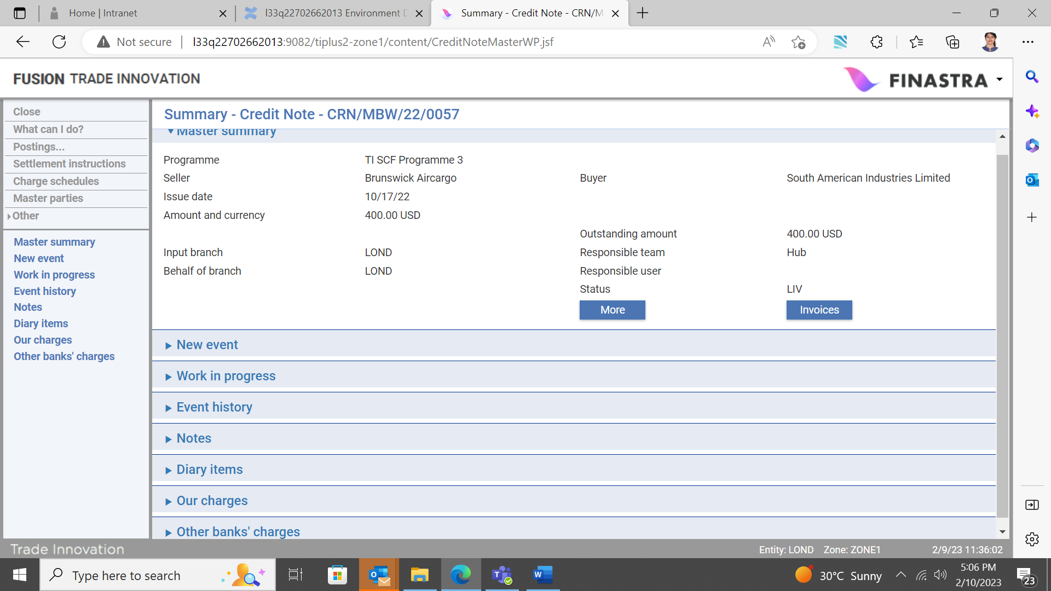

When the credit note create event completes, it is possible to view any linked invoices via the Invoices button on the credit note master summary screen.

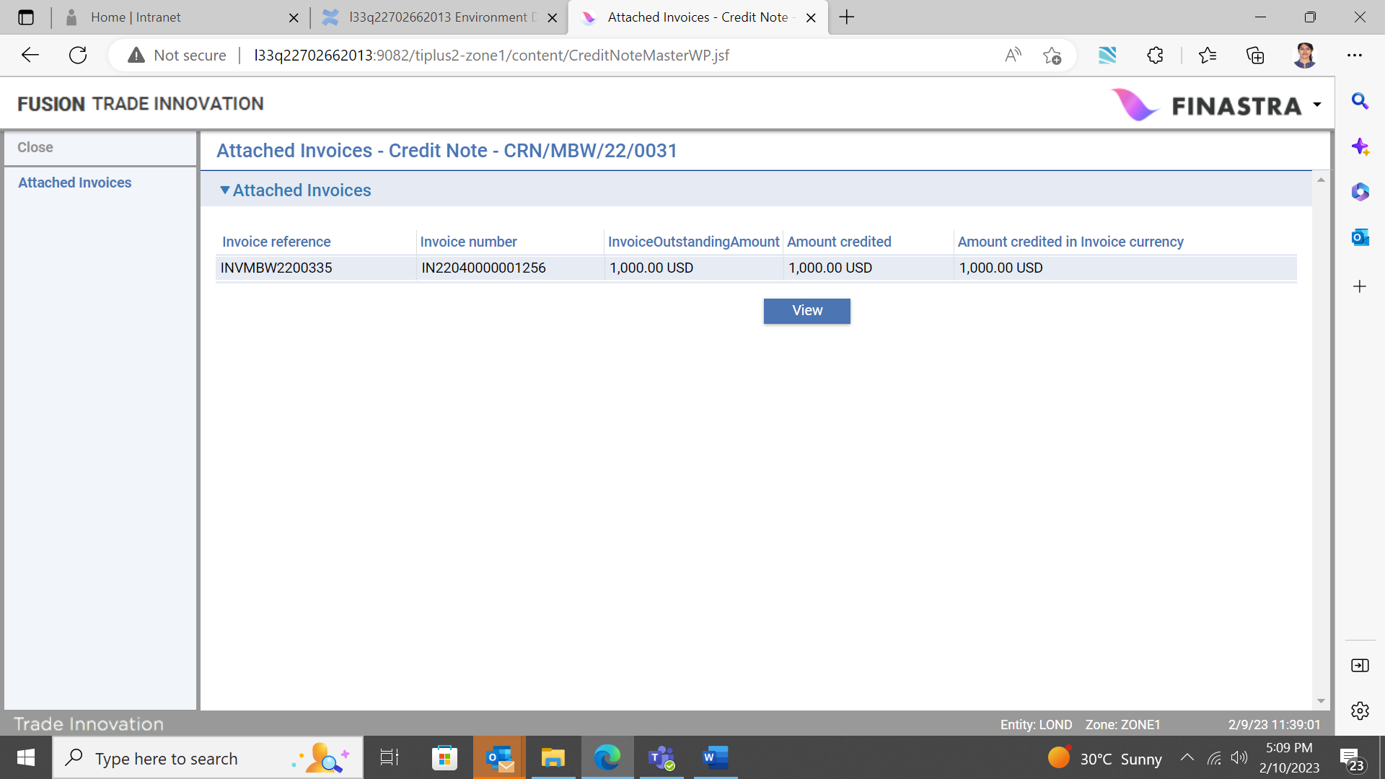

Individual invoice details may be viewed by highlighting an invoice and clicking the View button.

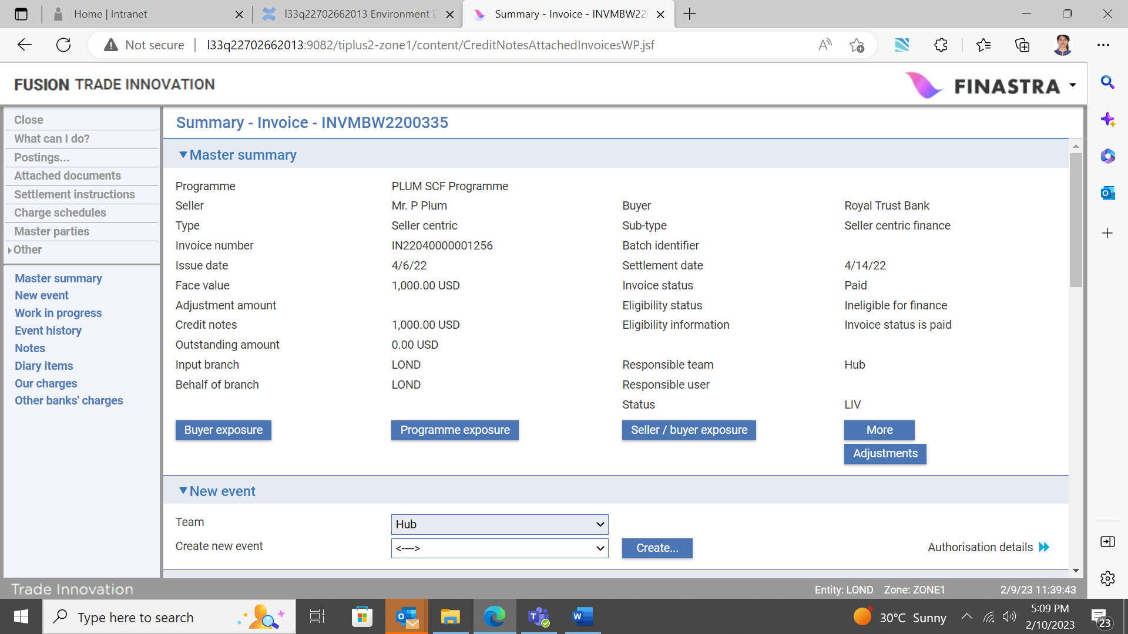

The invoice master summary screen is updated to show any adjustment to the face value amount, resulting in a new outstanding amount. Adjustments to the invoice face value amount also affect the buyer’s invoice concentration limit.

# The Credit Note Link/Unlink Event

A credit note may be received and recorded in Trade Innovation but not linked to any invoices in the create event. Subsequently, an instruction may be received by your bank to link the credit note to one or more invoices also recorded in your system. This is achieved via the Link/Unlink event.

Note that upon receipt of instructions to link a credit note to one or more invoices, the face value amount of each invoice is updated by the amount of the credit note that has been apportioned, thus adjusting the outstanding amount available for financing. The buyer’s invoice concentration limit is also updated accordingly.

To link the credit note to invoices; from the credit note master summary screen, select the ‘Link/Unlink’ option from the dropdown list and click the Create button.

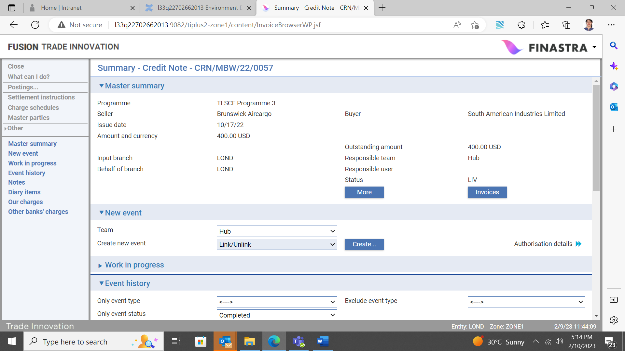

## The Credit Note Details Pane

In the window that opens, the credit note details pane displays the credit note amount available to be linked and apportioned to one or more invoices.

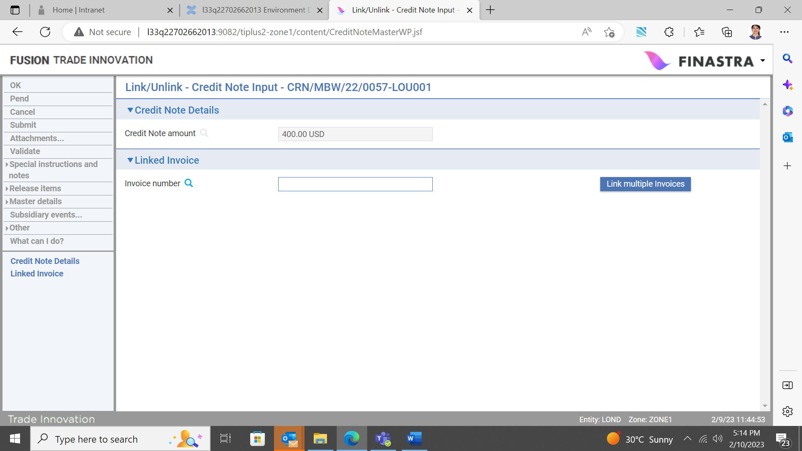

## The Linked Invoice Pane

The linked invoice pane allows you to filter on and link a single invoice, or to link multiple invoices to the credit note.



Functionality available via either of these buttons is the same as that described under the Create Credit Note event (see page 27). You may filter on and select a single or multiple invoices and apportion a specific amount to each invoice.

### Unlinking Invoices from the Credit Note before or after Financing

You may also use the Link/Unlink event to remove the linkage between the credit note and an invoice. This may be done before or after the invoice is financed.

Open the Link/Unlink event as described above and click the Link multiple invoices button.

The following window opens:

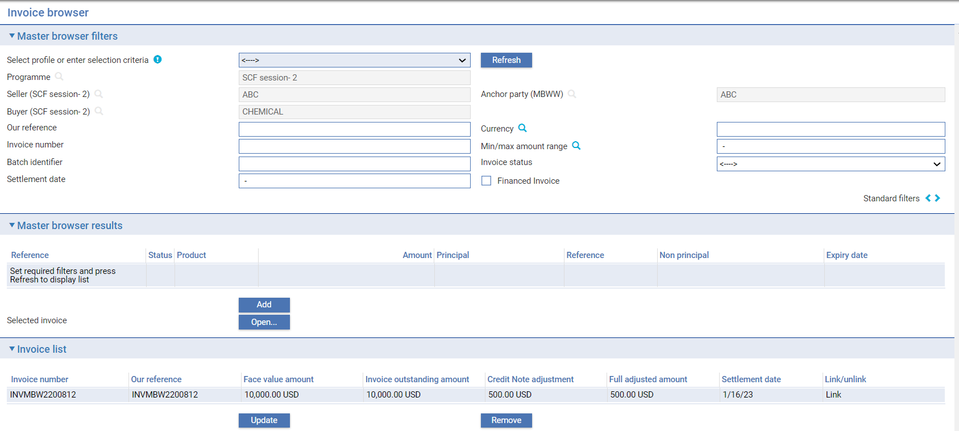

The Invoice list pane will display details of all invoices already linked to the credit note. Highlighting an invoice and clicking the Remove button will sever the link to the particular invoice.

The Close button is then clicked and you will be returned to the following screen:



If the OK button is clicked to complete the event, the following warning is generated:

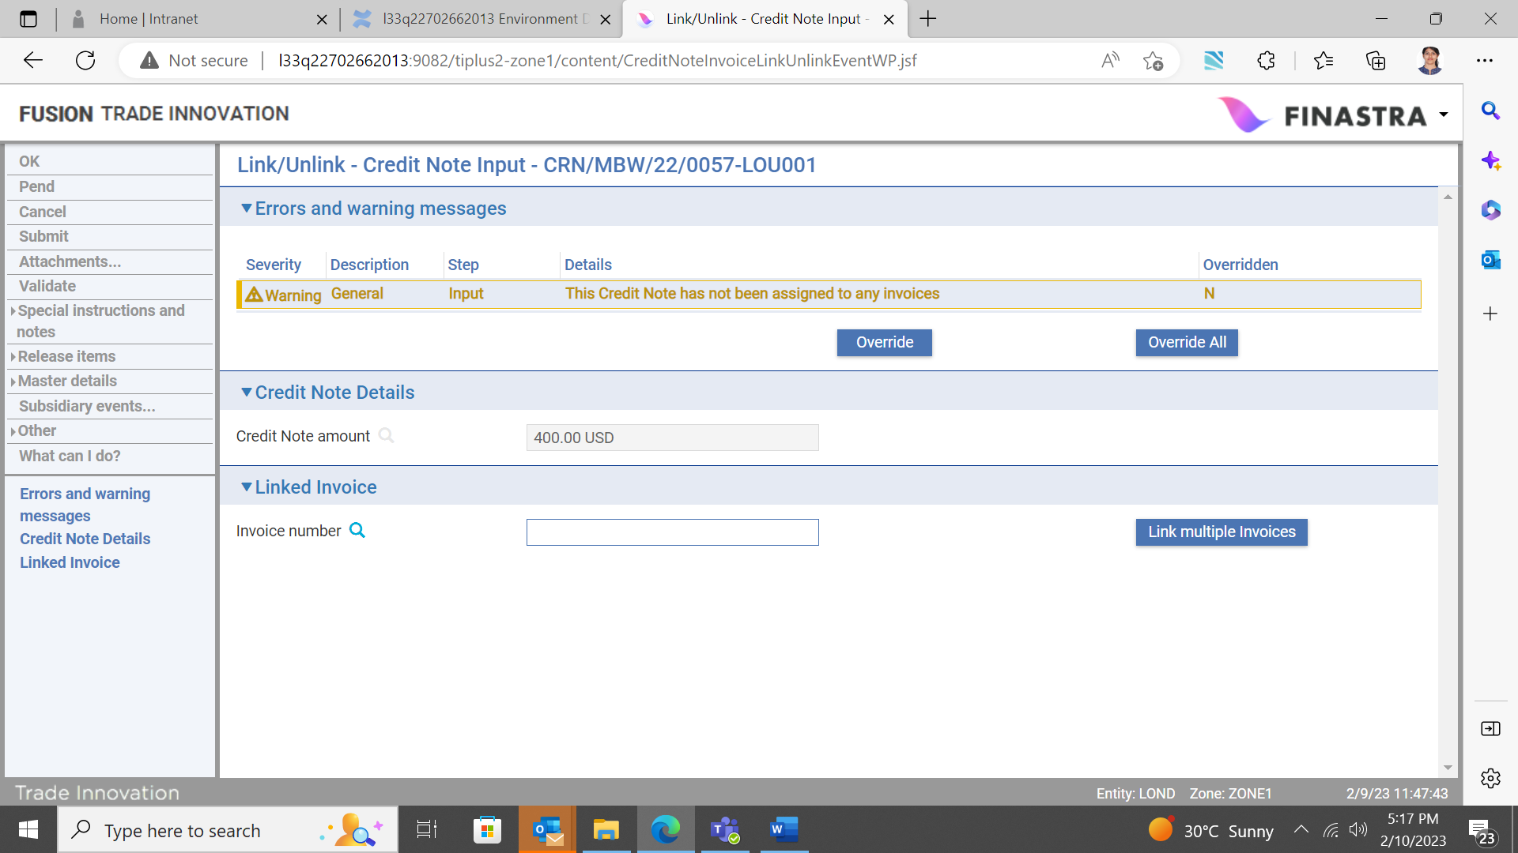

If you wish to complete the event and unlink the invoice, you may override this warning and complete the event in the normal manner.

Alternatively, you may want to link the credit note to other invoices and this can be achieved via the Invoice number filter, or Link multiple invoices buttons as described above. The event is then completed in the normal way.

# Settling an Invoice

This chapter explains how to record payment against an invoice.

Invoices are settled in Trade Innovation using the Settle Invoice event. Each Settle Invoice event is used to settle a single invoice. A Settle Invoice event is created as a diary event as each Create Invoice event completes. It may then complete automatically on the invoice settlement date, but will require manual input if an outstanding advance is recorded against it.

Settle Invoice events can also be created:

automatically, upon receipt of instructions from your bank’s corporate customers, received via the gateway or,

manually against an invoice master

at any time after the Create Invoice event that initiated the invoice master record has been released, provided that the invoice has a status other than ‘Paid’ or ‘Cancelled’.

1. Buyer/seller centric finance Create, Settle Invoice, Amend Invoice and Cancel Invoice events are mutually exclusive.

Once you have initiated a Settle Invoice event, the system will prevent you from opening another Settle Invoice, a Buyer/seller centric finance create, Amend Invoice or Cancel Invoice event for that invoice until the Settle Invoice event has completed.

A Settle Invoice event can be for the full outstanding amount or for a partial payment. It also allows outstanding charges against the invoice to be collected. Any such charges default to 'Take' when you open the Charges Summary window. See the Common Facilities User Guide – Trade Innovation for more on taking charges.

Instructions received from your customer(s) via the gateway may request you to effect early settlement

pay on time, or

defer payment and settle at a later date

For a financed invoice, the Settle Event can be used to repay an advance in part or in full, with or without settling the invoice. This allows, for example, an advance against a dishonoured invoice to be repaid (see page 47 for details of finance repayment).

## Settle Invoice Events

Settle events can be initiated automatically or manually.

Settle events are created automatically upon receipt of the TFINVSET gateway.xml message from your banks corporate customer(s).

When the TFINVSET message is received by Trade Innovation, the system matches the details with the appropriate invoice master and automatically creates an Invoice, Settle event. If the incoming message quotes a payment amount that matches the invoice amount exactly, the system is able to straight through process the Settle event (where the event map is configured appropriately). Validation is provided where the payment amount is:

* less than the invoice amount
* greater than the invoice amount

If the message quotes the reference of an invoice that has already been settled in full, the system provides validation and alerts the user.

Settle events are manually created in one of two ways:

* In the Supply Chain Finance Masters browser, highlight the invoice and click the Settle button. This opens a Settle Invoice event for the selected invoice. This method speeds up the settlement of invoices by allowing you to create a Settle Invoice event without having to open the Master Summary window for the invoice first
* Alternatively, open the invoice in the usual way. In the Master Summary window select 'Settle Invoice' from the Create New Event drop-down list and click New

In either case Trade Innovation creates a Settle Invoice event at either the Log step or the Input step, depending on how your system has been configured. The same fields are used by both steps.

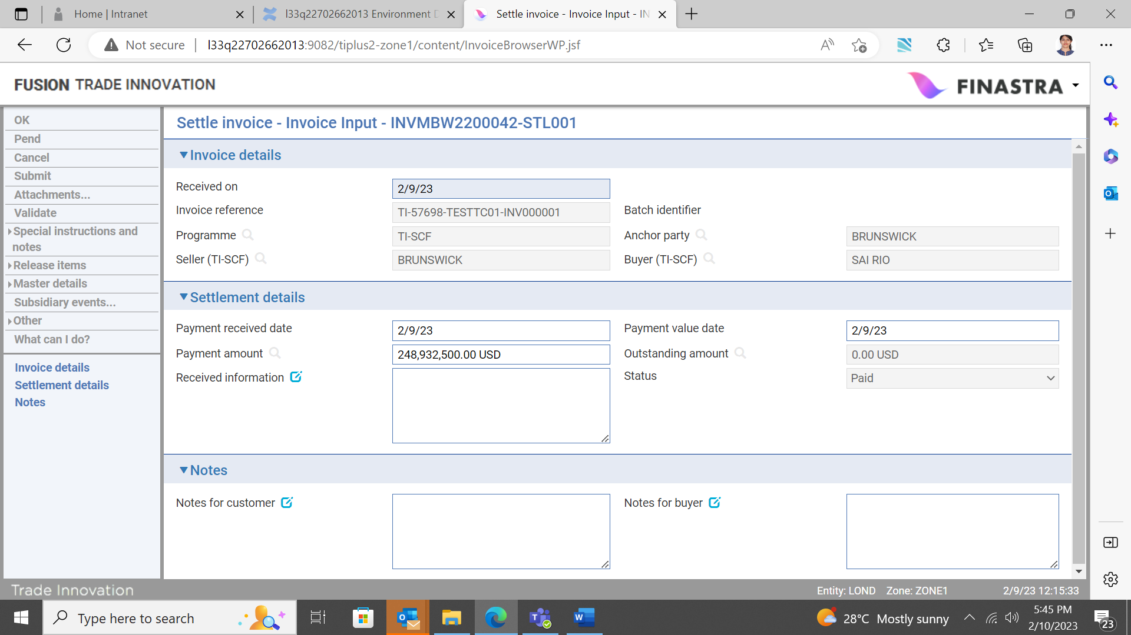

1. Finastra recommends that you check settlement details during this event.

This event can be used to:

* Settle an invoice without repaying the related legacy advance (created directly from the invoice using an older Trade Innovation version prior to TI Plus 2.5), as described below
* Settle an individually legacy advance invoice and use the invoice payment to repay the advance
* Repay the legacy advance against a financed invoice

The following table explains what to enter into the fields in this window to settle a factoring facility invoice or a finance programme invoice that has not been financed:

|  |  |  |
| --- | --- | --- |
|  | Field | What to Enter |
|  | Received On | Either the date the payment was received by your bank, or the current processing date. |
|  | Invoice Reference/ Batch Identifier | Trade Innovation displays the invoice's reference and batch identifier (if there is one). |
|  | Programme | Trade Innovation displays the programme under which the invoice is recorded. |
|  | Anchor party | Trade Innovation displays the anchor party for the programme. |
|  | Seller/buyer | Trade Innovation displays the unique identifiers of the seller who is expecting to be paid and the buyer who is making the payment. |
|  | Payment Received Date | The date the payment was received by your bank. |
|  | Payment Value Date | The value date of the payment, as processed by your bank. The Payment Received Date is used as the default here.  This date is used to schedule a Book Off event in the diary. The Book Off event's date is calculated as the date entered here, plus the book-off period specified in the product options for invoices. |
|  | Payment Amount | The amount being paid, in the invoice currency. Trade Innovation issues a warning if this amount involves a partial payment or an overpayment.  You can enter a foreign exchange deal in the usual way to accommodate payment or receipt of funds in a currency other than that of the invoice. See the Common Facilities User Guide – Trade Innovation for instructions. |
|  | Outstanding Amount | If the payment amount is not for the full amount, the system calculates and displays the amount left outstanding, once you have entered the payment amount. |
|  | Received Information | Any instructions received with the payment. |
|  | Status | The status of the invoice. After you have entered payment details the system sets the status to either 'Paid', if the invoice is being paid in full, or 'Inquiry' if it is being paid in part. |
|  | Notes for Customer | Any notes for the customer. |
|  | Notes for Buyer | Any notes for the buyer. |

1. Once an invoice is partially or fully settled, financing against that invoice is not permitted because the invoice has become ineligible for financing.

## Repaying Legacy Finance under an Invoice without Settling the Invoice

1. If your bank has upgraded from an earlier version of Trade Innovation and you therefore have invoices and (invoice level) finance deals outstanding, which were previously created, you can continue to repay finance deals without settling associated invoices.

For invoices recorded against a Supply Chain Finance programme the payment details are entered as described in the previous section. Provided that the payment amount is larger than or equivalent to the outstanding advance amount, Trade Innovation will repay the advance in full. Otherwise it will make a partial repayment equal in value to the payment amount.

The system automatically creates a Repay event against the related finance invoice advance transaction using the advance repayment details entered. You can access this using the Subsidiary link.

An additional pane - the Advance Repayment pane - is present. When you check the Repay Advance field in this pane the system displays details of the original advance and the repayment being made against it.

The values in these fields change, depending on what you enter into the Settlement Details pane. The following table explains what these fields show:

|  |  |
| --- | --- |
| Field | What it Shows |
| Exchange Rate | Relevant where the advance is in a different currency from the invoice payment. This shows the exchange rate used to convert the payment amount into the advance currency, which you can overtype. You can enter either an actual exchange rate, or an exchange rate code.  To access the current exchange rate value the system uses the exchange rate entered against the advance as the default.  Trade Innovation automatically updates the payment equivalent amount if you change the value here. |
| Payment Amount Equivalent | Relevant where the advance is in a different currency from the payment. This shows the payment amount in the advance currency. |
| Advance Start Date | The start date of the advance. |
| Advance Maturity Date | The date on which the advance matures. |
| Original Advance Amount | The initial advance amount. |
| Outstanding Advance Amount | The amount left outstanding after this event completes. The system calculates and displays this amount once you have entered the payment amount. |
| Repayment Type | Depending on whether the invoice payment amount entered in the Settlement Details pane covers the outstanding advance amount (plus any late payment interest due) in full or in part, this changes to show whether the repayment is a full repayment or a partial repayment. |
| Value Date | The value date of the repayment. The invoice payment value date is used as the default. This can be the actual advance maturity date.  If the repayment is being made earlier than the advance maturity date, then any overpaid interest is calculated and refunded, if required.  If the repayment is later than the advance maturity date, then any overdue penalty interest is calculated and applied. |
| Reference | This field is enabled to allow you to enter a reference for the repayment, if required. |
| Principal Repayment Amount | The principal amount being repaid against the advance. If the payment amount (or payment equivalent amount) is equal to or more than the advance, then the system will allocate sufficient funds to repay the advance in full; otherwise a partial repayment is recorded. |
| Late Payment Interest Amount | Displayed only if the advance is being paid late. The system calculates and displays the penalty interest accrued since the advance maturing date, using the relevant penalty interest rates. |
| Waive Interest | Displayed only if the advance is being paid late. Check this field if the late payment interest is to be waived. |
| Overpaid Interest Amount | Trade Innovation uses the repayment value date to calculate whether the customer has overpaid interest, and displays any overpayment amount here. This may be refunded by postings generated by the Settle Invoice event, or realised into profit and loss. |
| Total Repayment Amount | The total amount being repaid. This field allows you to repay an advance without recording a payment against the invoice, as described in the next section. |
| Balance Payment Amount | If relevant, the balance left for the customer from the invoice payment, after the advance repayment has been made. This amount excludes any outstanding charges or overpaid interest. |

## Repaying a Legacy Advance without Settling the Invoice

To repay a legacy advance against a financed invoice without settling the invoice, enter a payment amount of 0 (zero).

The Total Repayment Amount field is enabled. Use it to enter the amount being repaid against the advance.

## When the Settle Invoice Event Completes

Once a Settle Invoice event which is for the full amount of the invoice completes, it is removed from the diary. Where partial settlement is effected, FBTI automatically re-diarises the invoice outstanding amount, creating a scheduled diary event.

The outstanding amount recorded against the invoice is reduced by the amount paid and it ceases to be eligible for inclusion in available drawdown amount calculations or for financing. If your system is so configured, a payment advice is produced and sent to the customer. Postings are generated to reflect the payment.

The buyer’s invoice concentration limit available amount is increased by the payment amount as a result of liability postings.

If the invoice has been financed:

* The customer’s credit limit available amount is increased by the principal payment amount as a result of liability postings
* The buyer/seller limit available amount is increased by the principal payment amount
* Related exposures are updated accordingly

If the Settle Invoice event is for the full amount, upon completion of the event:

* The invoice's status is set to ‘Paid’ and no further payment may be made against it
* Trade Innovation schedules the invoice master to be booked off

If the Settle Invoice event is for a partial amount, upon completion of the event:

* The invoice's status is set to 'Inquiry'
* The amount outstanding is amended to take account of the partial payment

You can then enter further Settle Invoice events against the invoice to complete payment of the invoice.

## Settling Multiple Invoices

You can select multiple invoices to be settled together by creating a new master for Invoice Bulk Payment.

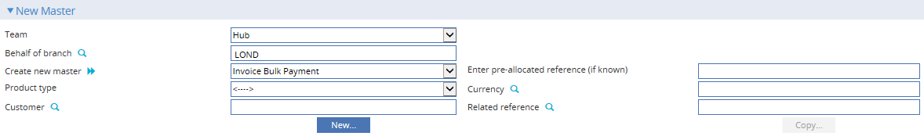

Refer to Chapter 10 for the processing of Bulk Payments.

# Repaying Buyer or Seller Centric Finance

## Repaying Finance

A buyer or seller centric finance create event is used to record details of the finance deal and Trade Innovation creates a scheduled repay finance event. The eligibility status of each invoice included in the deal is updated so that it is subsequently, ineligible for finance (see page 89 for details of eligibility criteria).

The finance deal may be repaid early, on the due date, or when it has gone past due. When the finance deal is repaid, in parallel each related invoice must also be settled individually, manually or automatically by a scheduled diary event. Both activities may coincide on the same date or occur on different dates. It is also possible to settle invoices partially or in full prior to the due date and to repay the finance deal accordingly.

It is important to note that Trade Innovation cannot automatically repay buyer or seller centric finance deals as a result of settlement of related invoices.

Following creation of a finance deal, you can manually initiate a Repay finance event from the dropdown list in the Buyer or Seller Centric Finance Master Summary screen.

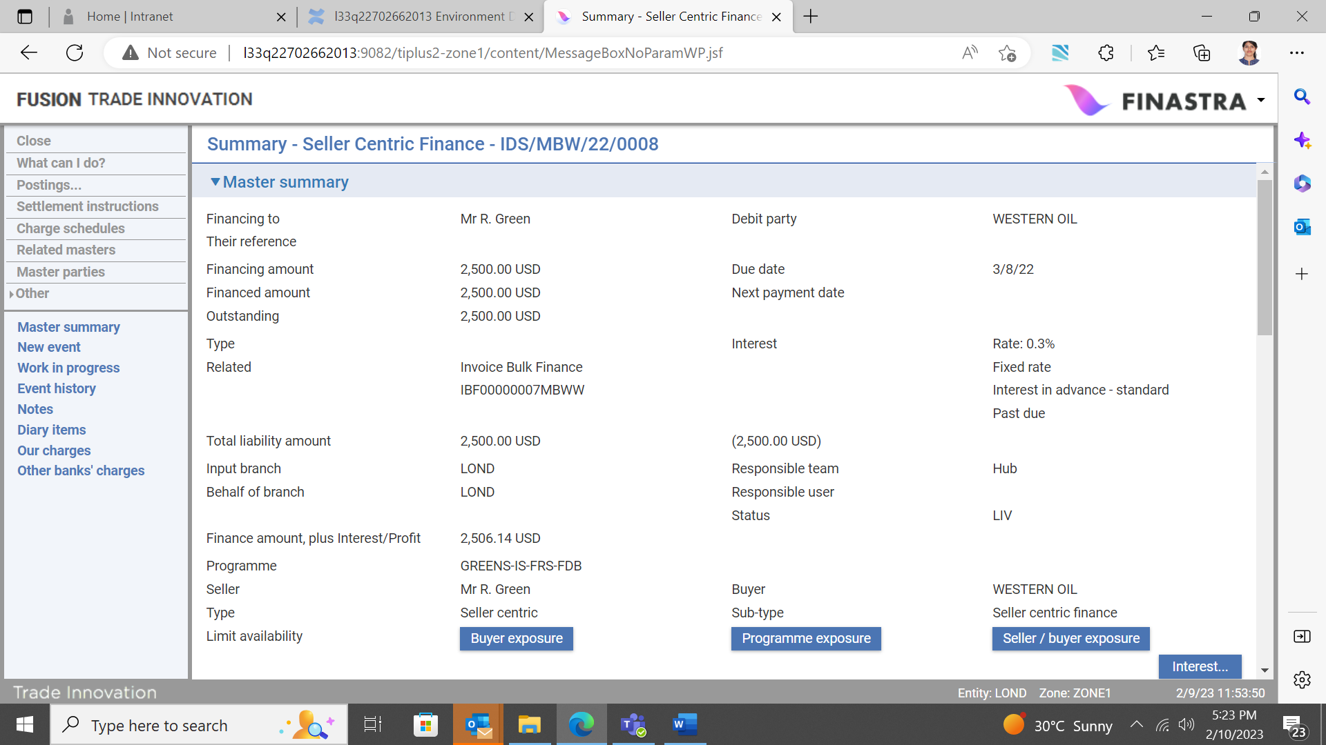

A Repay Finance event may also be initiated from the gateway, and it can be handled in the same way as a manually created event. Refer to the *Financing User Guide* – Trade Innovation for further details.

### Manual Repayments

Trade Innovation permits you to make manual repayments against a financing transaction at any point after it has been released.

Manual repayments use the Repay event, and can be processed in one of the following ways:

* Final payments, involving full repayment of interest and principal, after which no further actions can be carried out against the financing transaction
* Principal plus interest to date, for which the system calculates the amount of interest to be paid. You then enter the amount to be repaid in addition to the interest amount
* Interest to date, then principal, which involves entering the total amount received. The system calculates the interest due to date and apportions the appropriate amount to interest repayment. It then calculates how much is left to pay off the principal
* Repayment of any portion of the interest or principal amounts

In addition, you can use a manual repayment event to transfer the outstanding balance of the financing transaction in the past due state to a new financing transaction with new characteristics for example, for the purpose of tracking and dealing with troublesome finance.

If you enter a manual repayment against a financing transaction with scheduled repayments, the system takes the manual repayment into account when processing the next Scheduled Repayment event.

If you enter a manual repayment against a financing transaction which is subsequently repaid in full or in part during a payment event against the originating transaction, the amount of the manual repayment will be deducted from the amount outstanding. Refer to the *Financing User Guide* – Trade Innovation for further details.

When a repayment is made, its corresponding updates to the related customer credit limit and the buyer/seller limit are also generated in the form of a reservation (on completion of the input step), then in exposure form (on release of the event), in order to reduce/release the deal specific utilisation.

### Scheduled Repayments

When you first enter details of a financing transaction, the system permits you to define schedules determining the repayment of interest and principal amounts. You can set up separate schedules for interest and for principal repayments. When the financing transaction is released, the system uses these schedules to create diary entries to effect repayments as they fall due.

If you have defined repayment to occur automatically - by setting the Auto Repay flag - the system automatically generates the necessary postings using funds from the account designated for repayment.

Provided there are sufficient funds in the account the event is released without requiring manual intervention from you. Otherwise, the system places a Scheduled Repayment event in the Work in Progress pane for the financing transaction and you can either authorise or reject it, as appropriate.

If you have not defined repayments to occur automatically, the system places a Scheduled Repayment event in the Work in Progress pane for the financing transaction for you to authorise or reject.

For interest-bearing transactions, once the Scheduled Repayment event has been released, the system generates a diary event for the next repayment of interest or principal until the term of the transaction has been reached. Refer to the *Financing User Guide* – Trade Innovation for further details.

### Repaying Multiple Finances

You can select multiple finances to be repaid together by creating a new master for Invoice Bulk Payment. This is the same for settling multiple invoices. The next chapter explains Bulk Payments in further detail.

# Bulk Payments

The system permits you to settle invoices and/or repay finances in a single transaction through Invoice Bulk Payments. This enables multiple invoices, finances or both to be fully or partially settled/repaid in a single transaction.

Eligible invoices and finances which can be added in the bulk payment should have the following characteristics:

Have an outstanding balance to be settled

The information such as Customer and Reference should match

Should not be pending in another transaction

## Invoice Bulk Payment Master

From the SCF Master Browser, select Invoice Bulk Payment from the Create new master field. Select New and the below screen will appear.

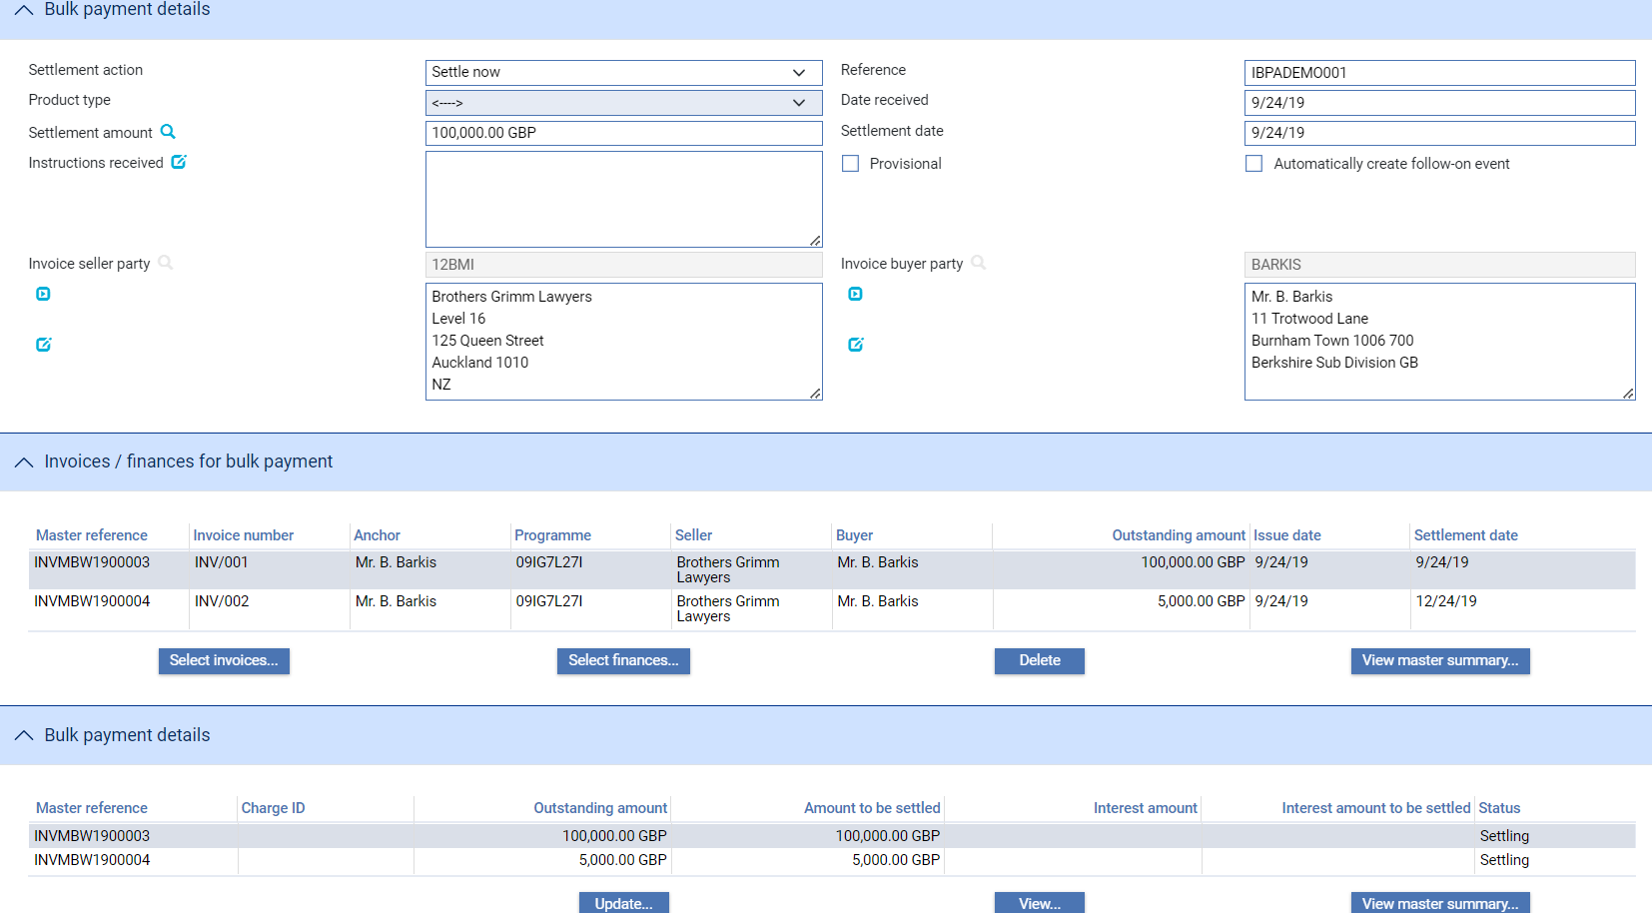

Invoices and Finances are added into the bulk payment separately. This is because invoices and finances have a different basis for settlement. When Invoices are selected , the system automatically picks up the corresponding finances and vice versa.

Invoices and Finances that have been selected as part of the bulk payment may be deleted from the Master via the Delete button where the system also automatically deletes the corresponding Finances and Invoices You may also revisit details of the invoice or finance by selecting it in the Master and clicking on View master summary.

### Select Invoices

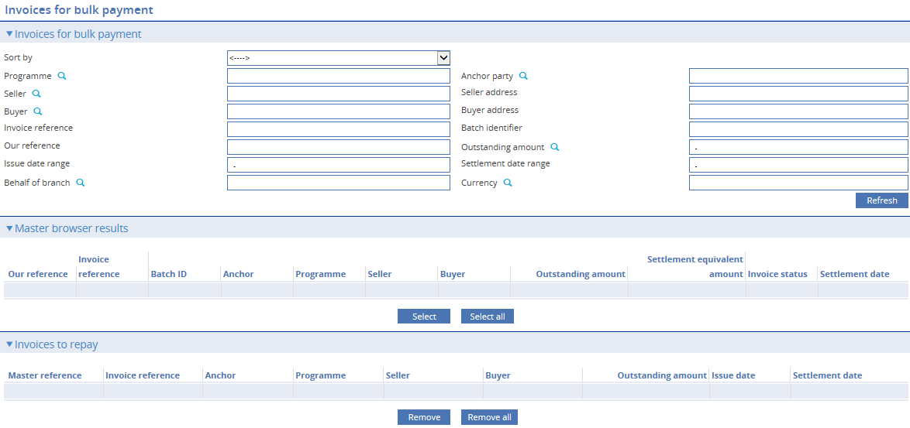

The following filters are available to search for invoices to add to the bulk payment:

|  |  |
| --- | --- |
| Field | What to Enter |
| Sort by | Select from the following to order the search results   * Last in / first out * First in / first out * Lowest outstanding amount * Earliest settlement dates * Latest settlement dates * Highest outstanding amount * Our transaction reference |
| Programme | The buyer or seller centric programme against which the invoice is being recorded. |
| Anchor Party | The party (either seller or buyer) that owns the programme and whose credit line is used. |
| Seller | The seller who is the credit party on the invoice. The system limits the browser display to sellers set up for the selected programme. |
| Seller address | The seller’s address as recorded in the programme against which the invoice is being recorded. |
| Buyer | The buyer who is the debit party on the invoice. The system limits the browser display to buyers set up for the selected programme. |
| Buyer address | The buyer’s address as recorded in the programme against which the invoice is being recorded. |
| Invoice reference | The unique identifier for the invoice per buyer/seller (and programme) combination, provided by the customer. |
| Batch identifier | The batch identifier associated with the invoice, provided by the customer. |
| Our reference | The reference generated by the system when the invoice was issued. |
| Outstanding amount | The remaining amount left for settlement or repayment. This could be a specific amount or a range. |
| Issue date range | Invioces are filtered with issue dates within this range. |
| Settlement date range | Invoices are filtered with settlement dates within this range. |
| Behalf of branch | The behalf of branch for the transaction as entered by the user in the invoice. |
| Currency | The currency of the invoice amount. |

Search results are displayed in the Master Browser results pane. Invoices selected in this pane will be moved to the Invoices to repay pane. Once this page is confirmed, all selected invoices can be seen in the Bulk Payments Master.

### Select Finances

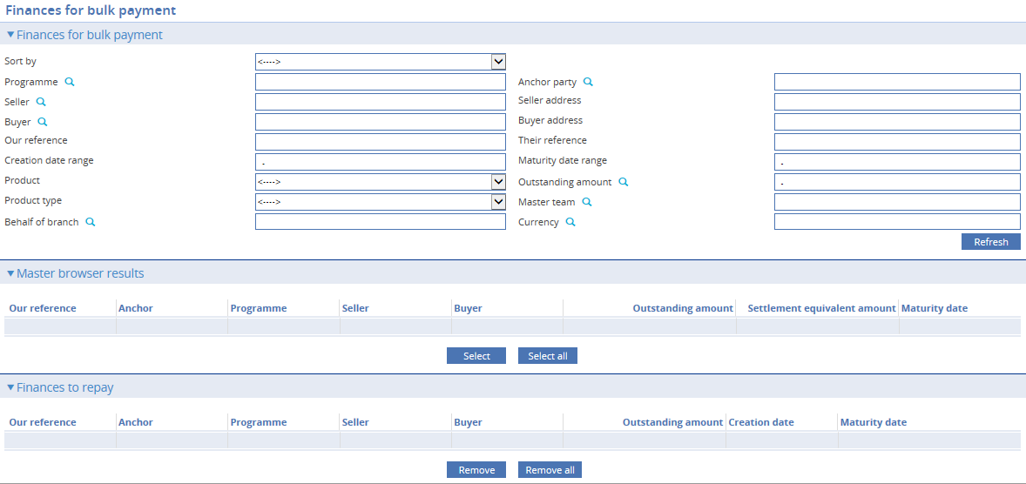

The following filters are available to search for finances to add to the bulk payment:

|  |  |
| --- | --- |
| Field | What to Enter |
| Sort by | Select from the following to order the search results   * Last in / first out * First in / first out * Lowest outstanding amount * Earliest settlement dates * Latest settlement dates * Highest outstanding amount * Our transaction reference |
| Programme | The buyer or seller centric programme against which the finance is being recorded. |
| Anchor Party | The party (either seller or buyer) that owns the programme and whose credit line is used. |
| Seller | The seller who is the credit party on the finance. The system limits the browser display to sellers set up for the selected programme. |
| Seller address | The seller’s address as recorded in the programme against which the finance is being recorded. |
| Buyer | The buyer who is the debit party on the finance. The system limits the browser display to buyers set up for the selected programme. |
| Buyer address | The buyer’s address as recorded in the programme against which the finance is being recorded. |
| Our reference | The reference generated by the system when the finance was issued. |
| Their reference | The other party’s reference for the finance. |
| Creation date range | Finances are filtered with creation dates within this range. |
| Maturity date range | Finances are filtered with maturity dates withinthis range. |
| Product | The product option for financing – Buyer centric, Seller centric. |
| Outstanding amount | The remaining amount left for settlement or repayment. This could be a specific amount or a range. |
| Product type | The type of financing transaction. This field is used to differentiate between financing transactions for the purposes of accounting, risk management and reporting. Both buyer and seller centric finance products can be further differentiated by the use of product type. |
| Master team | The particular team whose master record the finance belongs to. |
| Behalf of branch | The behalf of branch for the transaction as entered by the user in the finance. |
| Currency | The currency of the finance amount. |

Search results are displayed in the Master Browser results pane. Finances selected in this pane will be moved to the Finances to Repay pane. Once this page is confirmed, all selected finances can be seen in the Bulk Payments Master.

### Settlement Action

An Invoice settlement or Finance repayment may be processed on the same day or set to a future date. Related interest and charges may be deferred for partial settlements. It is possible to select interest only for repayments in the repayment action 'Interest then Principal'. However, a charge will automatically be taken together with a final payment or upon full settlement.

You have the option to settle/repay the bulk payment immediately or at a future date through the Settlement Action. The following options are available:

* Settle now – The settlement amount will be deducted from the Customer’s account when the transaction is completed.
* Settle later (Auto-Debit) – The settlement amount will be deducted from the Customer’s account on the date specified in the Settlement date. The bank user can find this in the Diary items as Scheduled repay finance.
* Settle later (Requires Approval to Debit) – This action gives the Customer an option to proceed, cancel or change a prior payment instruction. Therefore when a bulk is created with this action, the provisional flag is automatically ticked.

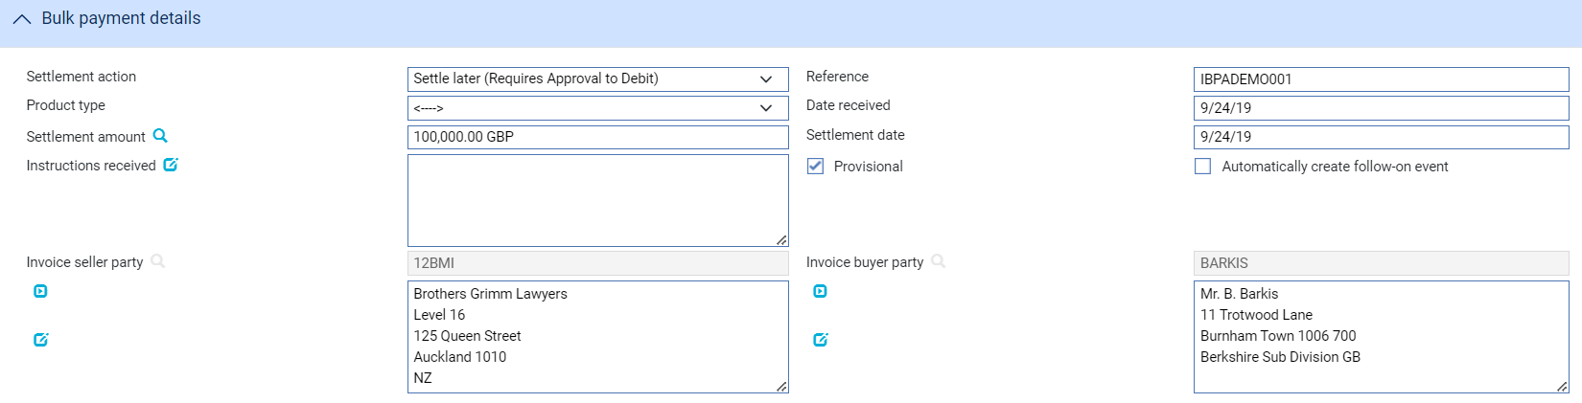

Completion of a provisional event will not deduct the Customer’s account even though a date specified in the Settlement date. Because this action implies that the payment instruction needs confirmation, another create event should be initiated (with the provisional flag deselected) in order to signify a definitive settlement.

1. Your bank will need to configure the postings, charges and other release items produced on completion of a Bulk Payment create event so that they are generated only if the event is not flagged as provisional; and so that, if the event is provisional, it represents a request to approve the payment instruction only. See the System Tailoring User Guide – Trade Innovation for information on using the rules facility to achieve this. Postings are additionally configurable by the ‘Applicable for’ attribute.

You are allowed to untick the provisional flag until the event is finalised. This effectively becomes a Settle later (Auto-Debit). It can be configured in the User-defined error/warning messages if you wish to restrict completion of the event without the provisional flag. Refer to *System Tailoring User Guide* – Trade Innovation for further details.

1. An invoice or finance that is part of a bulk payment whether for part or full repayment at a later date is not eligible to be selected for another Repay event until that bulk has been fulfilled.

The Invoices/finances for bulk payment pane displays the selected invoice and finance. You may select an invoice and finance in the Bulk payment details pane to indicate a specific amount or portion you wish to settle. This is reflected in the Amount to be settled column.

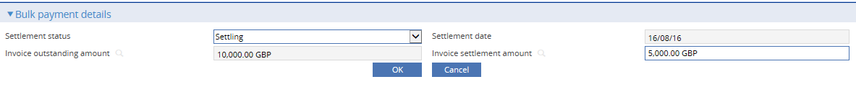

The Settlement status may be changed to Not Settling which is essentially removing the invoice or finance. However, this is left on the list in the bulk payment in case you decide to amend the bulk payment and add it back.

You may add foreign exchange contracts to accommodate repayments made in a currency that is different from the currency of the finance.

## Invoice Bulk Payment via Gateway

A Bulk Payment can be generated from a customer gateway interface service message but requires manual completion by opening the Master window in the usual way.

Trade Innovation opens the event at either the Log step or the Input step, depending on how your system has been configured. The same fields are used by both steps. The buttons such as ‘Add Invoices’, ‘Add Finances’ and ‘Delete’ will not be available when Bulk Payment is initiated from gateway, hence these buttons will only be available when Invoice bulk payment is initiated on Trade Innovation. The system will automatically add the corresponding Finance/Invoice based on the Finance/Invoice received via Gateway.

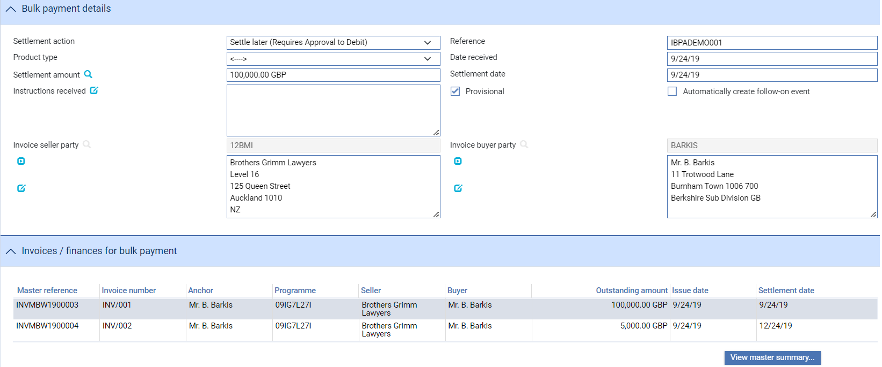

When details of the invoice or finance do not match with the system’s records except for the Master reference, this will still create a bulk payment with the discrepant invoice or finance compiled in the Invoices/finances ineligible for bulk payment pane.

All invoices and finances in the bulk payment are processed as if submitted individually. Therefore when you view the invoices and finances in the bulk payment separately, their Masters are updated.

# Setting up a Pool Based Factoring Facility

This chapter explains how to enter details of a factoring facility.

## Recording the Factoring Facility in Trade Innovation

When your bank enters into a factoring agreement with a customer, details of that agreement are recorded using a Supply Chain Finance programme and a factoring facility master record. Your bank sets up these for each customer/programme with whom it has a factoring agreement.

Once a factoring facility master record has been initiated, your bank can then record invoices against it and process them, as required. Any invoices for the customer already pre-recorded in Trade Innovation are matched up to the factoring facility, once it has been created, during overnight processing. Once a factoring facility expiry date is reached, a book-off date is set (the date is calculated as the expiry date plus the book-off period set in the product options for factoring facilities) and a Book Off event scheduled in the diary. The factoring facility can also be booked off manually - see the Common Facilities User Guide – Trade Innovation for details.

1. Factoring facilities cannot be booked off while there are any outstanding charges or active invoices recorded against them. Factoring facilities do not have an Expire event.

Your bank can specify that the factoring facility is to be reviewed at a regular frequency. The review is carried out using Amend Factoring Facility events, which are generated automatically as diary events when the review date is reached. These Amend events can also be used to amend a factoring facility’s expiry date.

The factoring facility master record is created using a Create event. Once the Create event has been released, Trade Innovation automatically schedules the following diary events:

* An Amend Factoring Facility event, used to review the factoring facility
* A Forecast Drawdown Availability event to calculate the amount available to the customer for drawdown
* A Scheduled Charges event, to collect any fees due

## Entering Details of the Factoring Facility

To create a new pool based factoring facility for a customer/programme, in the Supply Chain Finance Masters browser, New master pane, specify the team and behalf of branch and select ‘Pool based factoring’ from the Create new master dropdown list. The term, ‘Pool’ is referring to a pool of invoices.

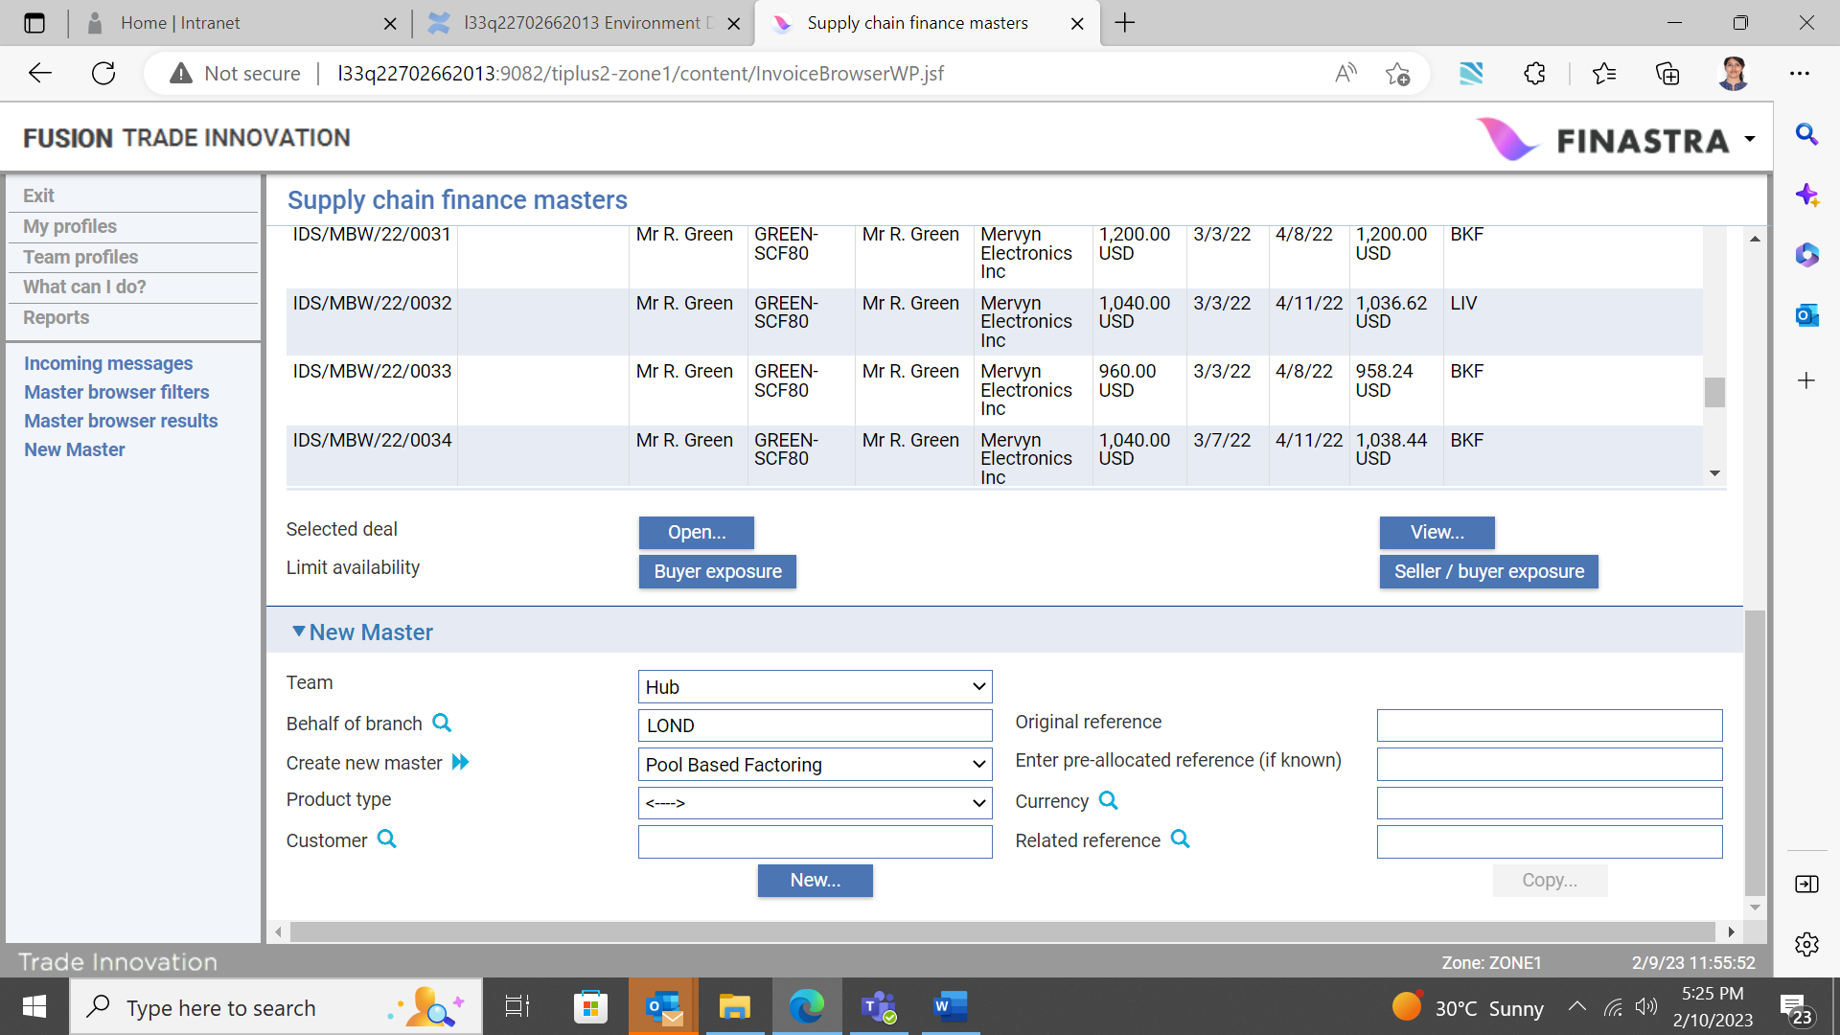

Trade Innovation creates a Create Pool Based Factoring Facility event at either the Log step or the Input step, depending on how your system has been configured. The same fields are used by both steps.

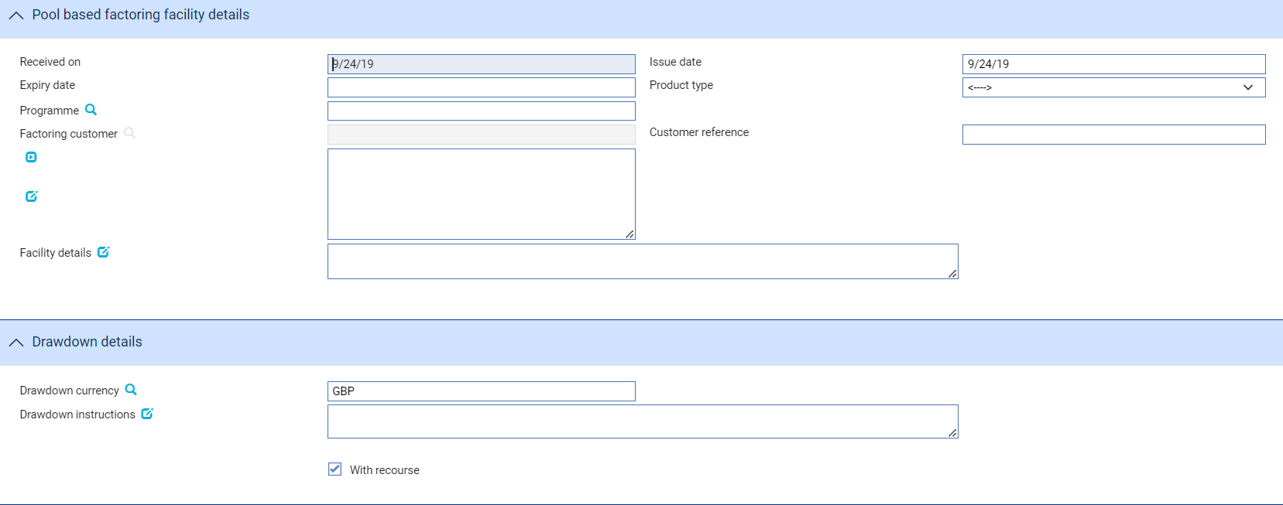

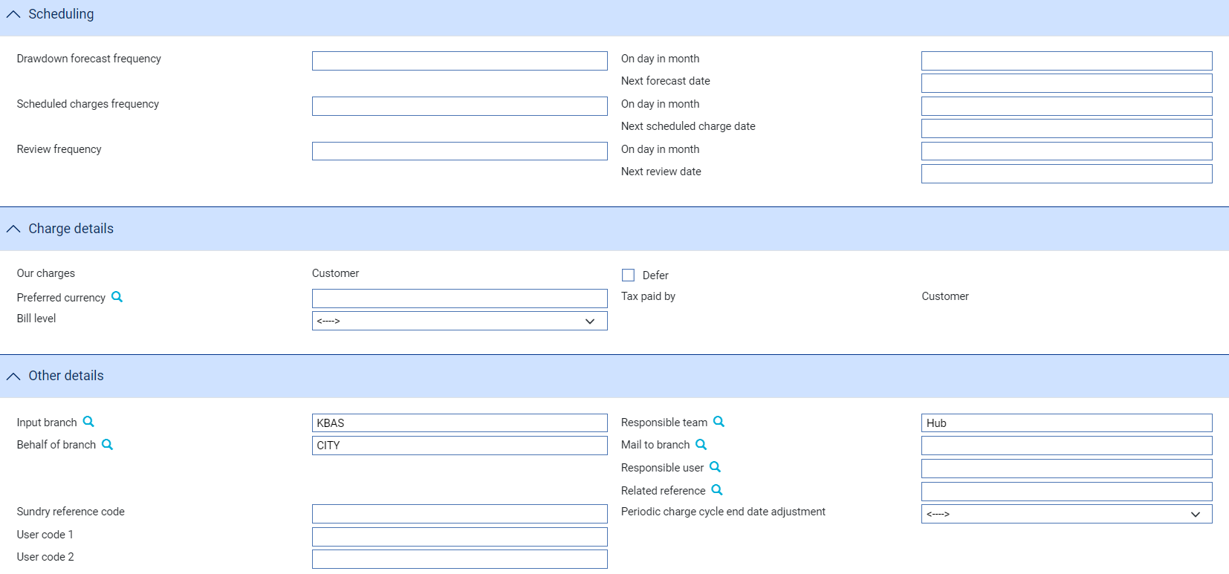

The window used to enter details of a factoring facility uses the following panes:

* The Pool based factoring facility details pane (see page 62)
* The Drawdown Details pane (see page 64)
* The Scheduling Details pane (see page 58)
* The Charge Details pane (see page 59)
* The Other Details pane (see page 59)

## The Pool Based Factoring Facility Details Pane

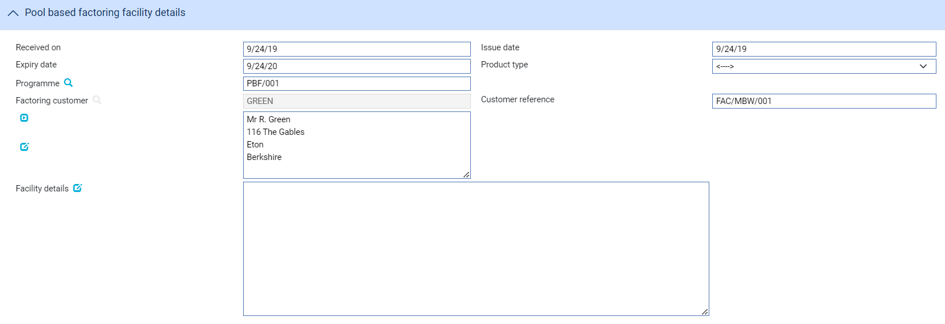

The following table explains what to enter into the fields in this pane:

|  |  |  |
| --- | --- | --- |
|  | Field | What to Enter |
|  | Received On | The date the request for a factoring facility was received by your bank. This must be the current processing date or earlier. |
|  | Issue Date | The date the factoring facility was granted to the customer. This must be the current processing date or earlier. |
|  | Expiry Date | The date the factoring facility will expire. This date is used to schedule a Book Off event in the diary. The Book Off event's date is calculated as the expiry date entered here, plus the book-off period specified in the product options for factoring facilities.  If the factoring facility is open-ended, leave this field blank. |
|  | Product Type | If your bank has set up product types for factoring facilities, select the appropriate one from the drop-down list on this field. Depending on how your system has been configured, this field may be mandatory. |
|  | Programme | The pool based factoring programme against which the facility is being set up. |
|  | Factoring Customer | The customer for whom the factoring facility is being set up. This customer owns the related programme, also referred to as the anchor party in this user guide.  Only one factoring facility is allowed per customer/programme. |
|  | Customer Reference | The customer's reference for the factoring facility. |
|  | Facility Details | A summary of the terms and conditions agreed with the customer, for information purposes. |

## The Drawdown Details Pane

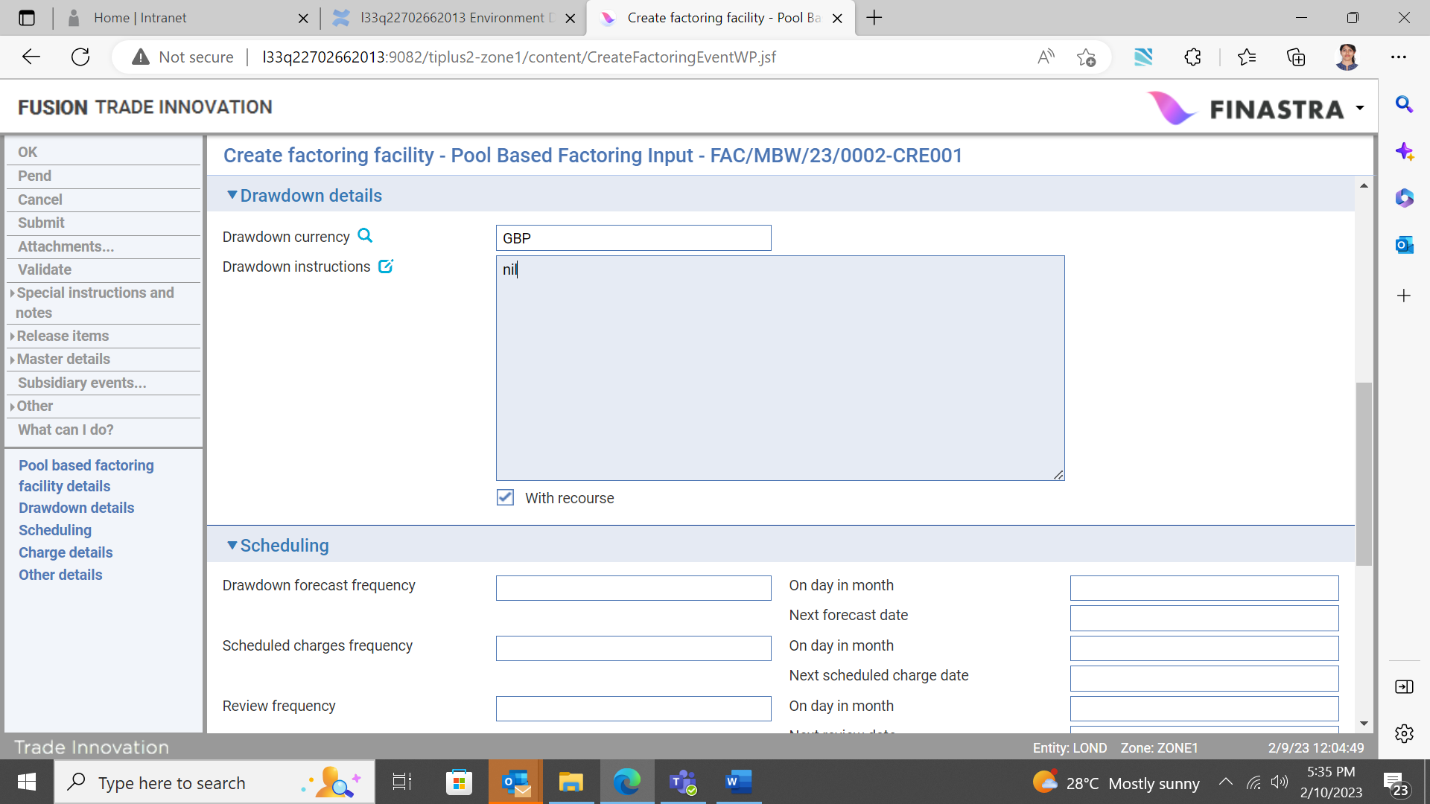

The following table explains what to enter into the fields in this pane:

|  |  |
| --- | --- |
| Field | What to Enter |
| Drawdown Currency | The customer’s preferred currency for making drawdowns. Local currency is used as the default. If you enter a currency that is different from base currency, spot rate is used for the necessary foreign exchange conversions. |
| Drawdown Instructions | A summary of the drawdown instructions agreed with the customer, for information purposes. |
| With Recourse | Indicate whether the factoring facility is with recourse or not. |

## The Scheduling Details Pane

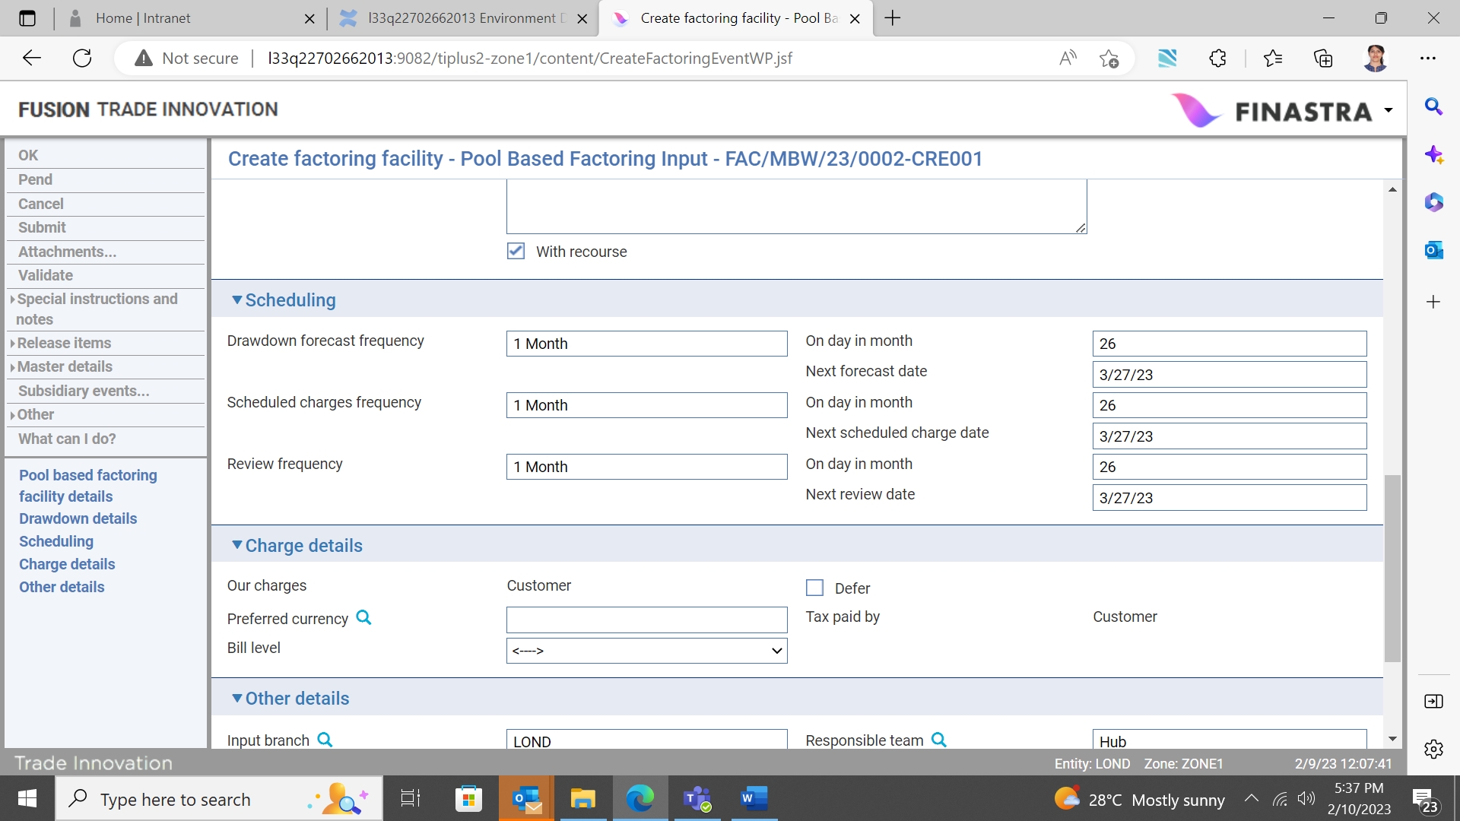

Use the three sets of fields to define the frequency with which:

* Drawdown forecasts will be made
* Charges will be collected
* The factoring facility will be reviewed

In each case, if you define a frequency of one month or greater, enter the day in the month on which the event will take place. You can also enter the actual date on which each event will next take place. If you leave these fields blank, the system calculates and displays the date using the frequency and day in month entered, using the issue date of the factoring facility as its point of reference. If you manually enter a 'next' date that falls on a non-business day, a warning message is issued.

Once the Create event is completed, the system uses the information entered in this pane to schedule a Forecast Drawdown Availability event, a Scheduled Charges event and an Amend Factoring Facility event, as relevant. As each scheduled event is completed (or if you abort the event), Trade Innovation schedules the next one. You can also create Forecast Drawdown Availability events, Scheduled Charges events and an Amend Factoring Facility events manually, in which case you can enter the next date for that event to take place.

Should any of these events be scheduled to occur on a non-business day, the system reschedules the event in the following way:

* If the frequency of the event is less than monthly, the system reschedules the event to occur on the next business day
* If the frequency has been defined as monthly or greater (meaning that the day-in-month will have been defined), the system also reschedules the event to occur on the next business day. However, if this takes it into the next calendar month, it will reschedule the event to fall on the previous business day instead

## The Charge Details Pane

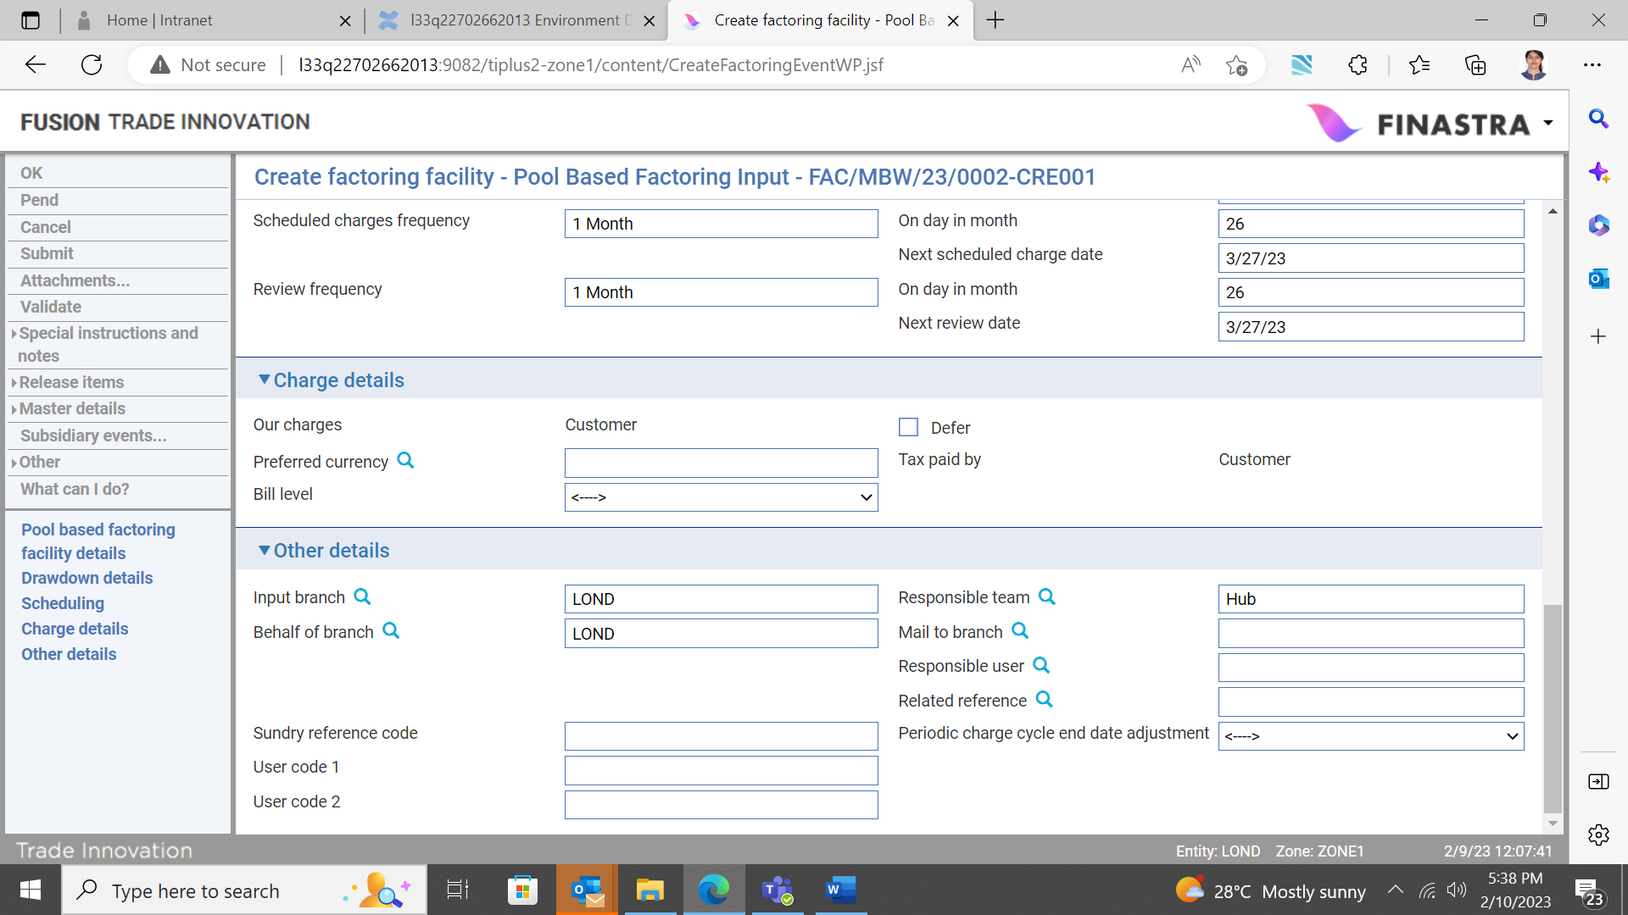

All charges raised for a factoring facility are for the customer for whom the factoring facility was set up.

The following table explains what to enter into the fields in this pane:

|  |  |
| --- | --- |
| Field | What to Enter |
| Defer | Check this field to allow charges to be deferred until a later date. |
| Preferred Currency | The currency in which the charges will be collected. If you leave this field blank, it defaults to the charge currency specified on the Product Options window. See the System Tailoring User Guide – Trade Innovation for product options.  If no currency is specified in the product options, the system uses the currency of the transaction. |
| Bill Level | Select whether charges for this transaction should be billed at customer level, transaction level or product level. |

## The Other Details Pane



The following table explains what to enter into the fields in the Other Details pane. This pane may also include input fields defined by your bank:

|  |  |
| --- | --- |
| Field | What to Enter |
| Input Branch | The input branch for the transaction. The input branch is set from either:   * the accounting branch from the user’s team, or * the transaction branch for the user if the user has a default transaction branch or is locked to a specific branch, or * a branch associated with the user where the user can enter transactions for several branches for a team |
| Behalf Of Branch | The behalf of branch for the transaction as entered by the user or set from the incoming SWIFT or gateway message. The behalf of branch determines the parameter sets that are to be used to generate charges, documents, postings, etc. during transaction processing. The branch can be changed to any other branch within the same main banking entity that shares the same parameter sets. |
| Sundry Ref Code /User Code 1/ User Code 2 | You may use these fields to enter values for analysis purposes. Your bank will have devised its own system for using these fields. |
| Responsible Team | The team that has overall responsibility for the master e.g. as the contact to resolve any queries or issues regarding the master and associated events. Trade Innovation defaults the responsible team when creating the transaction as follows:   * Manual – set from team creating the transaction * Gateway – set from the team specified on the incoming message (if present and valid) otherwise to the team to which the transaction is assigned through workflow allocation based on the behalf of branch * SWIFT – set to the team to which the transaction is assigned through workflow allocation based on the behalf of branch   It can be changed, if required, to either the team associated with the primary customer, default team for the product or the user’s current team. |
| Mail To Branch | If the customer requires documents to be sent to a branch other than that at which their account is held, specify the alternative branch here. Trade Innovation uses the mailing branch details held on the applicant's details as the default. |
| ResponsibleUser | A user that has responsibility for the master e.g. as the contact to resolve any queries or issues regarding the master and associated events. This can be any user assigned to the responsible team. |
| Related Reference | If the factoring facility is associated with an existing transaction, enter the reference number of the associated transaction here. |

# Reviewing and Amending the Pool Based Factoring Facility

Once a factoring facility has been set up, it can be amended using an Amend Factoring Facility event.

If the factoring facility has been configured so that it is to be reviewed at regular intervals, Trade Innovation will schedule an Amend Factoring Facility diary event to occur at the required interval. When the appropriate date is reached, overnight processing places the event in the Work in Progress pane, from where you can open it in the usual way. When that event completes, Trade Innovation schedules the next one.

1. While there is an Amend Factoring Facility event in progress, you will not be able to initiate another Amend Factoring Facility event or a Scheduled Charges, Forecast Drawdown Availability or Drawdown event against the factoring facility. Conversely, you will not be able to initiate an Amend factoring facility event while there is an outstanding Scheduled Charges, Forecast Drawdown Availability or Drawdown event in progress.

You can also create an Amend Factoring Facility event manually by selecting 'Amend Factoring Facility' in the Create New Event drop-down list and Clicking Create. Trade Innovation opens the event at either the Log step or the Input step, depending on how your system has been configured. Both steps use the same fields.

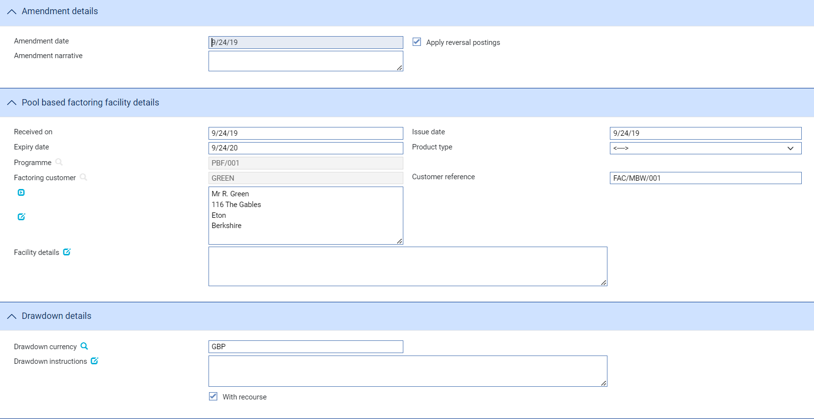

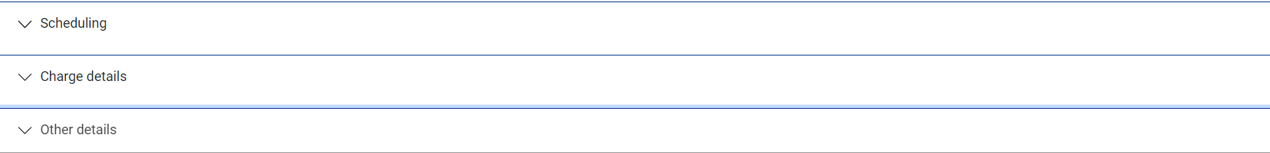

The window used to review and amend a factoring facility has the same fields as the factoring facility Create event (see page 55), but with additional fields for you to enter the date and reasons for the amendment. The Apply Reversal Postings field is shown only if the DoNotApplyReversalPostings system option is set to 'No'. Leave it checked if your bank has set up reversal postings for the Amend Factoring Facility event and wishes to apply them when the event is released.

The Changes button allows you - and reviewers and authorisers - to list those fields that have changed within the event. It opens a window that lists those fields whose value has changed and shows for each the value before the current event and the new value resulting from the event.

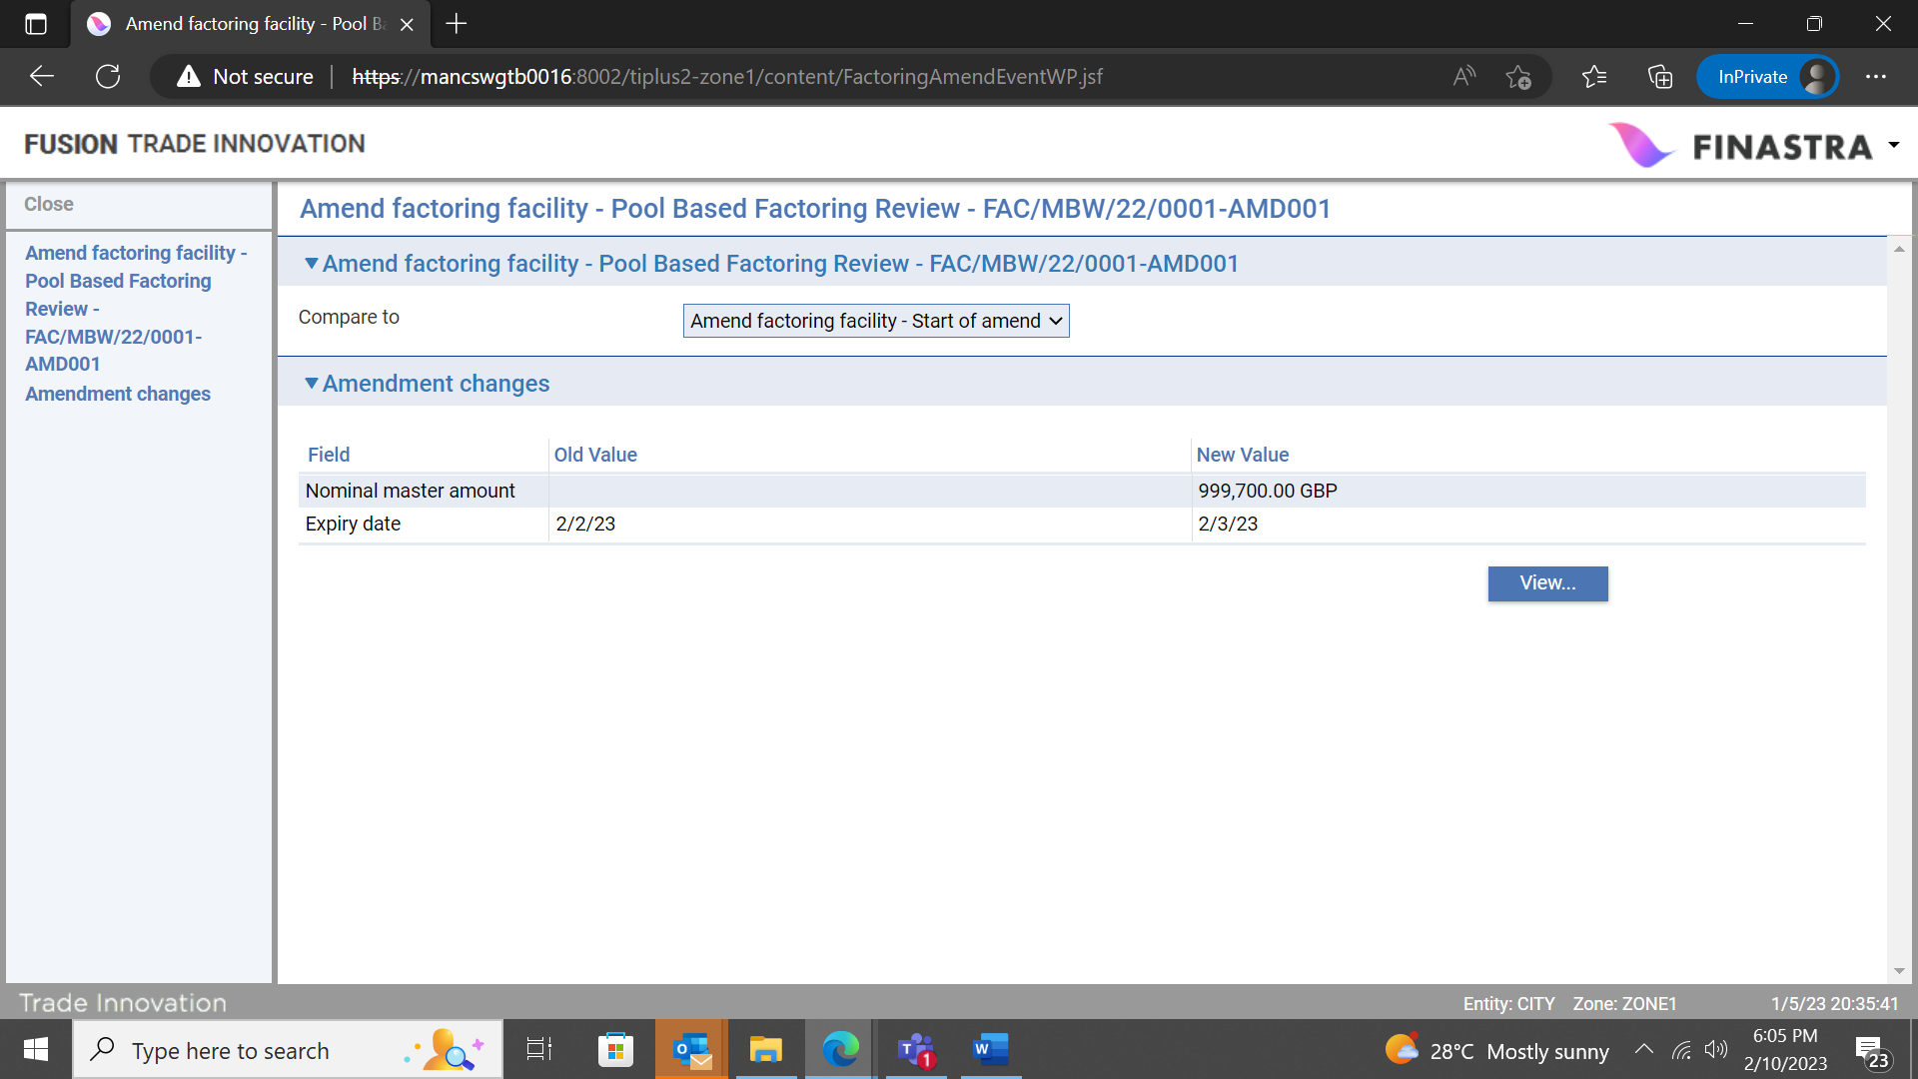

For fields where the value may not fit in the space available in this window (narrative fields, for example), you can select the field and Click the View button to see complete details.

## The Pool Based Factoring Facility Master Summary Window

Once you have created a factoring facility, the system will display its basic details using the Master Summary window.

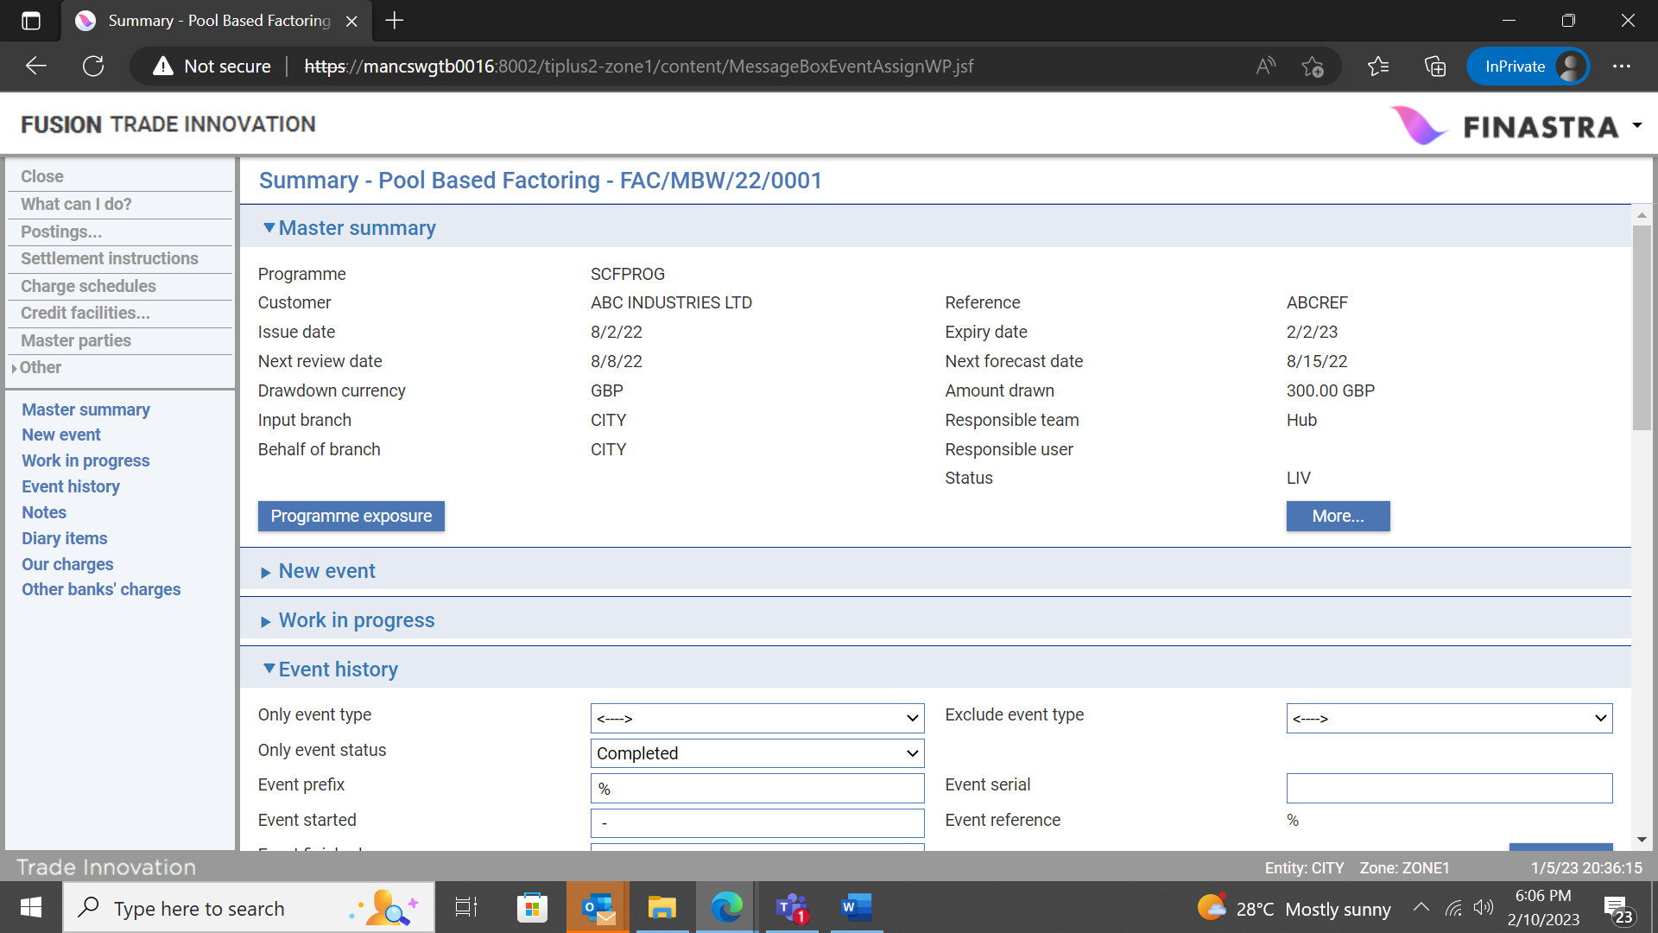

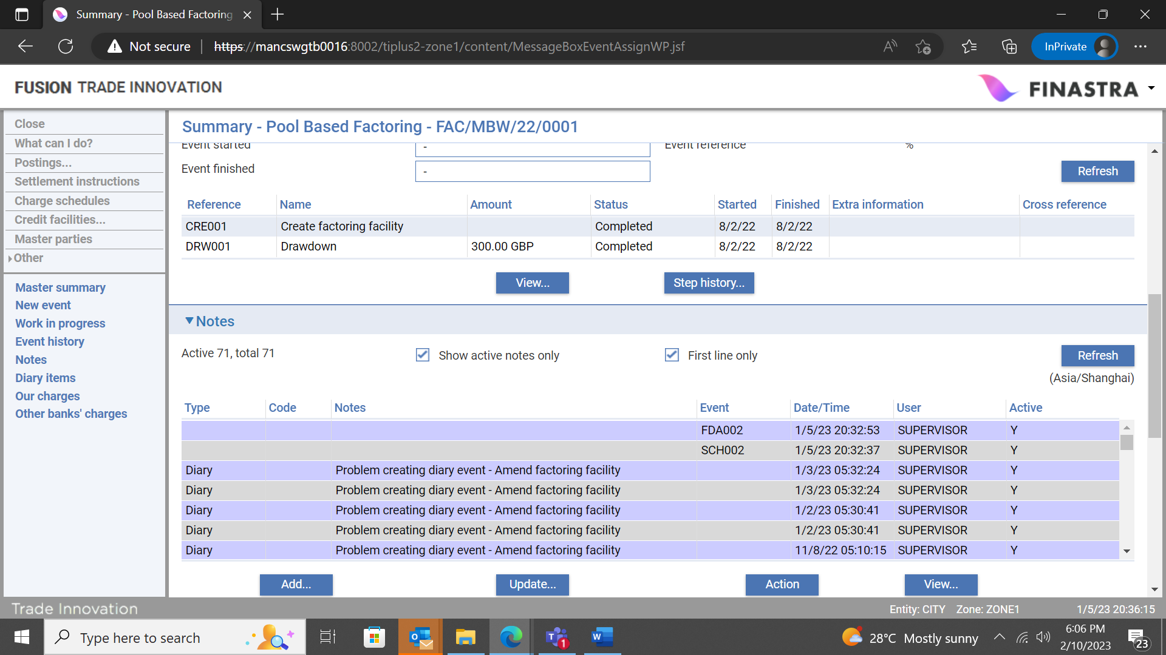

For more information on how the various panes and buttons in this window work see the Common Facilities User Guide – Trade Innovation.

The Programme Exposure button allows you to view customer exposure details (see page 90). To open the factoring facility subsequently, in the Supply Chain Finance Masters window set the ‘View...’ to Pool based factoring and enter the customer's unique ID into the Facility customer filter field, then Click Refresh. In the Master browser results pane, highlight the facility to be viewed and click the Open button to open the Master Summary Window for the specified customer's factoring facility.

If you do not specify a customer in the Customer filter field, then clicking the Refresh button returns a list of all facilities for all customers/programmes.

# Drawing down a Pool Based Factoring Facility

This chapter explains how Trade Innovation handles drawdowns against a pool based factoring programme.

Once a factoring master record has been created, the amount available to the customer for drawdown can be calculated using a Forecast Drawdown Availability event. Forecast Drawdown Availability events can be scheduled as diary events and occur automatically at regular intervals, as defined on the factoring master record. Your system may be configured so that you are required to manually intervene to complete an automatically generated Forecast Drawdown Availability event. Forecast Drawdown Availability events can also be initiated manually on an ad hoc basis when the customer requests them, or by an incoming customer gateway interface service message.

In addition to calculating the amount available for drawdown, the Forecast Drawdown Availability event also provides statistical data on activity against the factoring programme since the last Forecast Drawdown Availability event. This includes, for example, the number of invoices raised and the number of invoices settled since the last Forecast Drawdown Availability event. This information can be provided to the customer, and can also be used for charge calculation purposes.

For Forecast Drawdown Availability events scheduled as diary events, as one event is completed and released, the system automatically generates the next and places it in the diary.

The customer can ask to make a drawdown at any time. Drawdowns are handled using a Drawdown event. Drawdown requests can be received via the customer gateway interface service, in which case a Drawdown event is generated automatically but may need to be completed manually. You can also initiate a Drawdown event manually.

Once a Drawdown event has been released, the system generates any postings your bank has set up - for example, to debit the customer’s factoring account and to credit their settlement account. The relevant customer's credit limits and applicable buyer/seller limits are also updated to reflect the drawdown.

## Calculating the Amount Available for Drawdown

The amount available for drawdown by a customer is determined in relation to the value of eligible invoices (the criteria for eligibility are listed in the Appendix).

For each seller/buyer relationship your bank defines the percentage of the value of eligible invoices that is to count towards the amount available for drawdown. When Trade Innovation calculates the amount available for drawdown it does so in the following way:

* For the first buyer with eligible invoices it calculates the total amount of those invoices in the drawdown currency (using spot rate for any foreign exchange conversions that are necessary). It then applies the percentage set up for the relevant seller/buyer relationship to that total to arrive at an amount to count towards the available drawdown amount. This amount may be capped, if a buyer limit has been set for the seller/buyer relationship that is less than the amount calculated
* It then performs the same steps for the next and each subsequent buyer with eligible invoices in turn
* Finally, it adds together the amounts arrived at for each buyer to arrive at a total available drawdown amount. This amount may be capped by the customer's factoring limit available amount

## Manually Entering or Completing a Forecast Drawdown Event

An automatically generated Forecast Drawdown Availability event requiring manual completion can be opened from within the factoring master record’s Master Summary window in the usual way.

To create a Forecast Drawdown event manually, in the Master Summary window select 'Forecast Drawdown Availability' from the Create New Event drop-down list and click Create. Trade Innovation opens the event at either the Log step or the Input step, depending on how your system has been configured. The same fields are used by both steps.

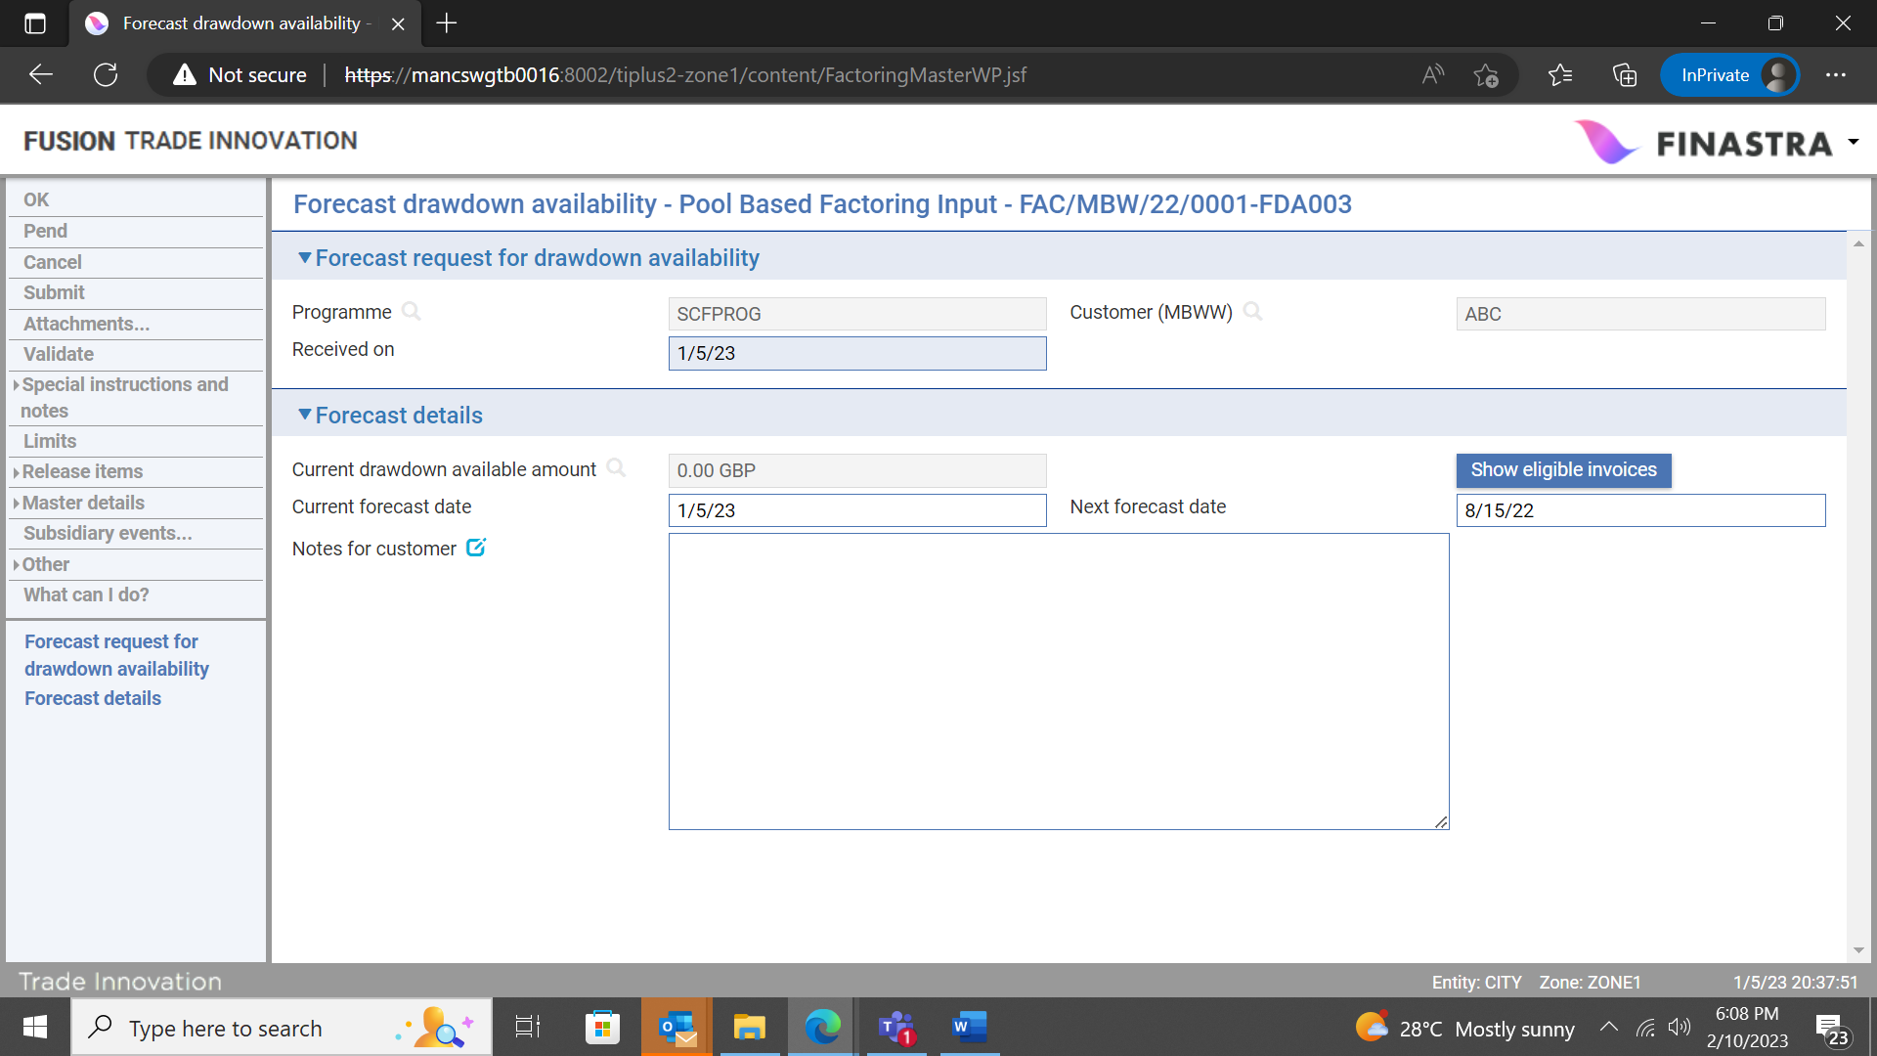

The Received On field records either the date the electronic message that initiated the event was received by your bank, or the date on which the event was initiated manually.

The Current Drawdown Available Amount field shows the amount currently available for drawdown. If the event has been left pending for any length of time, you can use the Recalculate button to recalculate the amount available for drawdown and update the figure displayed here.

The Current Forecast Date is the date on which the amount available for drawdown was calculated, and the Next Forecast Date is the date on which the next drawdown calculation will be made. This is calculated automatically according to the frequency for the Forecast Drawdown event entered on the factoring master record, but can be overridden.

The Notes for Customer field can be used to enter any relevant information for the customer.

The Show Eligible Invoices button displays details of the invoices taken into account when the amount available for drawdown was calculated.

During a Forecast Drawdown Availability event, the Other|Event Fields link can be used to view details of the amounts used to calculate the available amount. See the Common Facilities User Guide – Trade Innovation for instructions on using this link.

## Handling Drawdown Requests

A Drawdown event generated from a customer gateway interface service message but requiring manual completion can be opened from within the factoring master record’s Master Summary window (see page 55) in the usual way.

To open a Drawdown event manually, in the Master Summary window select 'Drawdown' from the Create New Event drop-down list and click Create. (This option is available in the drop-down list only if one or more eligible invoices exist against the factoring programme.)

Trade Innovation opens the event at either the Log step or the Input step, depending on how your system has been configured. The same fields are used by both steps.



If the event has been left pending for any length of time, you can use the Recalculate button to recalculate the amount available for drawdown and update the figure displayed here.

The Show Eligible Invoices button displays details of the invoices taken into account when the amount available for drawdown was calculated.

The following table explains what to enter into the fields in this window:

|  |  |  |
| --- | --- | --- |
|  | Field | What to Enter |
|  | Received On | Either the date the electronic message that initiated the event was received by your bank; or, for manually initiated events, the current processing date. |
|  | Instructions Received | Any instructions received from the customer. |
|  | Current Drawdown Available Amount | Trade Innovation displays the amount currently available for drawdown. The Show Eligible Invoices button displays details of the invoices taken into account when the amount available for drawdown was calculated.  If the event has been left pending for any length of time, you can use the Recalculate button to recalculate the amount available for drawdown and update the figure displayed here. |
|  | Drawdown Amount | The amount of the drawdown, in the customer’s drawdown currency. Trade Innovation uses as the default the amount currently available for drawdown, which can be overridden to be a lesser amount.  You can enter a foreign exchange deal in the usual way to accommodate payment or receipt of funds in a currency other than that of the invoice. See the Common Facilities User Guide – Trade Innovation for instructions. |
|  | Drawdown Date | This field must be set to the current processing date - the system issues an error message if this is set to any other value. This is the date to be used as the value date on postings generated by the drawdown. |
|  | Notes for Customer | Any information for the customer regarding the drawdown request. |

## When the Drawdown Event Completes

Upon completion of the Drawdown event’s Input step the system carries out credit limit checking against the customer factoring limit held in the credit risk management system your bank uses.

It performs a limit check against the customer's (factoring) credit limit which, which, if successful, makes a reservation against the limit using the drawdown amount. Standard limit checking processing is applied to the event as it progresses.

Upon release of the event, the reservation is recorded as exposure against the customer's (factoring) credit limit.

Similarly, respective seller/buyer limits are updates.

## Displaying Invoice Details



The window lists all the invoices taken in to account when calculating the amount available for drawdown. Information is shown under the following headings:

|  |  |
| --- | --- |
| Heading | What it Shows |
| Buyer | The buyer against whom the invoice was raised. |
| Invoice Reference | The invoice's reference. |
| Master Reference | The reference of the invoice's master record. |
| Invoice Amount | The face value of the invoice. |
| Buyer Percent | For each buyer your bank specifies what percentage of the value of eligible invoices is to be made available to the customer for drawdown. The percentage to be used for this buyer (as defined for the seller/buyer relationship) is shown here. |
| Available for Drawdown | The amount contributed to the total amount available for drawdown by this invoice, in the drawdown currency. Spot rate is used for any foreign exchange conversions. |

# Financing Invoices in Trade Innovation

Instructions to finance invoices may be received in electronic format via the customer gateway interface service, in which case they automatically create a new finance event, or you can create the finance event manually via the SCF Masters browser.

It is possible to finance a single invoice, or multiple invoices under a single finance deal, provided that they are for the same currency, settlement date, buyer/seller combination and programme.

The invoices must be eligible for financing. The Appendix (page 88) lists the criteria governing eligibility for financing.

As a Finance Create Event is released, the related invoices are flagged as 'Financed' and each invoice’s status is changed so that it is no longer eligible for financing.

1. The Invoices for financing Create event, Settle Invoice, Amend Invoice and Cancel Invoice events are mutually exclusive. You cannot initiate a Financing create event while there is an Amend Invoice, Settle Invoice or Cancel event in progress. Conversely you cannot initiate an Amend Invoice, Settle Invoice or Cancel event when there is a Finance Invoice event in progress.

## Creating a Finance Deal in the SCF Masters Browser

To create a finance deal manually in the SCF Masters browser, in the Master browser filters pane, from the drop-down list set the ‘View...’ to ‘Invoices for financing’ and click the Refresh button. Trade Innovation returns a list of all invoices available for financing.

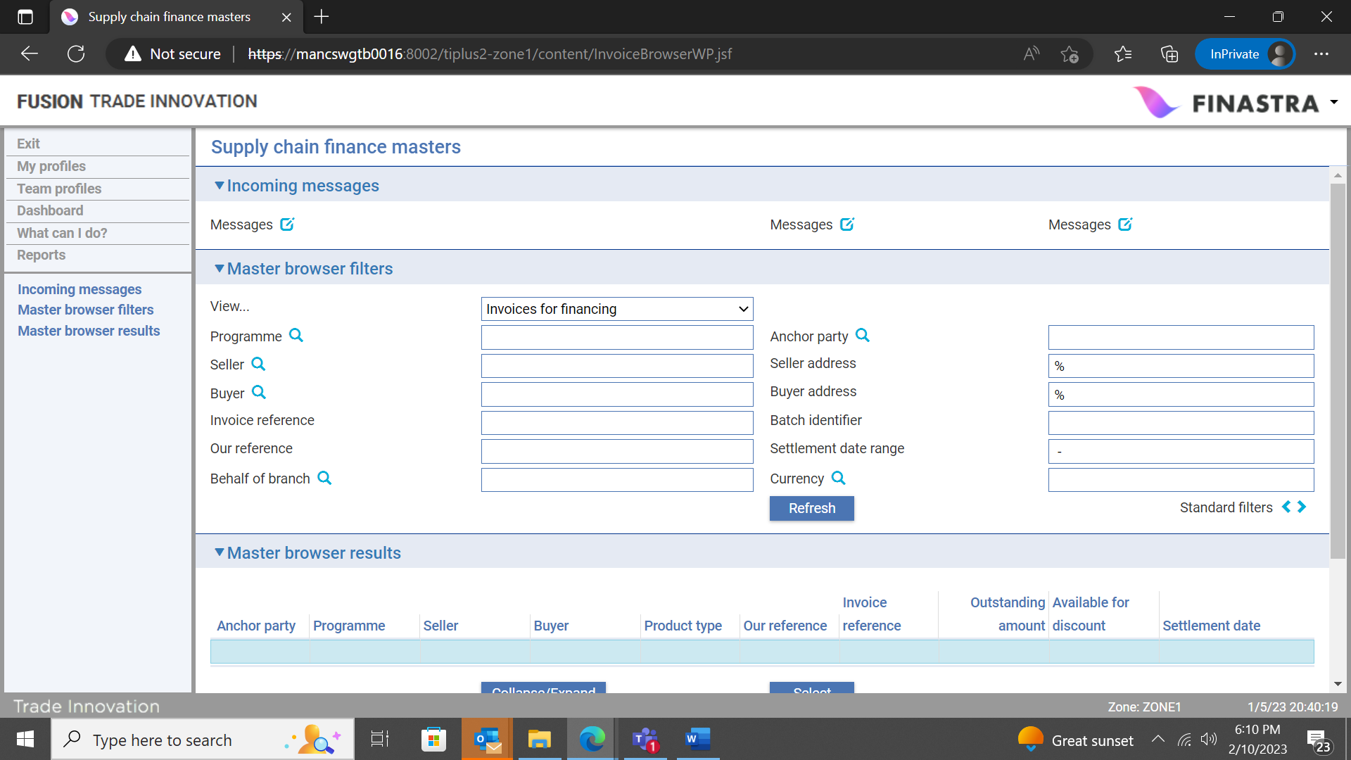

The filters available in the Master browser filters pane allow you to display invoices available for financing matching the eligibility criteria.

## The Master Browser Results Pane

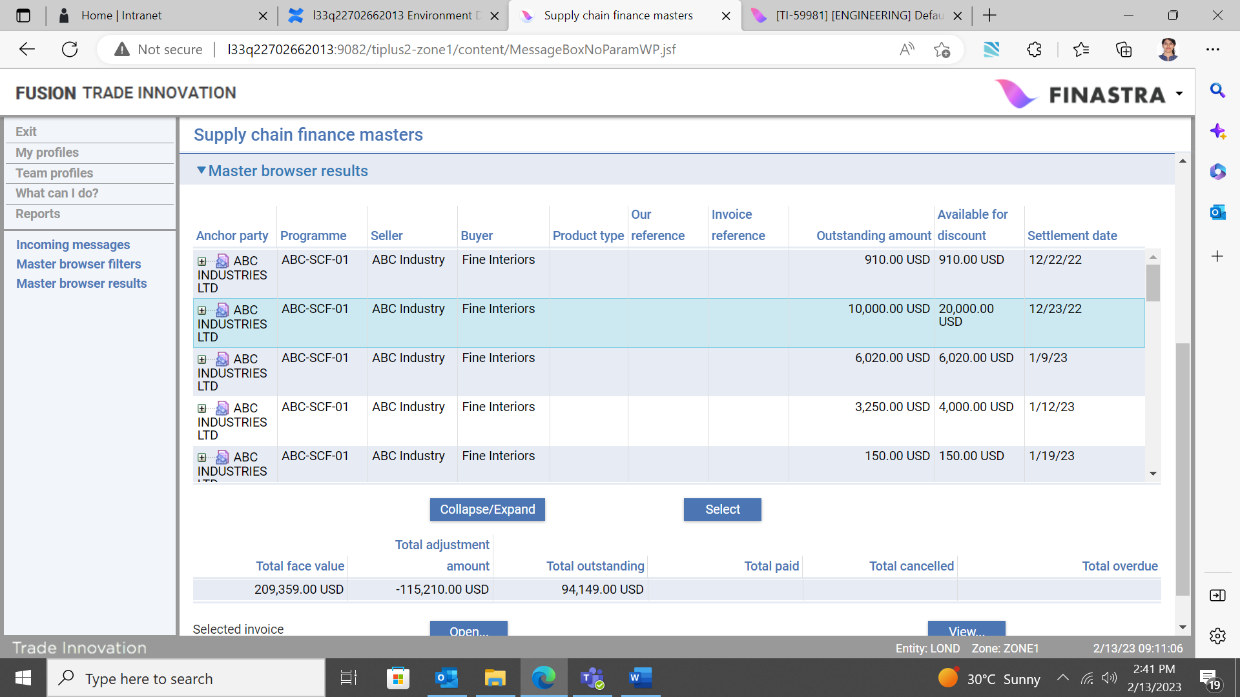

The Master browser results pane displays a list of all invoices available for financing, grouped in single rows subject to the bulk finance criteria (see page 90 for details).

For buyer centric finance, eligible invoices must also have been ‘Approved’ for financing by the buyer (see page 88 for details).

It is possible to expand each row via the ‘Total +’ symbol, or the ‘Collapse/Expand’ button. This has the effect of displaying further rows, listing each individual invoice included in the group. The rows may also be collapsed if required.

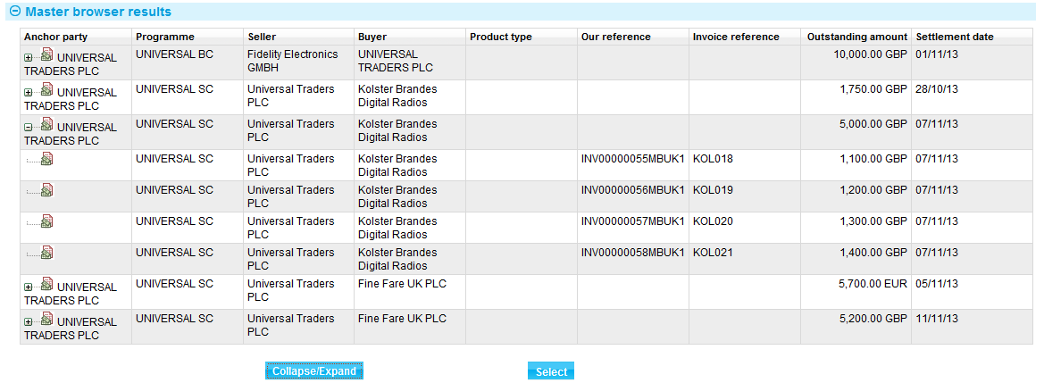

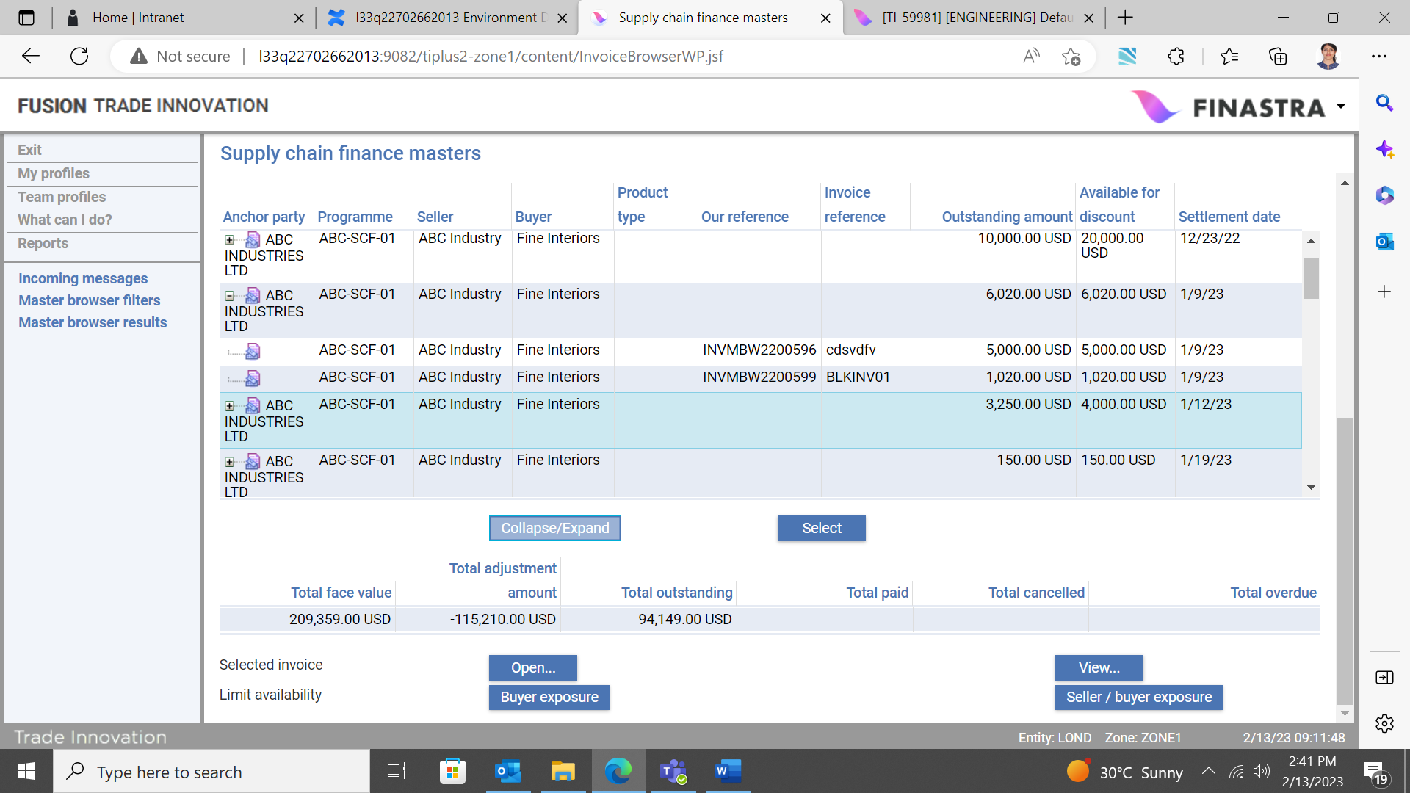

## The Invoices to Finance Pane

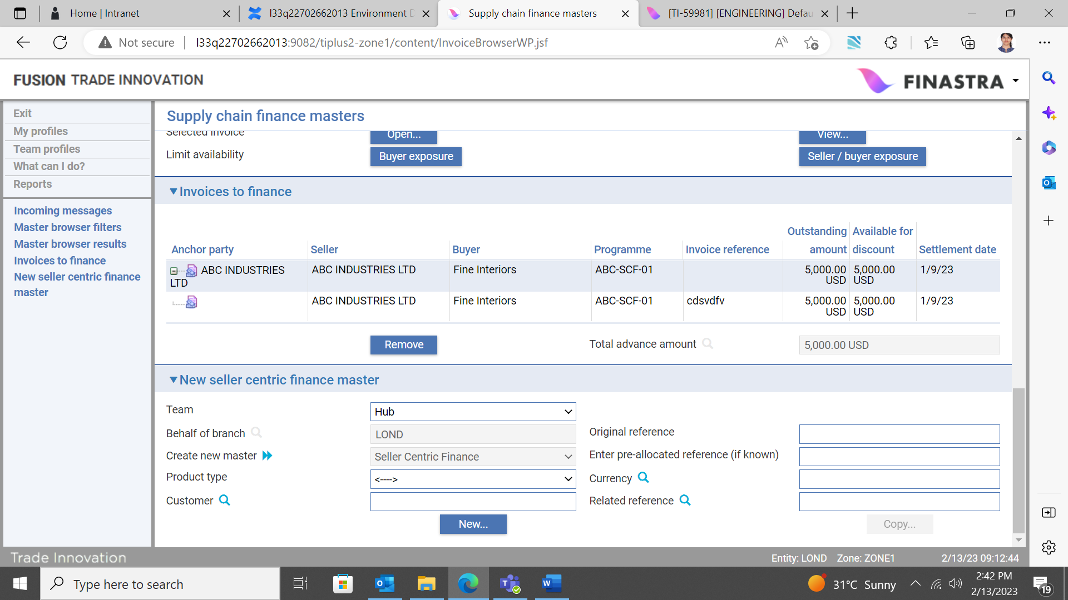

To create a new finance deal, you must select one or more invoices from those listed in the Master browser results pane. The above criteria must be met in order to create the finance deal.

Highlight a single invoice or group of invoices and click the Select button. When a single invoice or group of invoices is selected a new ‘Invoices to finance’ pane is opened and those invoices selected for financing are listed.

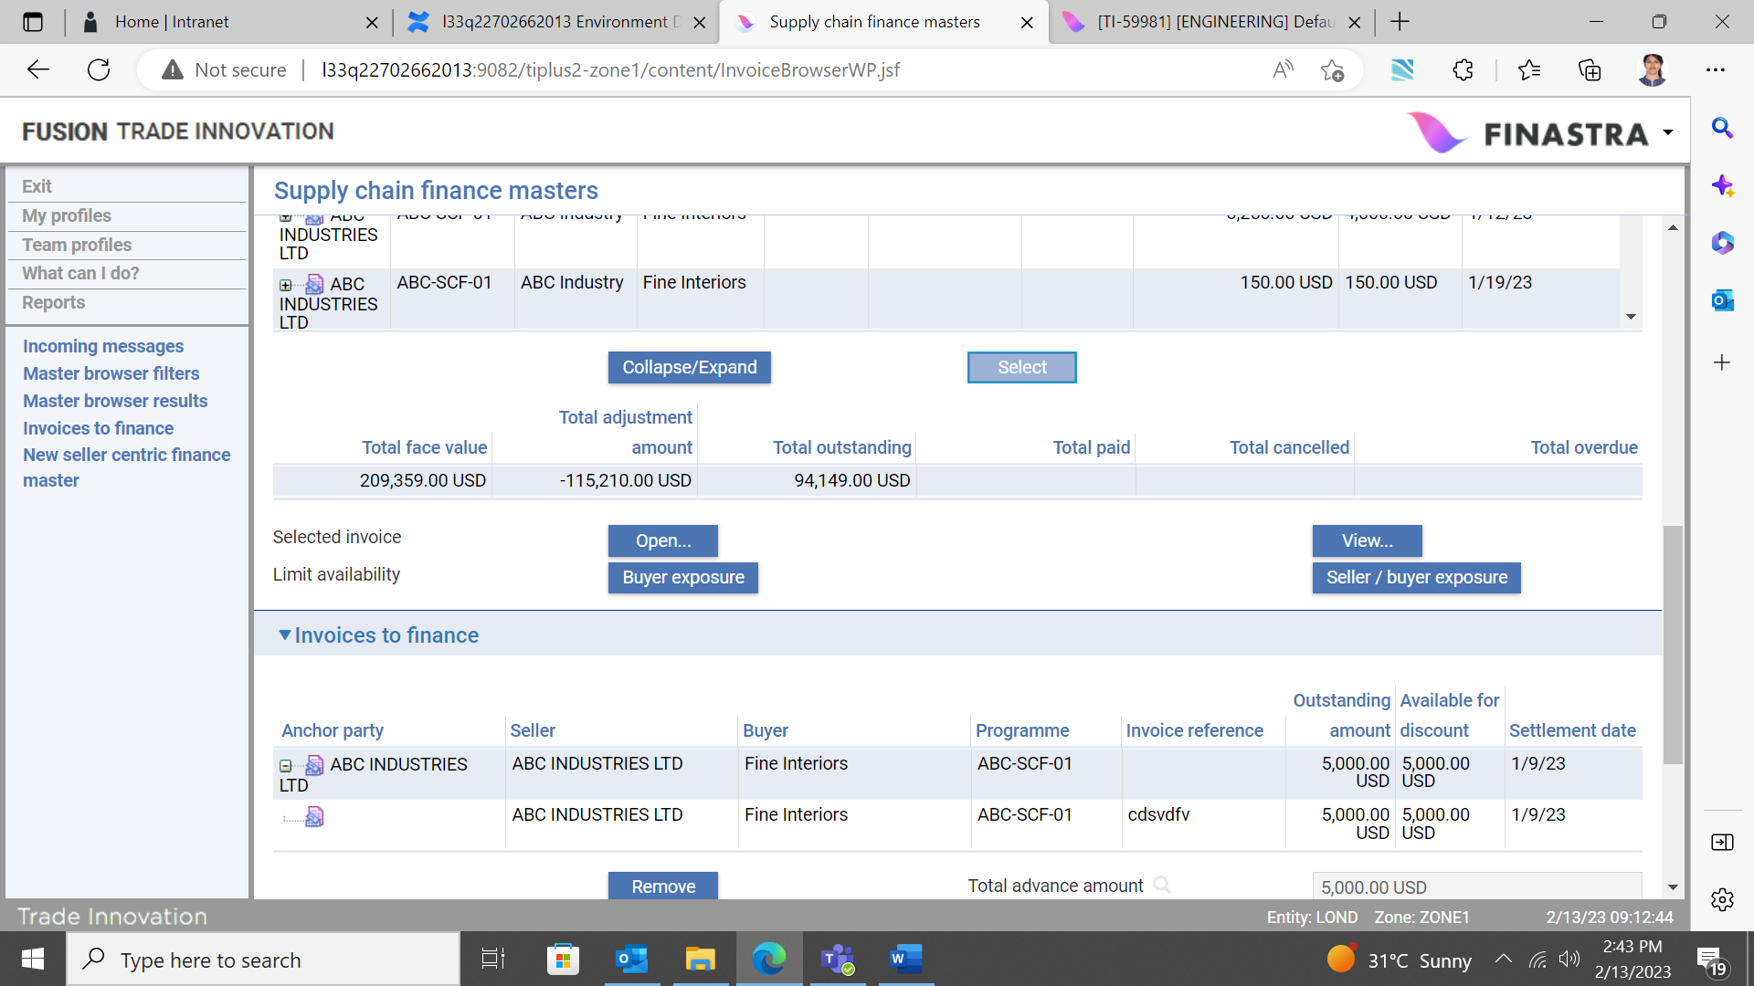

It is possible to add further invoices provided that the criteria are met and all invoices are due for settlement on the same date. Also, by using the ‘Remove’ button, one or more invoices may be deleted from the list of those to be financed.

The amount to be financed determined from the selected invoices is displayed in the ‘Total advance amount’ field and this automatically updates as invoices are add to, or removed from, the list of those to be financed.

## The New Seller/Buyer Centric Finance Master Pane

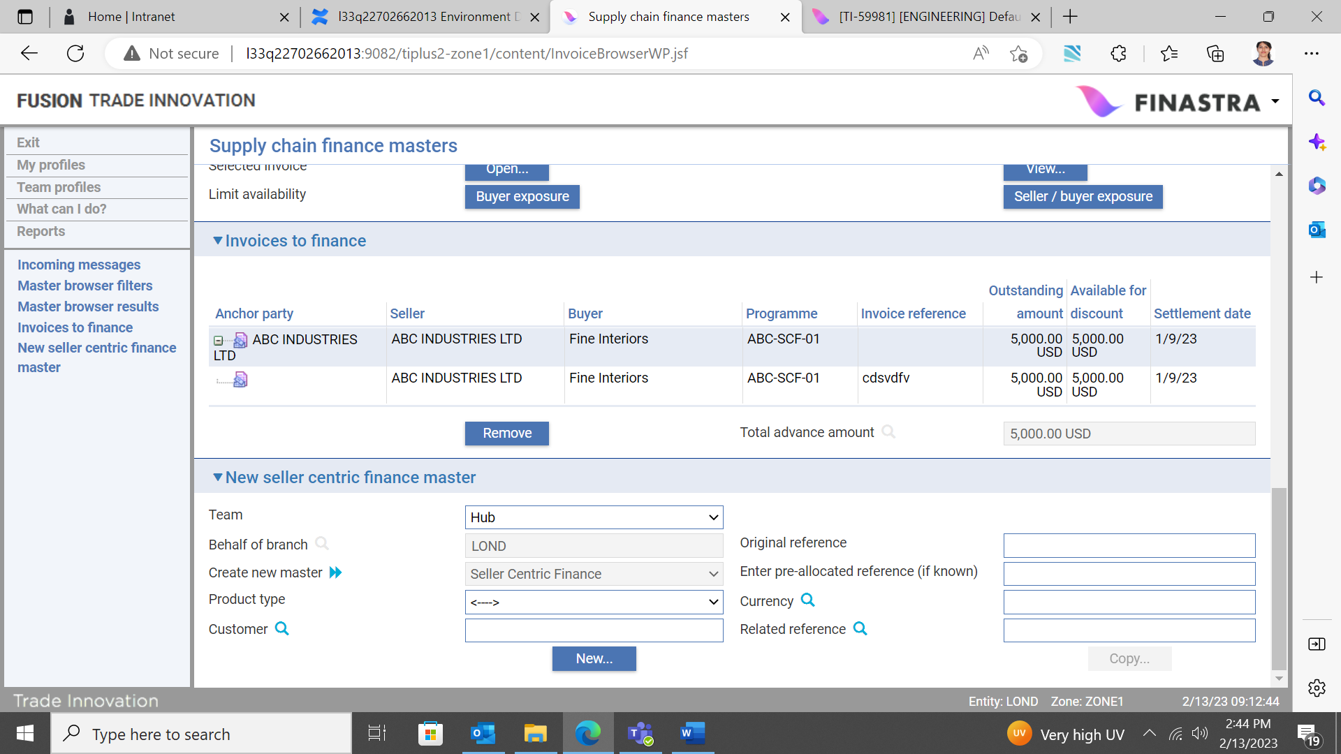

When you have selected all invoices to be financed, the finance deal is created by clicking the ‘New’ button in the ‘New seller/buyer centric finance master’ pane.

Depending on how your system is configured, the following mandatory fields may automatically default; otherwise data must be entered manually:

* Team
* Behalf of branch
* Create new master

The following optional filters are also available if required:

* Enter pre-allocated reference (if known)
* Product type
* Currency
* Customer
* Related reference

### Cancelling the Finance Create Event after Clicking the ‘New’ Button

Note that once you have clicked the ‘New’ button and the finance event is created, it must be cancelled and aborted in the event that a mistake has been made (i.e. you have selected an incorrect invoice, thus resulting in the total advance amount being wrong), or you do not subsequently want to finance the selected invoices. However, if the event is completed, it may also be subsequently cancelled via the Cancel Finance event (see page 84).

If you do cancel and abort the event, the selected invoices are reinstated and will be available for financing once again.

## The Create Seller/Buyer Centric Finance Event

Trade Innovation creates a Create seller/buyer centric finance event at the Input step. The window used to enter details of the finance deal has the following panes:

* Invoices for discount (see page 73)
* Party details (see page 74)
* Financing details (see page 73)
* Interest details (see page 75)
* Repayment schedules (see page 78)
* Collateral (see page 80)
* Other details (see page 80)
* Charges (see page 81)
* Foreign exchange deals (see page 81)
* Party list (see page 81)

## The Invoices for Discount Pane

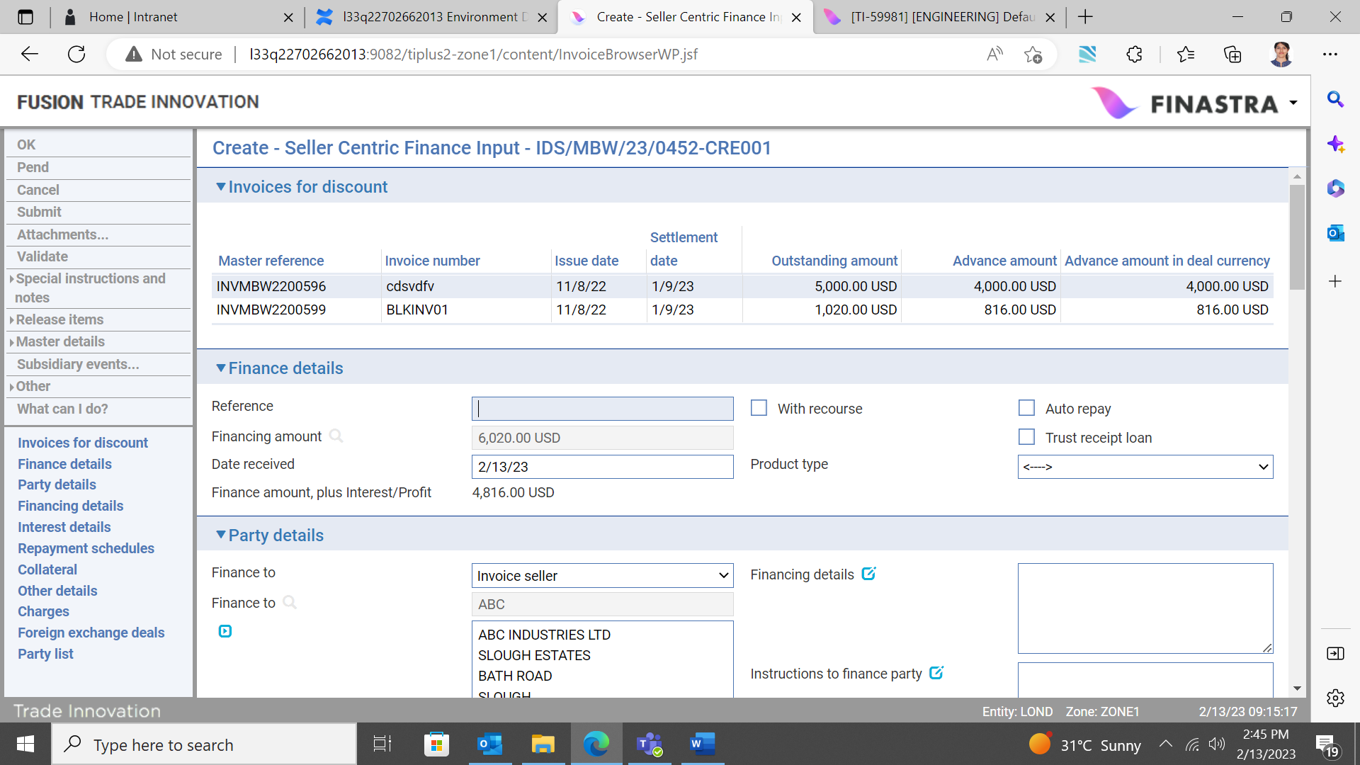

When the event opens, the Invoices for discount pane displays a list of all invoices selected for financing in the particular deal.

## The Finance Details Pane

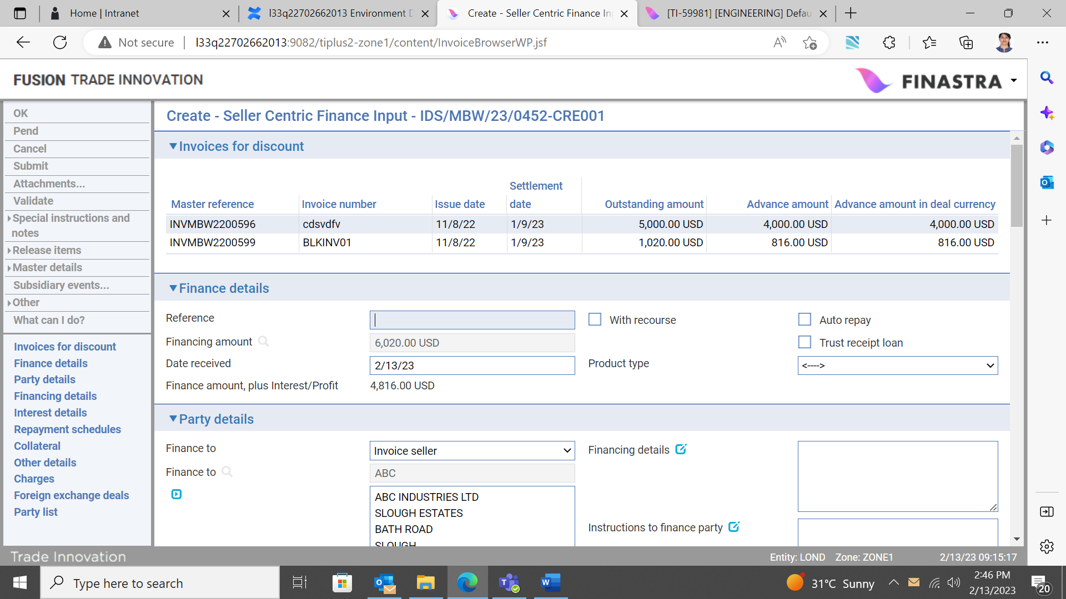

The following table explains what to enter into the fields in the Finance Details pane:

|  |  |  |
| --- | --- | --- |
|  | Field | What to Enter |
|  | Reference | The borrower's reference for the financing transaction. |
|  | Financing Amount | Total outstanding amount of selected invoice(s) use to initiate a finance deal. |
|  | Date Received | The date the request for finance was made. Trade Innovation uses today's date as the default. |
|  | With Recourse | Check this box if the payment is with recourse to the financing party in case of non-receipt of funds from the debit party. |
|  | Auto Repay | Check this box if scheduled repayments are to be processed and released automatically. If you check this box, the system generates the necessary postings for repayments automatically (provided that postings have been set up) as repayments fall due, using funds deducted from the designated account.  If you leave this box unchecked, or if insufficient funds are available in the designated account when a scheduled repayment falls due, then you will be required to process the repayment manually. |
|  | Product Type | The type of financing transaction. This field is used to differentiate between financing transactions for the purposes of accounting, risk management and reporting. Both buyer and seller centric finance products can be further differentiated by the use of product type.  Depending on how your system is configured, this field may be mandatory. |
|  | Provisional | Check this box if you are making an offer of finance to the finance to party. |
|  | Automatically create follow- on event | Check this box if you are making an offer of finance to the finance to party. |

### Finance Offers

Depending on your bank’s business process, you may want to make an offer of finance to the Finance to party, detailing the interest rate, period of finance etc. However, you must define your own message/advice which can be sent to the Finance to party.

If you wish to make an offer, you can use Trade Innovation’s provisional event functionality.

A ‘Provisional’, Create event is generated and is held in a ‘Pre-live’ state until a response is received from the Finance to party.

The following two flags must be set in the Create event:

* Provisional - This flag is defaulted from Event Options and means that the event (e.g. CRE001) can be completed in a ‘Provisional’ state. This is set where the finance offer needs to be made to the seller.
* Automatically create follow-on event – This is also defaulted from Event Options and means that the next iteration of the event (e.g. CRE002) can be completed in the final state if required, upon receipt of the seller’s response to the finance offer.

Please refer to the *Common Facilities User Guide* – Trade Innovation for more details about provisional event functionality.

## The Party Details Pane

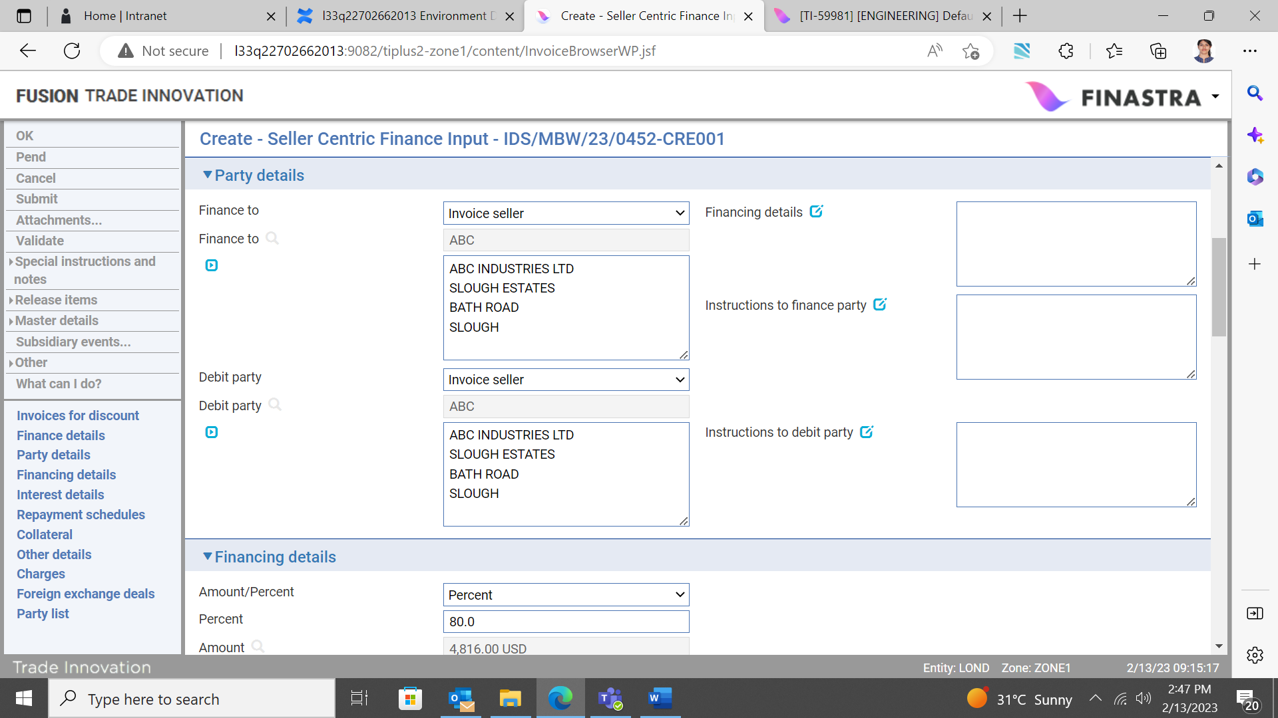

The following table explains what to enter into the fields in the Party Details pane:

|  |  |  |
| --- | --- | --- |
|  | Field | What to Enter |
|  | Finance To | The borrower. The invoice seller for both buyer and seller centric transactions. uses details taken from the invoice parties. The default value for this field is derived from the programme set-up. |
|  | Debit Party | The party who is meant to repay the finance. The finance liability is meant to be recorded against the anchor party. The buyer for buyer centric finance transactions, or the seller for seller centric finance transactions. Trade Innovation uses details taken from the related programme. The default value for this field is derived from the programme set-up. |
|  | Financing Details | A narrative description of the financing transaction. |
|  | Instructions to Finance Party | Any instructions, for example terms and conditions of the financing transaction, for the borrower. |
|  | Instructions to Debit Party | Any relevant instructions for the debit party. Only if any information can be disclosed providing the debit party is set from the buyer. |

## The Financing Details Pane

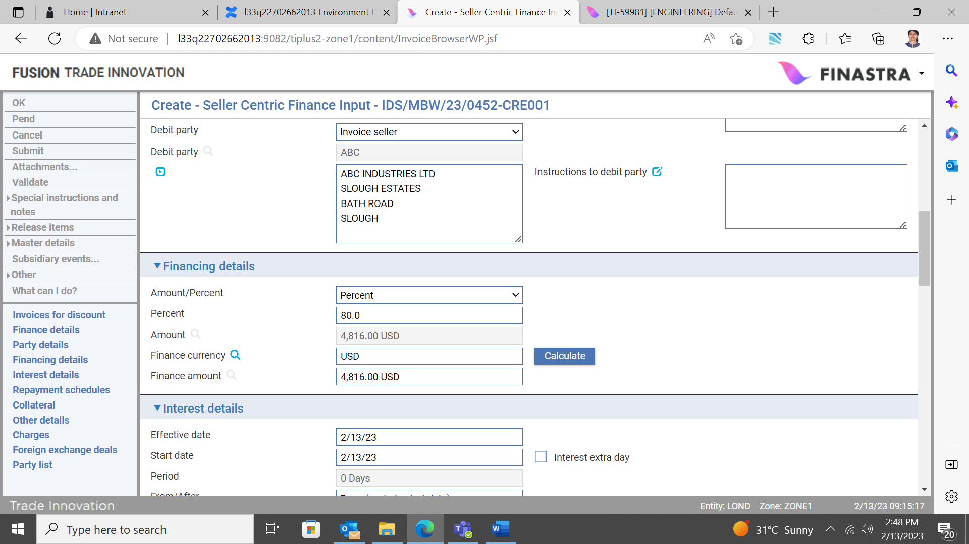

These are automatically defaulted. Use the fields in the Financing Details pane to indicate the amount of the finance/advance.

If you have entered one or more foreign exchange deals the system displays their total value and currency, which cannot be amended. Otherwise use the Amount/Percent field to select whether you are defining the advance as an amount or as a percentage of the financing transaction. Trade Innovation uses as the default the finance percentage set up for seller/buyer relationship for the related programme. This value may be manually overridden by the user with provision to generate a bank defined alert message for the user.

To define the amount of the advance as a percentage, select 'Percent' in the Amount/Percent field, then enter the percentage into the Percent field.

To define the advance as an amount, select 'Amount' in the drop-down list and enter the amount into the Amount field.

You can use the Finance Currency field to select a currency for the advance that is different from the currency of the transaction. Clicking the Refresh button displays an extra field - Exchange Rate - that you can use to identify the exchange rate to be used to convert the loan amount from the financing transaction currency.

When you click Refresh the system calculates and displays the finance amount.

## The Interest Details Pane

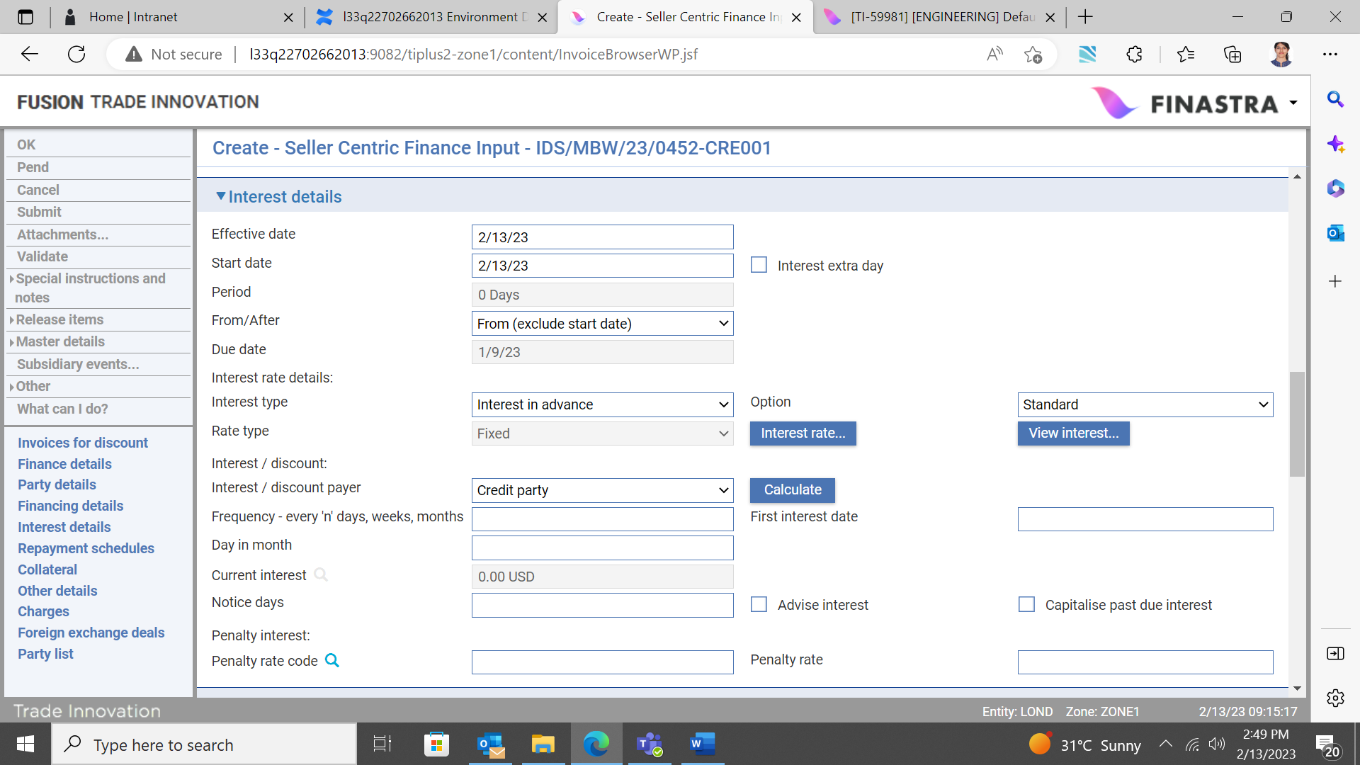

Depending on how your system is configured, the interest details displayed in the Interest Details pane may be retrieved from the back office, or from defaults held within the Trade Innovation system.

Interest can be defined as one of the following types:

* Interest in advance, calculated at inception uses the standard interest formula; collection set for in advance Interest in advance - interest to yield, calculation at the inception uses the interest to yield formula; collection set for in advance
* Interest in arrears, calculation at the inception uses the standard interest formula; collection set for in arrears

If an interest type has been specified as part of the product type to which the financing transaction belongs, that interest type will be automatically selected as the default value.

### Interest

Interest rate determined from the appropriate interest schedule or manually entered by the user is considered fixed for the whole term of the finance deal.

Trade Innovation display details of the default interest rate type schedule for the buyer or seller centric finance deal. The first fields in this window show the currency and, if relevant, whether the schedule is defined to provide a special interest rate for the branch and/or customer. The Narrative field displays any additional information about the schedule.

The actual interest rate is provided in the first Interest Rate field. You can amend this, and other details of the schedule.

Refer to the *System Tailoring User Guide* – Trade Innovation for details on how to set up interest schedules and tiers.

#### Interest in Advance or Arrears



In the Interest Type field select 'Interest In Advance' or 'Interest In Arrears' and click Calculate. The following table explains what to enter into the fields displayed to define interest in advance or in arrears:

|  |  |  |
| --- | --- | --- |
|  | Field | What to Enter |
|  | Effective Date | The start date of the financing transaction, which cannot be later than today's date. |
|  | Start Date | The start date for interest calculations. Trade Innovation uses the current processing date as the default here.  When the financing transaction becomes operative depends on the FinanceOperativeOnEffectiveDate system option. If this system option is set to Yes, financing transactions become operative on the Effective Date. If it not set or set to No, they become operative on the Start Date. |
|  | Period | The financing period.  Trade Innovation displays the term of the advance, calculated as the period between the advance date and the maturity date. |
|  | From/After | Indicate whether the period defined in the previous field is 'From' or 'After' the Start Date. If 'After', then the tenor will be calculated to start after the Start Date (that is, one extra day of interest). |
|  | Due Date | The settlement date of the invoice(s) being financed and due date of the financing transaction, which must be later than the start date for interest calculations. |
|  | Interest rate details: Interest type | Whether interest is in advance or arrears.  For interest in advance select from one off the following options:   * Standard * Interest to yield   For interest in arrears, the system defaults to:   * Standard |
|  | Rate Type | For interest in arrears select from one of the following:   * Fixed * Special * Variable   If a value has been set up as part of the options for the product type the system uses it as the default. |
|  | Interest/Discount Payer | The party who will pay the interest - the credit party or the debit party. |
|  | First Interest | The date the first interest payment is due. The default is derived from the values of ‘Day in month’ and ‘Frequency’ of the processing date or start date (whichever is later) as the base date.  Where the default falls on a non-business day and is not the end of the month, then the system automatically adjusts the date based on the set-up of the *InterestSetNextCycleDate* general system option. |
|  | Frequency | Define how often interest payments are to be made. The default is derived from the set-up on the product type. |
|  | Day In Month | If you define interest frequency as being in months, or longer, enter the day of the month on which the interest is to fall due. The default is derived from the set-up on the product type. |
|  | Projected Next Interest/Discount | Once you have entered details of the interest rates to be applied the system calculates and displays:   * For interest in arrears the interest amount due for the first period * For interest in advance the interest due on the first interest repayment date |
|  | Notice Days | If the party paying the interest requires notice of penalty interest, enter the number of days prior to the date of the repayment notice is required. The default is derived from the set-up on the product type. |
|  | Transit Interest | For interest in arrears, check the box if transit interest is to be applied. |
|  | No of Days for Transit Interest | The number of days for which transit interest is to be applied. |
|  | Interest Rate | The interest rate to be used for transit interest. |
|  | Advise Penalty Rate | If the party paying the interest requires notice of penalty interest, check this box. |
|  | Penalty Rate Code/Penalty Rate | The penalty interest rate to be applied in addition to the normal interest rate for overdue payments. Either enter a predefined code into the first field, or enter the rate to be applied using the second field. If a value has been set up as part of the options for the product type the system uses it as the default.  Alternatively a past due specific interest schedule can be defined. |

## The Repayment Schedules Pane

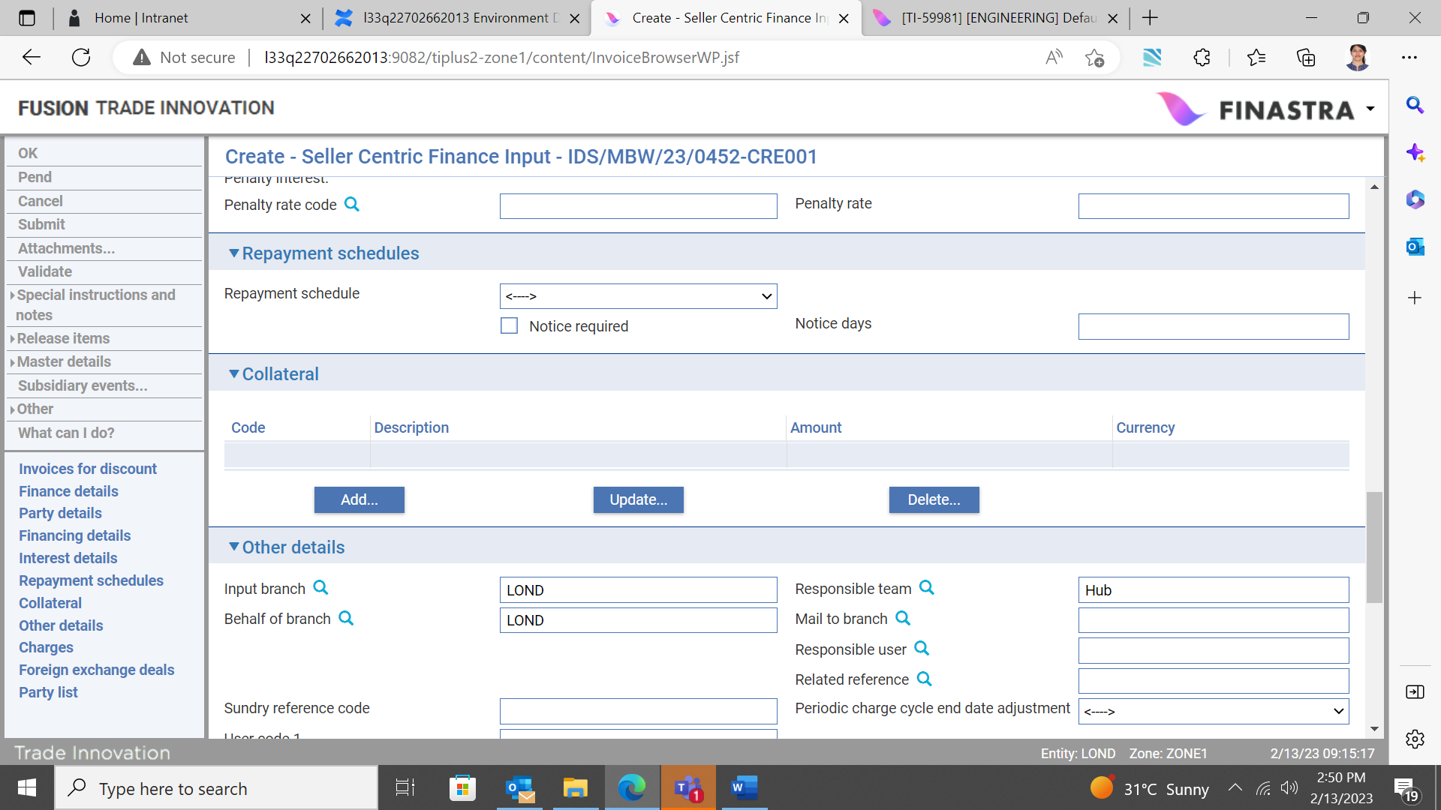

The Repayment Schedules pane permits you to define schedules for the repayment of principal. Schedules can be regular or irregular.

### To Define a Regular Repayment Schedule

To define a regular repayment schedule check the Regular box. Trade Innovation displays additional fields.

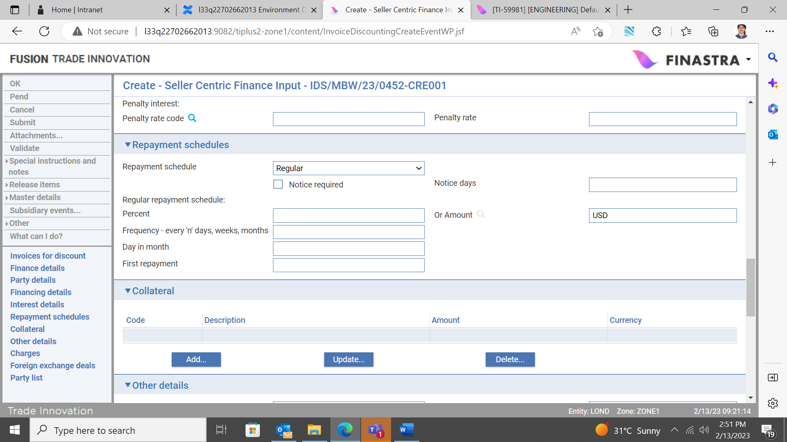

The table below explains what to enter into the fields used to define a regular repayment schedule:

|  |  |
| --- | --- |
| Field | What to Enter |
| Notice Required | If the borrower requires notification of repayments before they are due check the Notice Required box. |
| Notice Days | Indicate how soon before the repayment the notification is to be produced. |
| Percent/Or Amount | Specify the amount of each repayment. You can specify this as a percentage of the original financing transaction using the first field, or as an amount in the currency of the financing transaction using the second field.  If you enter values in both fields, the value entered into the Or Amount field will be ignored. |
| Frequency | The frequency at which repayments are to be made. |
| Day in Month | If you define repayment frequency as being monthly or longer, enter the day of the month on which the repayment is to fall due. |
| First Repayment | Trade Innovation applies the frequency defined in the Frequency field to today's processing date to work out the date the first repayment is due, then displays the date here.  You can overtype this date, if required. |

### To Define an Irregular Repayment Schedule

To define an irregular repayment schedule check the Irregular check box and click Refresh. The system displays an additional pane.

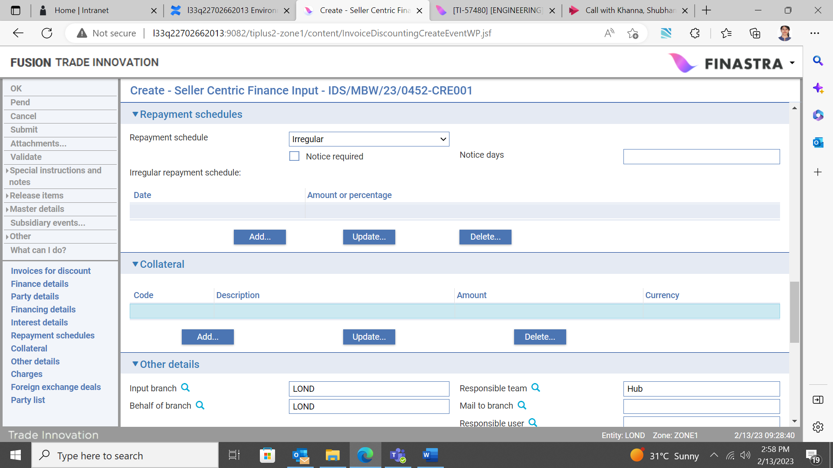

Click Add.

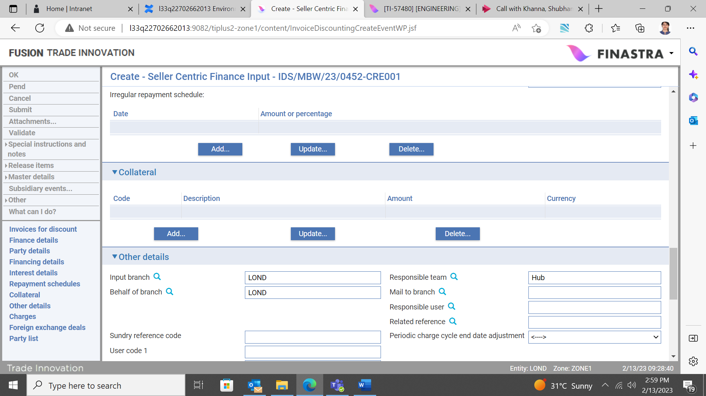

In the window that appears use the Date field to identify the date of the repayment, and then enter the amount of the repayment either as a percentage or as an actual amount using one of the two fields provided.

Click OK to save the repayment details.

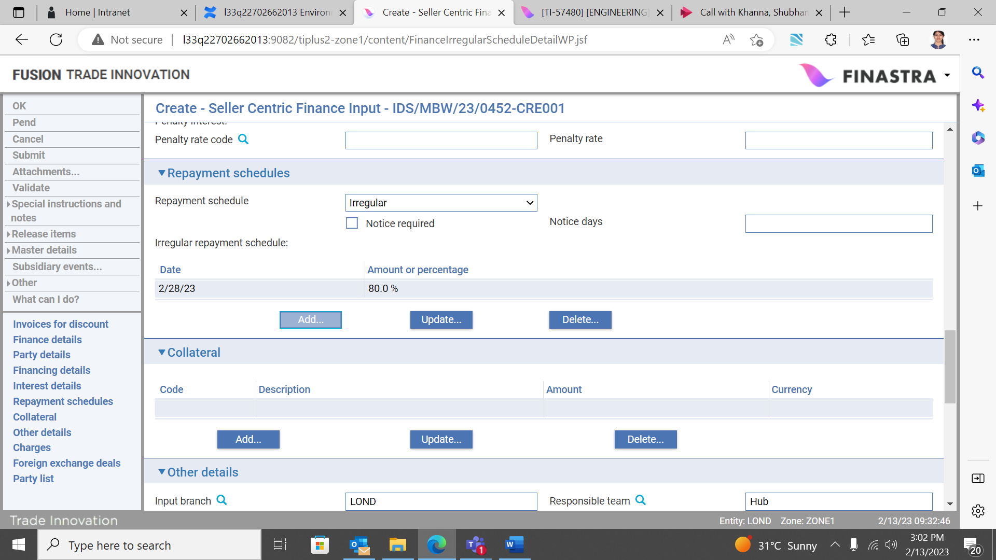

Trade Innovation closes the window and displays details of the repayment in the Repayment Schedules pane. Repeat the process to define each of the remaining irregular repayments in turn. Repayments do not have to be defined in chronological order, and you can mix repayments defined as a percentage with repayments defined as an amount.

The system checks that the value of all the repayments does not exceed the amount of the financing transaction as part of the general validation of the event.

You can amend or delete entries listed in this pane in the usual way using the Update and Delete buttons.

## The Other Details Pane

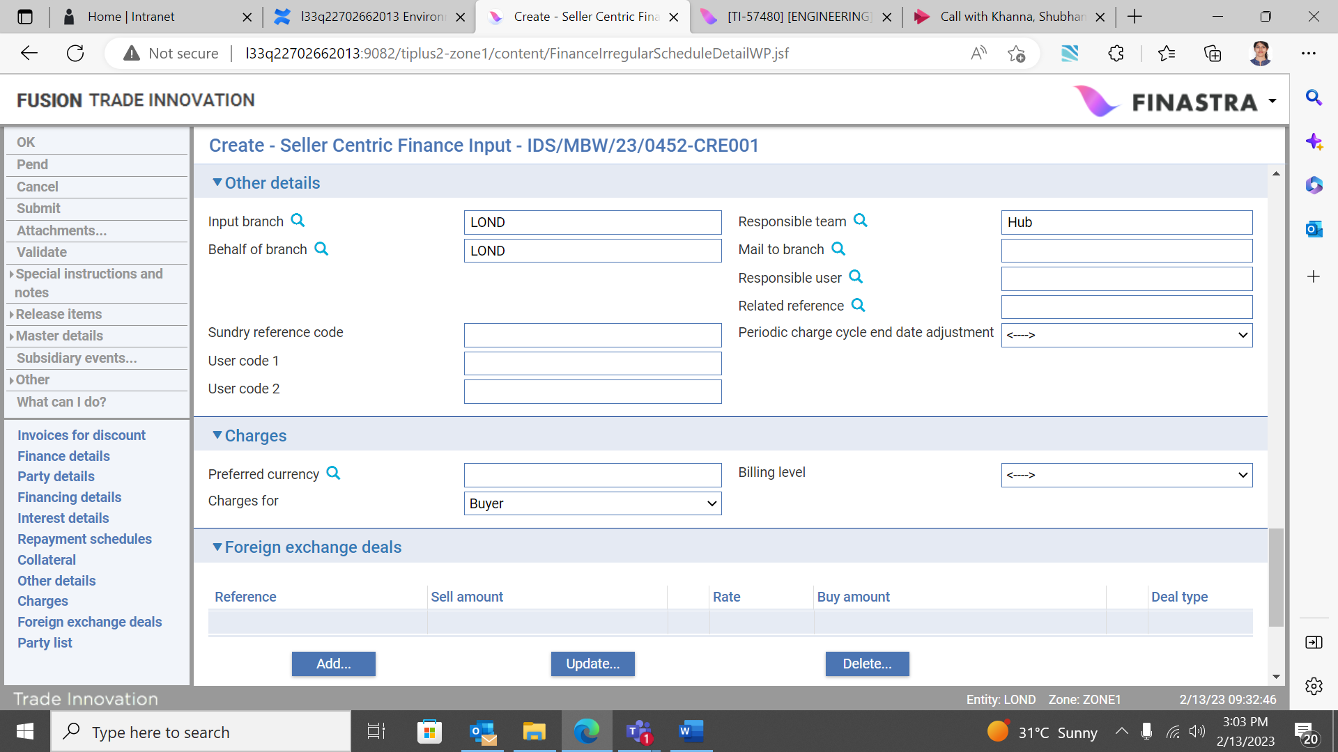

The following table explains what to enter into the fields in the Other Details pane:

|  |  |
| --- | --- |
| Field | What to Enter |
| Input Branch | The input branch for the transaction. The input branch is set from the either :   * the accounting branch from the user’s team, or * the transaction branch for user if the user has a default transaction branch or is locked to a specific branch, or * a branch associated with the user where the user can enter transactions for several branches for a team |
| Behalf Of Branch | The behalf of branch for the transaction as entered by the user or set from the incoming SWIFT or gateway message. The behalf of branch determines the parameter sets that are to be used to generate charges, documents, postings, etc. during transaction processing. The branch can be changed to any other branch within the same main banking entity that shares the same parameter sets. |
| Sundry Ref Code /User Code 1/ User Code 2 | You may use these fields to enter values for analysis purposes. Your bank will have devised its own system for using these fields. |
| Responsible Team | The team that has overall responsibility for the master e.g. as the contact to resolve any queries or issues regarding the master and associated events. Trade Innovation defaults the responsible team when creating the transaction as follows:   * Manual – set from team creating the transaction * Gateway – set from the team specified on the incoming message (if present and valid) otherwise to the team to which the transaction is assigned through workflow allocation based on the behalf of branch * SWIFT – set to the team to which the transaction is assigned through workflow allocation based on the behalf of branch   It can be changed, if required, to either the team associated with the primary customer, default team for the product or the user’s current team. |
| Mail To Branch | The mail to branch can be set to any branch within the main banking entity of the behalf of branch. |
| Responsible User | A user that has responsibility for the master e.g. as the contact to resolve any queries or issues regarding the master and associated events. This can be any user assigned to the responsible team. |
| Related Reference | You can specify any other transaction to which the finance is related. This may already have been done when the master record was created. You can use the browser to select from possible references to include. |

## The Charges Pane

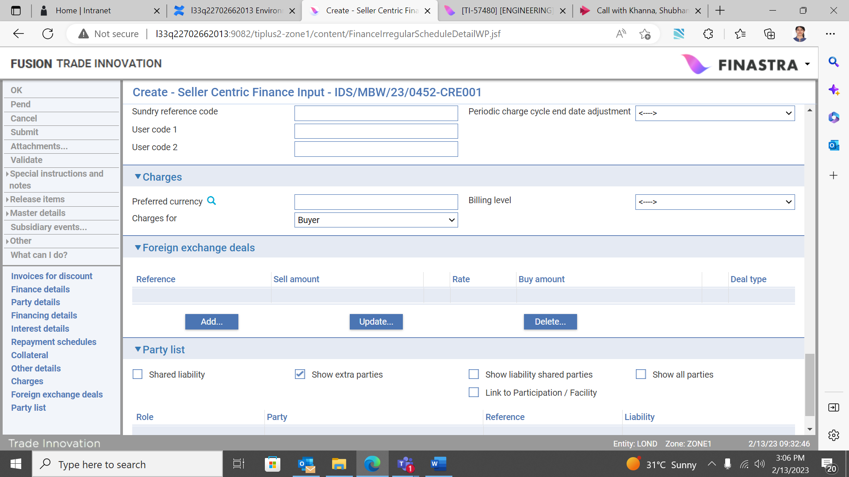

The following table explains what to enter into the fields in the Charges pane:

|  |  |
| --- | --- |
| Field | What to Enter |
| Preferred Currency | The currency in which your bank will collect the charges. The default currency value is taken from the charge currency specified in product options. |
| Billing Level | Select whether charges for the invoice(s) should be billed at customer level, transaction level or product level. |
| Charges For | Select which party will pay the charges. |

## The Foreign Exchange Deals Pane

The fields displayed in the FX Details pane allow you to enter one or more foreign exchange deals to support the financing transaction. See the Common Facilities User Guide – Trade Innovation for information on how to define a foreign exchange deal.

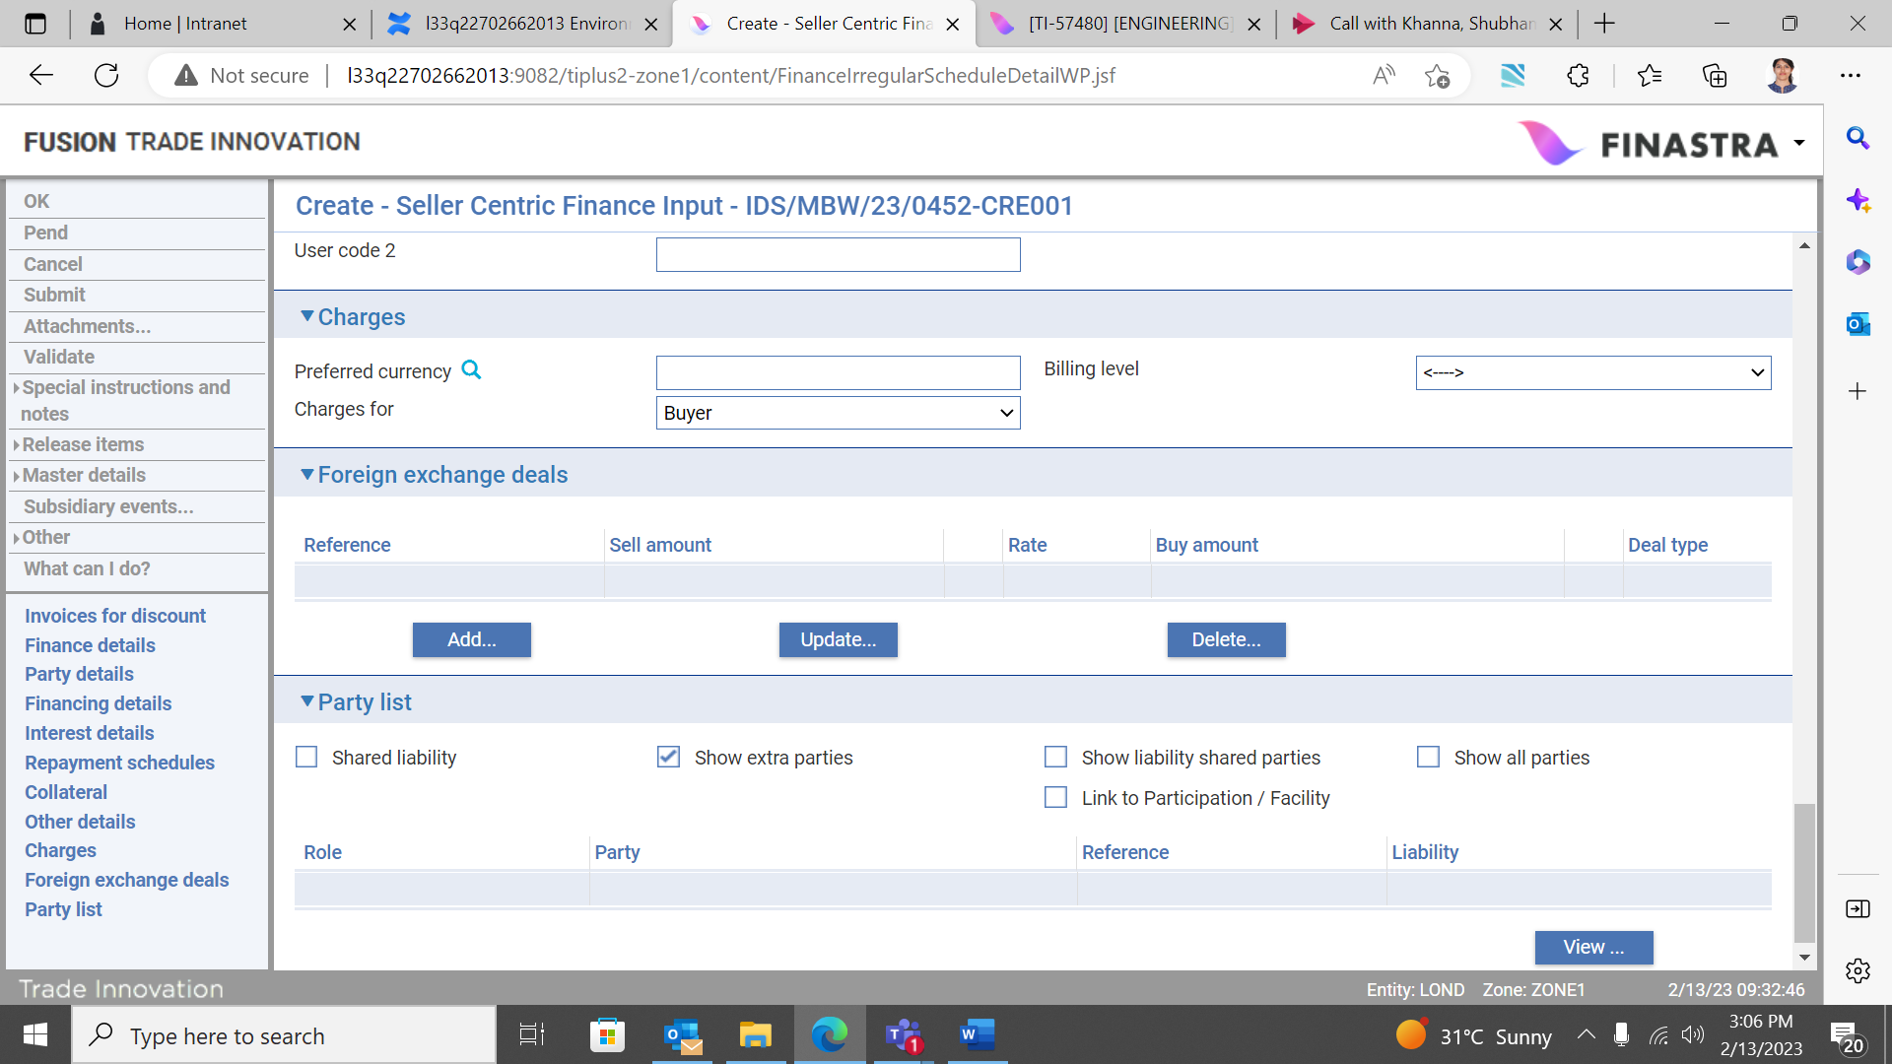

If you enter more than one foreign exchange deal, they must all be in the same currency. Trade Innovation totals all foreign exchange deals entered here and uses the consolidated amount as the amount of the financing transaction in the window used to enter the amount advanced.

## The Party List Pane

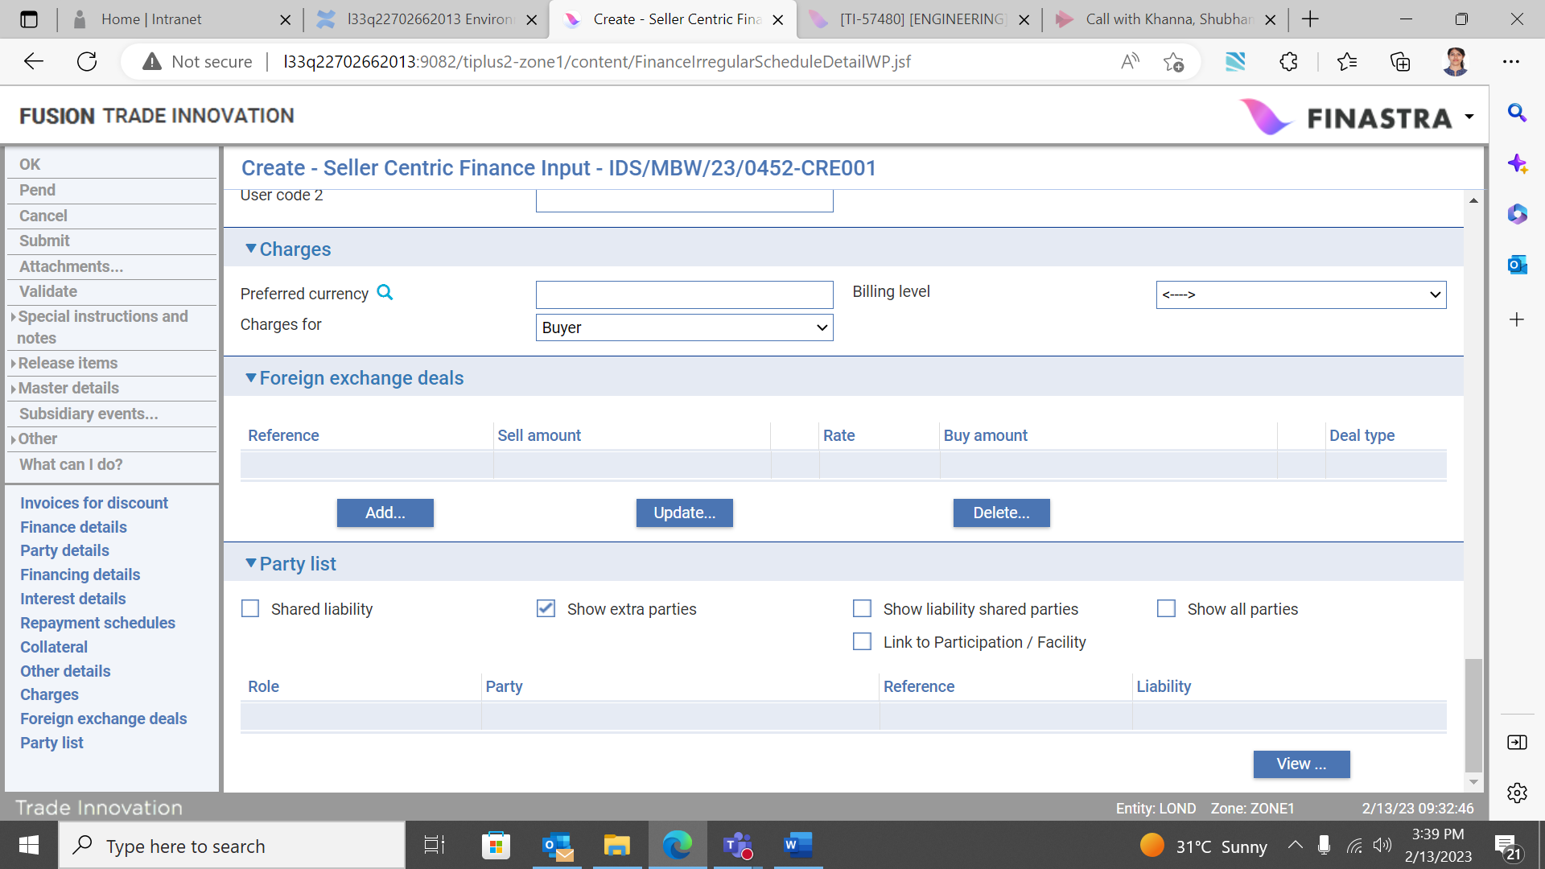

The Party List pane is described in full in the Common Facilities User Guide – Trade Innovation. Additional fields are present in the Party List field for financing products that can be linked to an export credit agency facility or a participation deal. They allow you to link the financing transaction to an export credit agency facility or participation deal if required.

## Programme Specific Participation Deals

If a participation deal has been created and linked to the finance customer’s programme prior to creation of the finance deal, then the system automatically displays the related (selected) participation deal reference in the Participation deal / Facility pane.

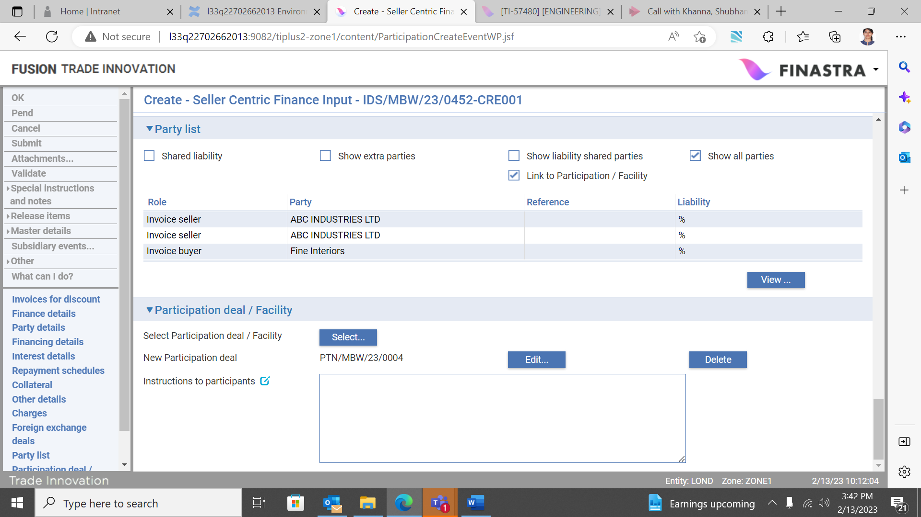

It’s also possible to filter on and link a participation deal to the finance transaction if one is not automatically linked, or to remove the linkage to the programme specific deal and create a new non-programme specific participation deal. Use the Select, New or Remove buttons in the normal manner to link to, create or delete a linkage to a participation deal.

You may view details of the linked participation deal by clicking the ‘View’ button. This opens the Participation deal, Master summary pane.

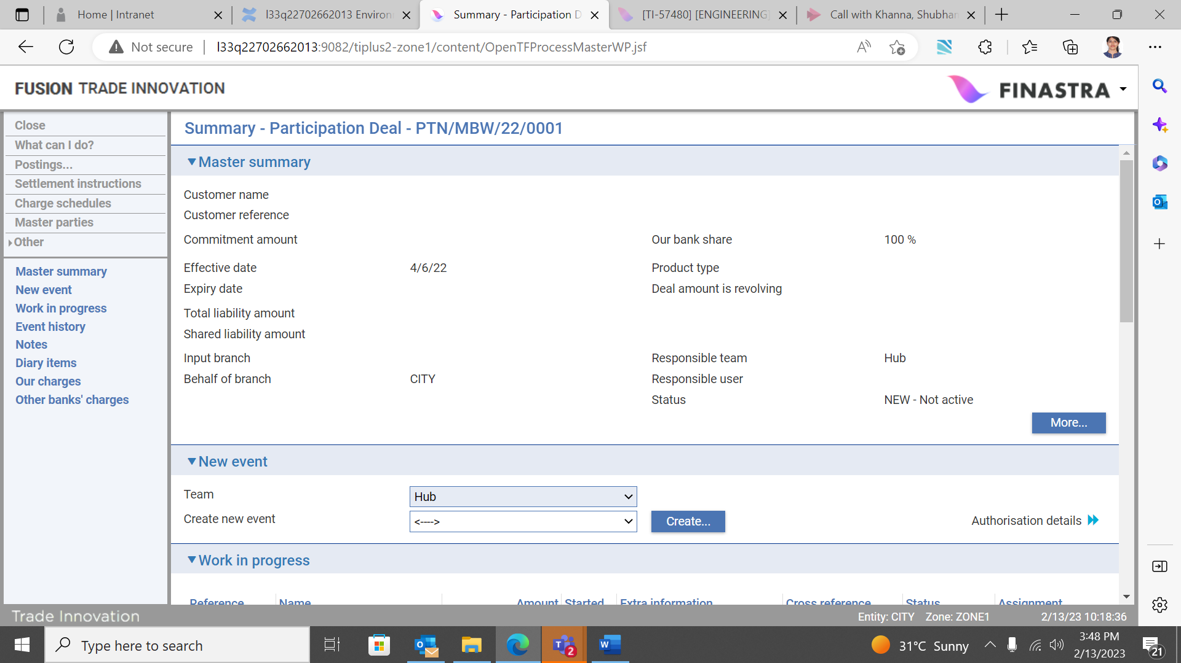

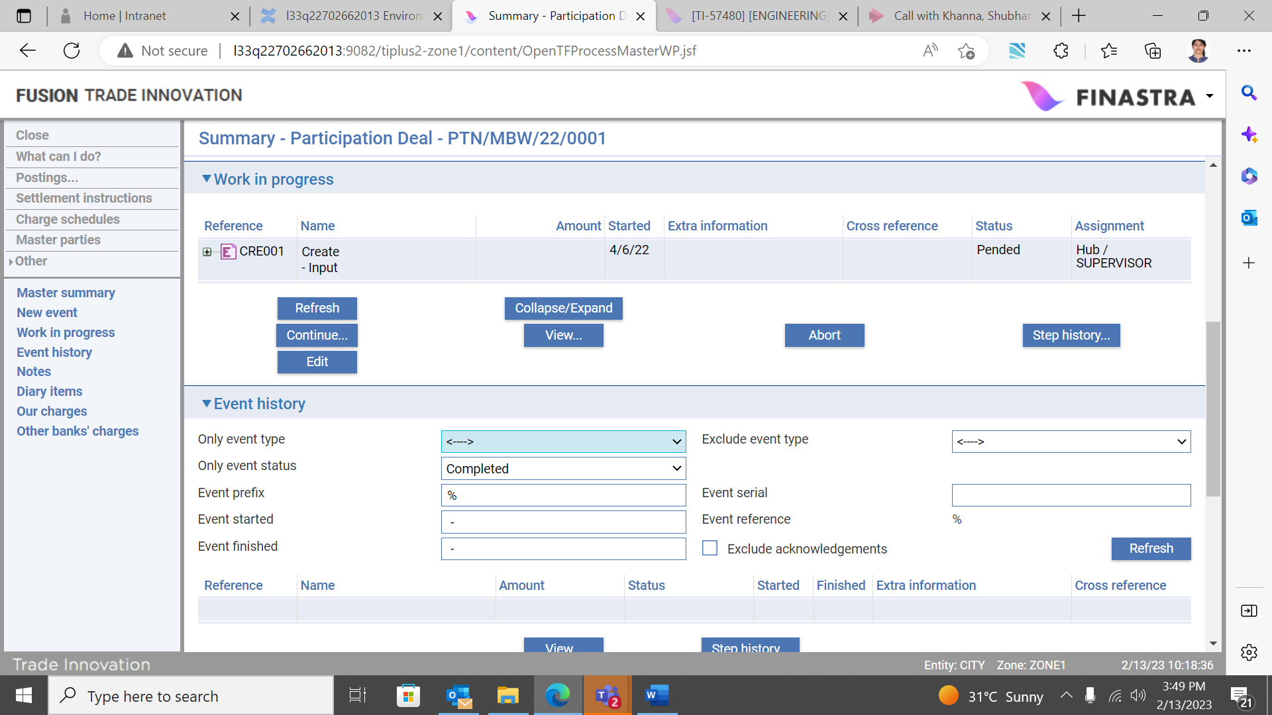

You can now complete the event in the normal manner.

1. The warnings and error messages resulting from validation are defined by your bank.

## On Completion of the Finance Create Event

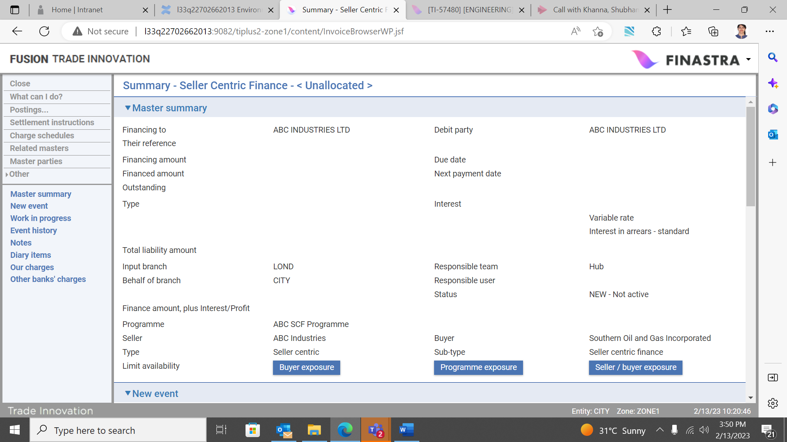

Following completion of the finance create event, the master summary screen displays full details of the finance deal.

By clicking the appropriate buttons, it is possible to view Buyer, Programme and Programme/buyer exposure, to view the interest relating to the deal and also to view the invoices that make up the deal, via the Related masters menu item.

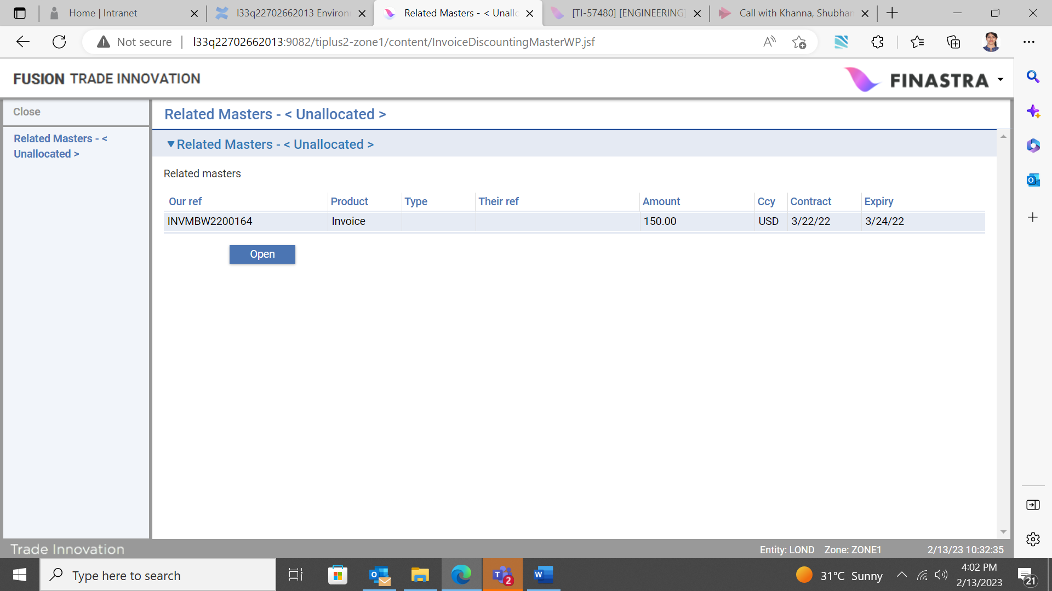

# Cancelling a Finance Deal

Following creation of a buyer or seller centric finance deal, it may become necessary to cancel the deal where an input error is discovered, or your customer requests cancellation of the deal. For example, this might be due to the use of an incorrect interest rate, or if it is subsequently discovered that an invoice has been included in the bulk finance deal in error.

You can cancel the discount deal via the buyer or seller centric finance Cancel event.

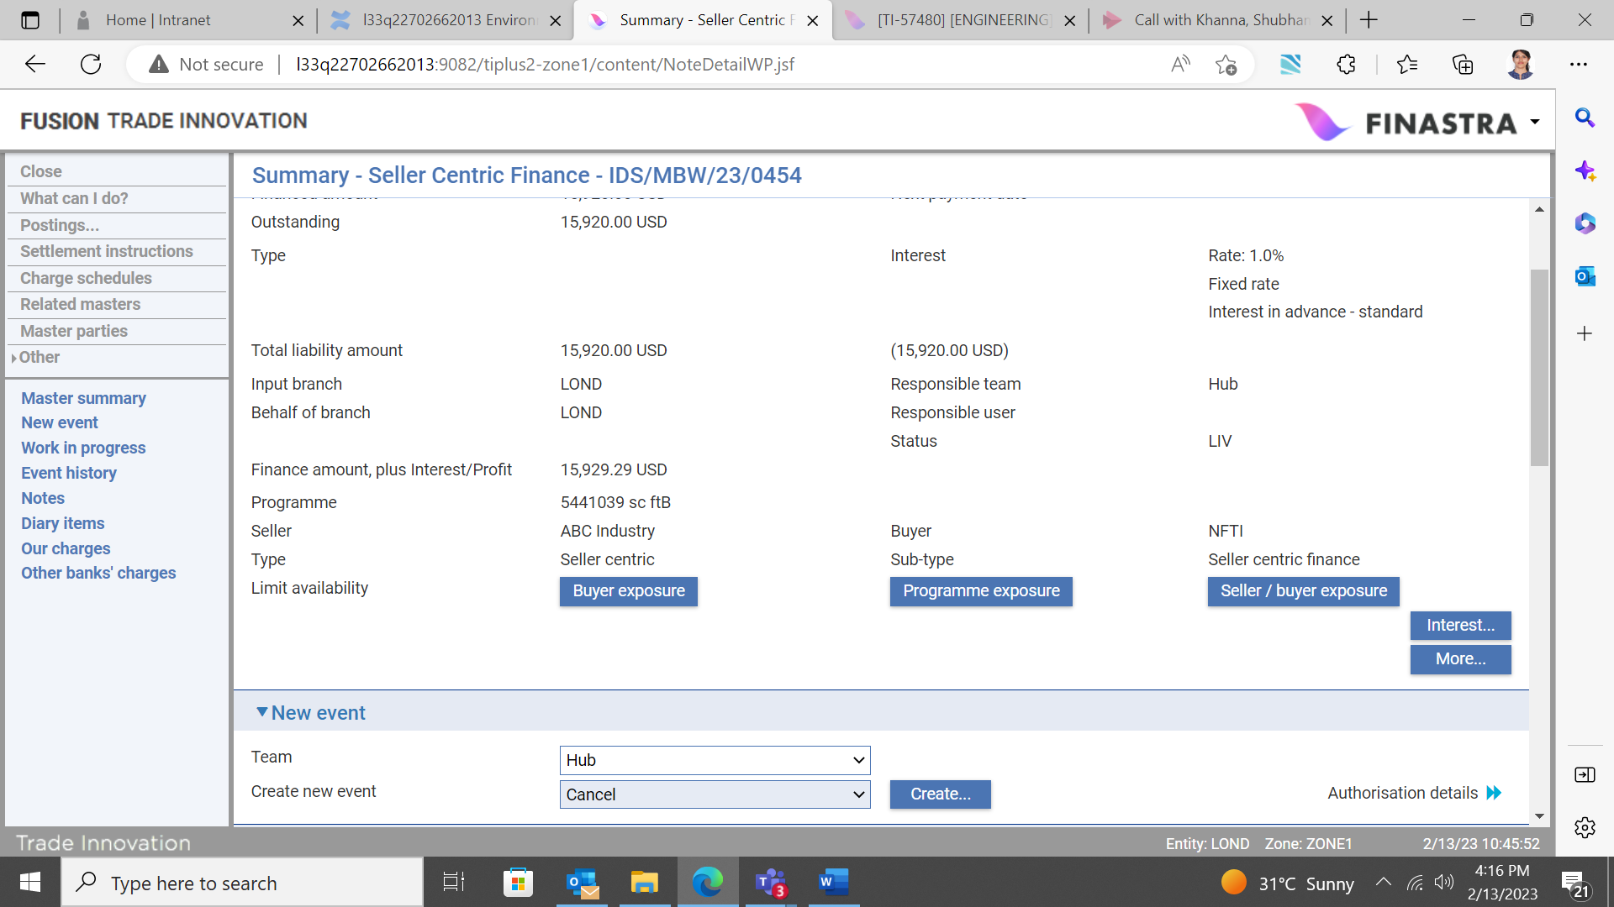

You can filter for the finance deal to be cancelled in the SCF master browser by setting the View to ‘Invoice finance deals’ (see page 9). Use the filters to search for the deal.

Select and open the finance deal and in the New event pane, select the Cancel event from the dropdown list. The following screen opens, showing the deal amount and listing all finance against invoices.

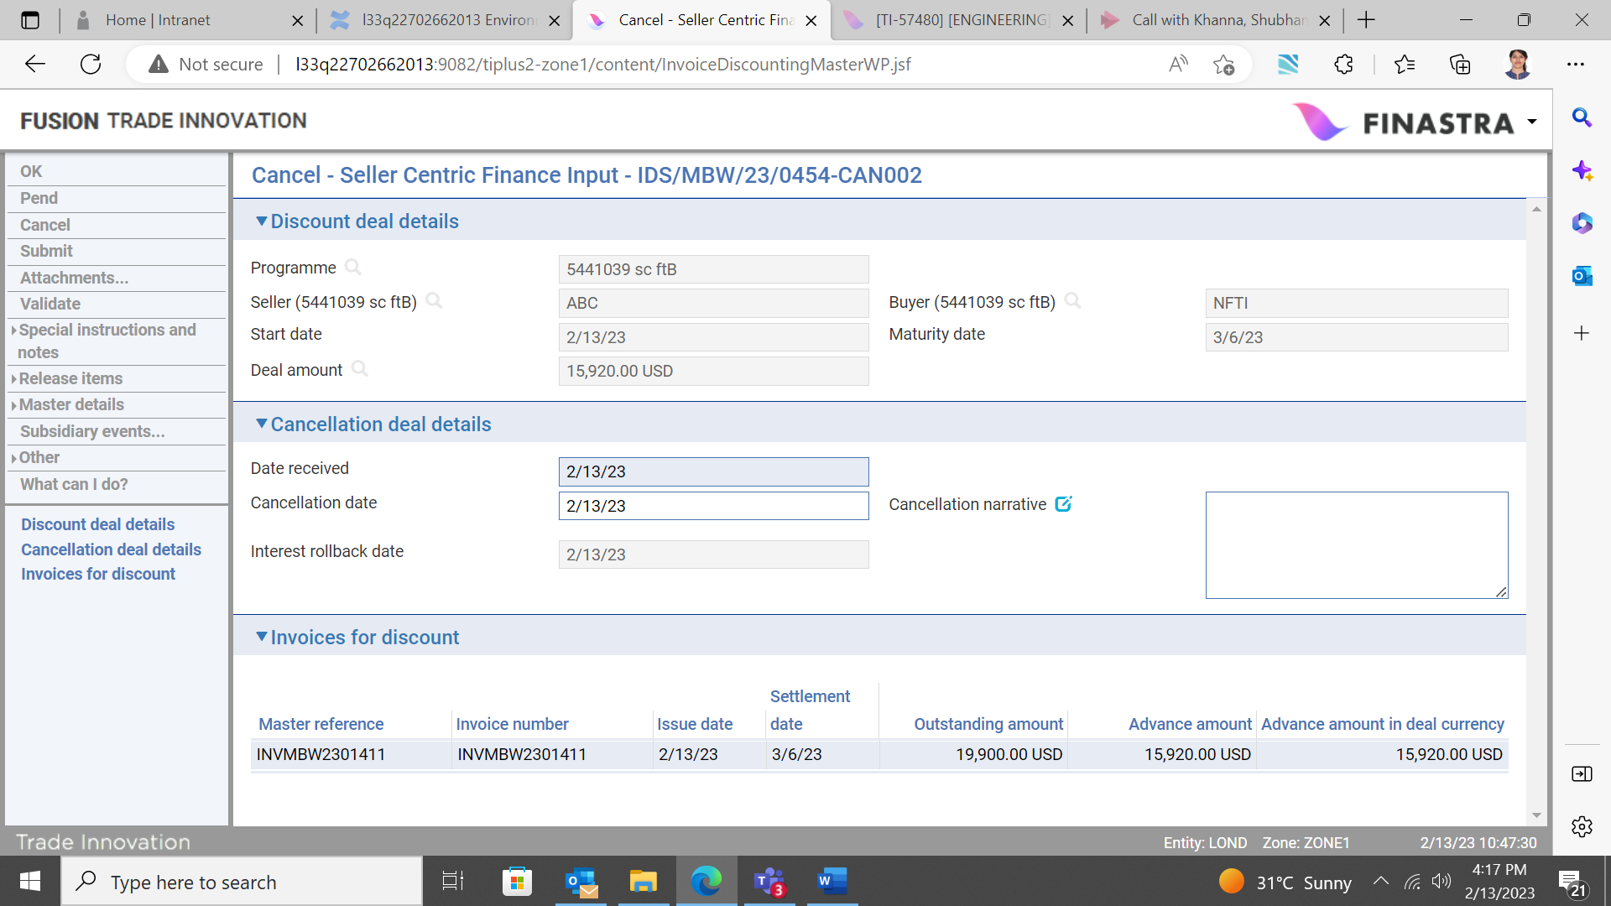

## The Cancellation Deal Details Pane

The fields displayed in the Cancellation deal details pane allow you to enter the date the cancellation request was received, the actual date of cancellation and a narrative field to describe the reason for the cancellation. The event is completed in the normal manner.

Where cancel event functionality is required, appropriate accounting entries must be defined by your bank to reverse out and close the discount deal and handle the interest, depending on whether it is taken in advance, or in arrears.

### Reinstatement of Invoices

Following completion of the cancel finance deal event, all invoices included in the original deal are automatically reinstated so that they are available to be discounted under a new deal. Also the finance deal related exposures recorded against the customer’s credit limit and the related buyer/seller is reversed.

# Charges

This chapter describes some Supply Chain Finance specific considerations applicable to invoices, credit notes, buyer and seller centric finance programmes and pool based factoring programme/facilities. Standard Trade Innovation charges functionality is referred to in this section.

## Invoice, Credit Note and Buyer and Seller Centric Finance Charges

Transaction processing charges for recording invoices and credit notes and for buyer and seller centric finance transactions are set up using Trade Innovation’s standard charges functionality as described in the System Tailoring User Guide – Trade Innovation. They are then processed in the usual way, as described in the Common Facilities User Guide– Trade Innovation.

## Pool Based Factoring Charges

Transaction processing charges arising from a seller centric programme set up for a pool based factoring facility are collected at regular intervals using a Scheduled Charges event raised against the factoring facility master record. Scheduled Charges events collect charges generated against the factoring facility master only; any charges generated against invoice masters are handled in the usual way from within invoice masters.

However, your bank can set up charges for invoices that are collected against the factoring facility using the statistics calculated by the Scheduled Charges event. These statistics enable your bank to set up a single charge for all invoices processed during a particular period which is collected against the factoring facility master, rather than having to set up separate charges for each invoice.

Scheduled Charges events are scheduled as diary events and occur automatically at regular intervals, as defined on the factoring master record. Your system may be configured so that you are required to manually intervene to complete an automatically generated Scheduled Charges event. As one such Scheduled Charges event is completed and released, the system automatically generates the next and places it in the diary.

You can also initiate a Scheduled Charges event manually.

### Charges and Billing

If your bank uses Trade Innovation’s billing functionality, for customers who prefer to be billed/invoiced, then charges for factoring and invoicing will be included in the regular billing of charges, otherwise charges arising against the factoring facility will be included in the Scheduled Charges event described in this chapter.

You can, however, exclude factoring and related invoice charges from billing using the Suppress Billing button. See the Periodic Billing and Invoicing User Guide – Trade Innovation for information on how billing is carried out.

1. For factoring-related charges your bank should use either Trade Innovation’s billing functionality or the Scheduled Charges event.

### Manually Entering or Completing a Charges Event

An automatically generated Scheduled Charges event requiring manual completion can be opened from within the factoring master record’s Master Summary window (see page 55) in the usual way.

To open a Charges event manually, in the Master Summary window select 'Schedule Charges' from the Create New Event drop-down list and click Create. Trade Innovation opens the event at either the Log step or the Input step, depending on how your system has been configured.

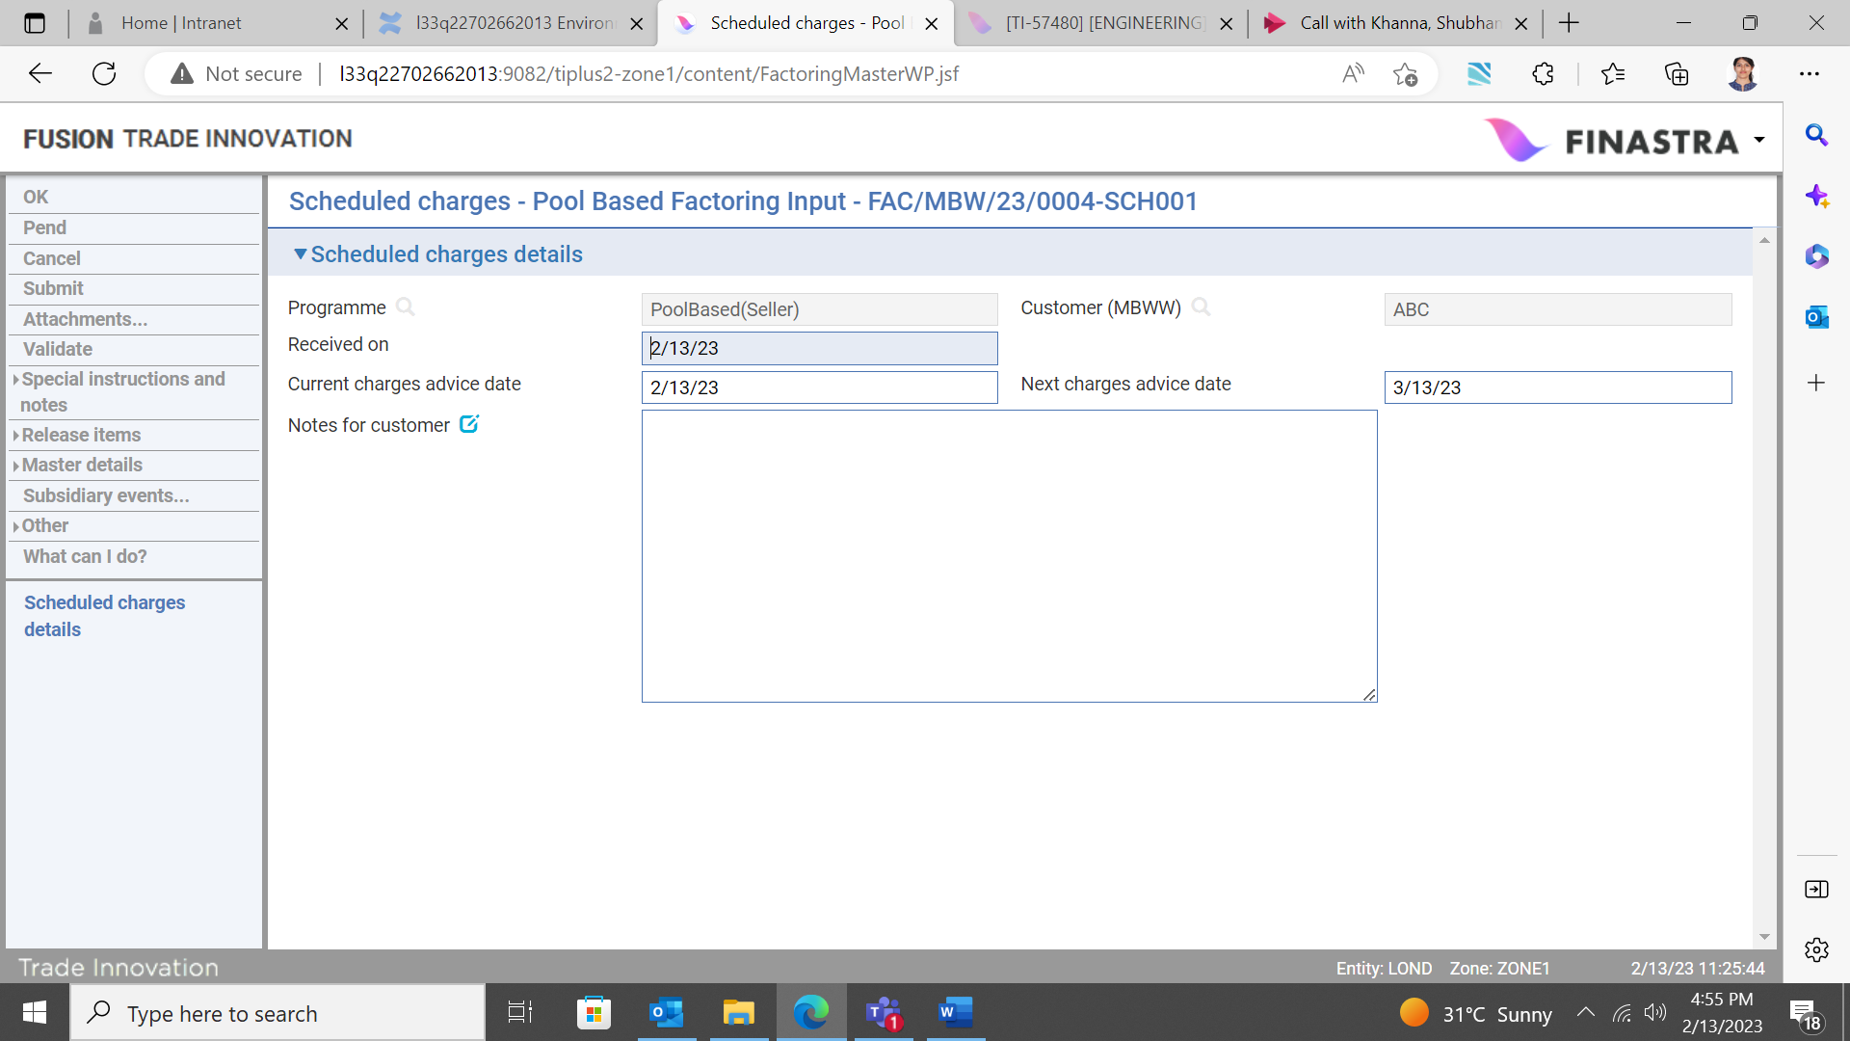

The following table explains what to enter into the fields in this window. The charges themselves can be seen using the Release Items|Charges link, and further information viewed using the Other|Event Fields link. See the Common Facilities User Guide – Trade Innovation for instructions on using these two links:

|  |  |  |
| --- | --- | --- |
|  | Field | What to Enter |
|  | Received On | Either the date the payment was received by your bank, or the current processing date. |
|  | Current Charges Advice Date | The date on which the charges are being advised and collected. |
|  | Next Charges Event Date | The date the next Charges event will be used to advise charges. This is calculated automatically according to the frequency for the Charges event entered on the factoring master record, but can be overridden. |
|  | Notes for the Customer | Any information for the customer regarding the charges being collected. |

# Appendix - Invoice Statuses, Eligibility Criteria, Ineligibility Statuses and Limits

## Invoice Statuses

The following table lists the statuses an invoice might have:

|  |  |
| --- | --- |
| Main Status | What it Means |
| Cancelled | An invoice is set to have this status by a Cancel Invoice event. It then proceeds to book-off in the usual way.  You can also set an invoice to have this status using a Create or Amend Invoice event.  You would set an invoice to have this status based on information received from the customer. Cancelled invoices are concluded and booked off without any payment being made (unless they are subsequently reactivated for further processing).  This status makes the invoice ineligible for financing. |
| Dishonoured | An invoice can be set to have this status by a Create event or an Amend Invoice event.  An invoice would be set to have this status when the buyer has refused to pay it. However, the invoice is still expected to be paid, unless the customer decides to cancel it.  The decision to set an invoice to this status would typically be made jointly by your bank and the customer. The bank may proceed with a legal action when the invoice was included in a finance deal.  This status makes the invoice ineligible for financing. |
| Inquiry | An invoice can be set to have this status by a Create event or an Amend Invoice event. With this status, the invoice is retained on the system while the dispute is resolved, but is excluded from any new finance or factoring drawdown.  Also, the Settle Invoice event sets an invoice to this status when a partial payment is made, leaving an outstanding amount.  An invoice would be set to this status when there is an outstanding query with either the customer or the buyer (resulting, for example, from a payment refusal or a partial payment). However, the invoice is still expected to be paid, unless the customer decides to cancel it. This status can escalate to Dishonoured.  This status makes the invoice ineligible for financing. |
| Outstanding | This is the status initially given to an invoice when it is first recorded in the system. The invoice is expected to be paid without any issues.  This status makes the invoice eligible for financing. |
| Overdue | Overnight processing sets an invoice to this status if it has not been paid when its payment due date, plus any grace period, has passed.  The Create or Amend Invoice events can automatically set an invoice to have this status, based on the settlement date entered.  The invoice is still expected to be paid.  This status makes the invoice ineligible for financing. |
| Paid | The Settle Invoice event sets an invoice to this status once the full outstanding amount has been paid. It then proceeds to book-off in the usual way.  The Create or Amend Invoice events can automatically set an invoice to have this status when Decrease Amount and Credit note amount is equal to Outstanding Amount.  This status makes the invoice ineligible for financing. |

|  |  |
| --- | --- |
| Approval Status | What it Means |
| Approved | This status is applicable to invoices loaded into buyer centric programmes.  The approval refers to whether an invoice has been accepted by the buyer for payment on the settlement date.  You can also set an invoice to have this status using a Create or Amend Invoice event. |

|  |  |
| --- | --- |
| Finance Status | What it Means |
| Financed | This status is applicable to invoices loaded into buyer or seller centric programmes.  This refers to whether an invoice has been included in a finance deal.  You can also set an invoice to have this status using a Create or Amend Invoice event. |

## Eligibility Criteria

This section outlines the criteria an invoice must meet to be eligible for financing or factoring drawdown, for financing in bulk and for settling in bulk.

### Eligibility Criteria Applicable to Invoices for Drawdown or Financing

To be eligible for inclusion in a factoring drawdown or financing, an invoice must meet the following criteria:

* Its reference is unique (that is, it is not a duplicate in the context of a given buyer and seller combination)
* It must not be stale. The system option InvoiceStalePeriod defines the period after which an invoice is considered stale. This period is measured from the issue date of the invoice
* It must not be post dated (that is, its issue date must not be later than the current processing date)
* Its settlement/ due date must fall within the period (measured against the current processing date) defined by the seller/buyer relationship details. This period is measured from either:
* the issue date of the invoice, or
* the invoice received date
* Its status must be ‘Outstanding’(it is not yet settled)
* The buyer must not be referred or blocked
* The seller must not be referred or blocked
* Its buyer has accepted the invoice existing in a buyer centric programme
* It has not been financed

Overnight processing changes the status of a post-dated invoice from ineligible to eligible when the invoice's issue date is reached and from 'Outstanding' to 'Overdue' when the invoice becomes overdue, ineligible.

### Eligibility Criteria Applicable to Invoices for Bulk Finance Deals

To be eligible for inclusion in a buyer or seller centric, bulk finance deal, the selected invoices must meet the following criteria:

* They are eligible for financing
* They must have the same seller (which may be a bank customer)
* They must have the same buyer (which may be a bank customer)
* They exist in the same programme
* They must have the same anchor party (the customer with buyer or seller role who owns the programme)
* They must be denominated in the same currency
* They must have the same settlement (due) date

### Eligibility Criteria Applicable to Invoices and Finances for Bulk Payments

To be eligible for inclusion in a bulk payments transaction, the selected invoice and/or finance must meet the following criteria:

There is an outstanding balance left to be settled.

There is no existing settlement or repayment in progress or selected for settlement at a future date.

It is not part of another bulk payment in progress or selected for settlement at a future date.

There are no restrictions (e.g. buyer/seller is blocked, programme is disabled) on the attributes of the selected invoice or finance.

## Ineligibility Statuses

The following table lists all the possible reasons why an invoice is ineligible for financing:

|  |
| --- |
| Ineligibility Status |
| Invoice has duplicate reference |
| Invoice status is overdue |
| Invoice has invalid issue date |
| Invoice is post-dated |
| Invoice is stale |
| Invoice has invalid seller |
| Invoice has invalid buyer |
| Invoice has blocked buyer |
| Invoice has invalid seller buyer relationship |
| Invoice has invalid settlement date |
| Invoice settlement date outside of maximum period |
| Invoice status is dishonoured |
| Invoice status is cancelled |
| Invoice status is under inquiry |
| Invoice status is paid |
| Invoice has referred buyer |
| Invoice is being financed |
| Invoice requires approval |
| Invoice has blocked seller |
| Invoice has referred seller |
| Invoice has invalid received on date |
| Invoice is already financed |
| Invoice is booked off |

## Limits

This section provides information on limits used by the Supply Chain finance application set at buyer level and against seller/buyer relationships, and the anchor party customer credit limits.

For further information on other credit limit checking used by Trade Innovation see the Common Facilities User Guide – Trade Innovation.

## Buyer (Debtor) Concentration Limits

Under Supply Chain Finance programmes, each buyer is assigned an invoices concentration limit. This is used in limit checking to monitor and control loading of new invoices. The utilised amount represents the total value of invoices that are yet to be paid by the buyer. This limit is not related to finances or drawdowns raised against invoices.

This limit is effective across all invoices for all of your bank's customers. It is used whenever a new invoice is recorded or an existing one amended, to ensure that the buyer's limit is not breached. Your bank can ensure that this limit is not breached by setting up error messages to prevent a Create Invoice event or an Amend Invoice event from completing if the limit would be breached.

When an invoice is fully settled or cancelled, the relevant exposure entry against the buyer concentration limit is updated or removed.

## Seller/Buyer Relationship Limits

Under Supply Chain Finance programmes, each seller/buyer relationship includes an advance percentage figure, which is used to calculate the amount available for drawdown or financing. This specifies the percentage of the value of eligible invoices for this seller/buyer relationship to be taken into a factoring drawdown or buyer/seller centric finance.

In addition, a credit limit is allocated to each seller/buyer relationship for the purpose of finance or drawdown calculations and limit checking and control.

This is the total amount of finances or drawdown that can be derived from eligible invoices controlled by the relationship. Outstanding advances or drawdown are recorded as exposure entries against this limit. The current available limit is the total amount that can be advanced to a customer against eligible invoices raised against that relationship.

When finance is repaid, the relevant exposure entry against the seller/buyer limit is updated or removed.

Anchor party (programme owner) credit limit is allocated to each anchor party customer at the programme level or across all of their programmes, representing the ultimate limit to be imposed on finances or drawdown against eligible invoices. This is used in finance or drawdown calculations, limit checking and control.

This credit limit is used on drawdown calculations and any limit checking carried out by your bank using a credit risk management system linked to Trade Innovation via interface service messages. For each drawdown, the amount of the drawdown is recorded against this limit as an exposure (debit) entry. An invoice settlement is recorded against this limit as a reinstatement (credit exposure) entry.

These credit limits are maintained using the credit risk management system your bank uses. Any limit checking carried out by your bank using a credit risk management system linked to Trade Innovation via interface service messages is based on finance or drawdown liability accounting entries as usual.

However, the current state of such a limit is represented in the system at the programme level for calculation and exposure tracking purposes. Trade Innovation maintains this type of limit in parallel with the bank’s credit risk management system.

Trade Innovation is designed to keep the credit limits held in the system in line with the credit limits held in the credit risk management system your bank uses. If your bank changes a credit limit in its credit risk management system, it must also manually change the corresponding figure recorded in Trade Innovation.